Meta Description: An anonymous Satoshi-era Bitcoin whale has gained 400,179% profit and invested it into ETFSwap (ETFS).

Keyword:
Altcoin
Satoshi
Satoshi-era
Bitcoin
ETFSwap
ETFS
ETF

OG Satoshi-Era Bitcoin Wallet Rotates 400,179% Profits Into This Trending Altcoin - No, It’s Not Shiba Inu Or Dogecoin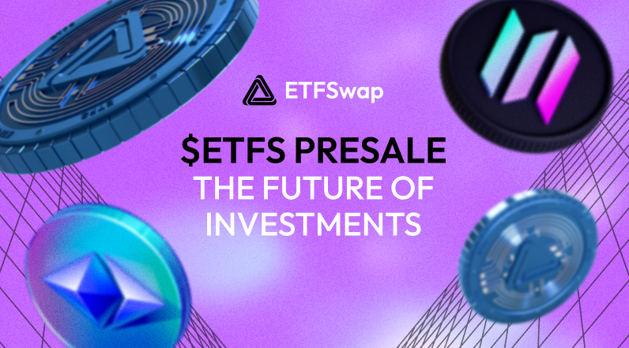

A Satoshi-era Bitcoin whale has reportedly accrued a substantial profit, 400,179%, on his Bitcoin (Bitcoin) holdings. The Satoshi-era OG, which re-emerged after being dormant for about 13 years, has been a trending topic in the crypto space. Following its massive success, the anonymous Satoshi-era Bitcoin whale has invested a substantial chunk of his profit into this trending altcoin: ETFSwap (ETFS).

ETFSwap (ETFS) is a new Ethereum-based altcoin that is performing exceptionally well in the crypto market. Read on to find out more.

Satoshi-Era Bitcoin OG Invests Gains Into ETFSwap (ETFS)

In a post on its X (formerly Twitter) platform on Monday, popular Blockchain tracker and analytics system WhaleAlert claims that a Bitcoin address which contained 48 BTC valued at $2.57 million has been activated after being dormant for 13 years. This price represents a staggering 400,179% gain, a figure that is rarely seen in any investment market.

This development, which trended on several social media platforms, has since garnered so many mixed reactions. Some enthusiasts believe that Bitcoin wallets are getting hacked since these cases are becoming increasingly frequent. Others feel that these investors are just remembering their seed phrases. However, whichever the case may be, this is an astonishing ROI.

Following this considerable gain, the Satoshi-era Bitcoin whale has invested massively into the ravaging presale, ETFSwap (ETFS), with the aim of making even better profits. ETFSwap (ETFS) is besting other popular altcoins like Shiba Inu (SHIB) and Dogecoin (DOGE) due to its viability, dynamic features, and relative resistance to market volatility.

ETFSwap (ETFS): Providing DeFi Solutions For Institutional Investors

ETFSwap (ETFS) is a trending altcoin that has captured the interest of both crypto investors and enthusiasts. It has unique features and potentials that set it apart from other popular altcoins, such as Shiba Inu (SHIB) and Dogecoin (DOGE). This is the major reason the Satoshi-era OG chose it among other alternatives.

Built on the Ethereum blockchain, ETFSwap (ETFS) allows investors to own and trade tokenized assets. It prides itself on enabling an environment where investors can seamlessly invest in a vast collection of tokenized institutional exchange-traded funds and cryptocurrencies. ETFSwap (ETFS) achieves this by closing the gap between institutional investment and the decentralized realm of decentralized finance (DeFi), working with MiCa-compliant regulated investment banks to deal in securities and crypto trading.

The ETFSwap (ETFS) platform is built with an ETF Screener and ETF Tracker. The ETF Screener and Tracker recommend the best ETF option to investors based on data analysis, market analysis, market trends, and sentiment, among others. This AI algorithm is a selling point for the altcoin, allowing investors to make the best choice and maximize their returns.

They can also maximize their returns by leveraging their trades. ETFSwap (ETFS) allows investors to leverage their trades up to 10x and offers a 50x leverage, thereby maximizing their profits. Likewise, they can continually trade short and long-term options without expiration dates with the altcoin’s market-making features.

The altcoin further allows investors to gain by staking their assets in pools available on the platform. The bigger the ETF pools grow, the higher their yield.

The Satoshi-era Bitcoin whale and other investors won’t have to worry about security, as the altcoin prioritizes security and transparency. To reiterate its commitment, CyberScope, a top blockchain security provider, has run a comprehensive audit of its smart contracts, and the results were impeccable.

Currently in its presale phase, ETFSwap (ETFS) offers both new and proven investors a chance to earn great yields. Selling for only $0.01831, now is the best time to acquire the tokens, as the next price is set to rise to $0.03846. This reflects an immense 110% increase.

Final Thoughts

Just like the Satoshi-era Bitcoin OG who invested his proceeds into the ETFSwap (ETFS) presale, crypto investors should do likewise now. The altcoin promises a range of features and benefits tailored to maximize profits; however, early investment is key. This is an opportunity you don't want to miss.

For more information about the ETFS presale:
Visit ETFSwap Presale

Join The ETFSwap Community

