Title Tag: BlockDAG’s 91st Software Update: New Enhancements for X1 App & BlockDAGScan
Meta Description: Dive into BlockDAG’s recent release, emphasizing the X1 App’s new Dynamic FAQ feature and design updates, along with BlockDAGScan’s latest UTXO explorer functionality.

BlockDAG's 91st Dev Release: Enhancing User Experience in X1 App & Expanding BlockDAG Scan Functionality
The BlockDAG team is delighted to unveil the most recent enhancements to the BlockDAG X1 app, emphasizing their continued commitment to refining the user interface and providing advanced solutions in the blockchain space.
A standout feature in this update is the introduction of the Dynamic FAQ component, which automatically updates to deliver the most relevant and up-to-date information to user queries. This innovative functionality ensures that users have access to the latest data, greatly facilitating the user experience by making the app more intuitive and easier to navigate for both new and existing users.
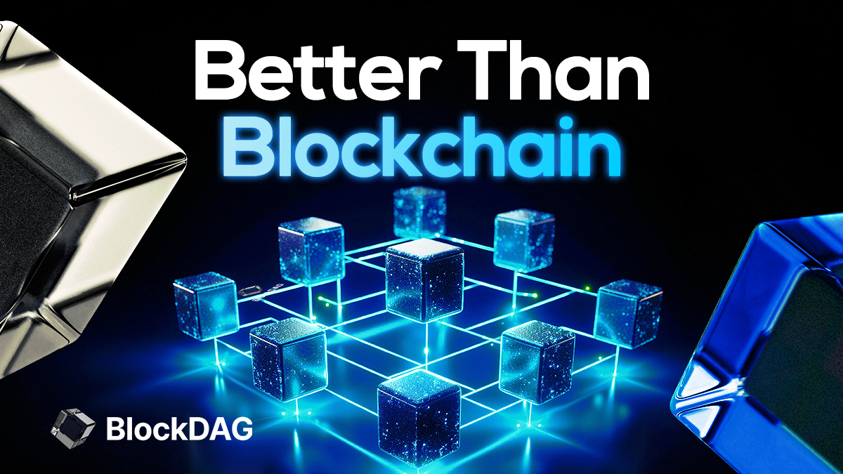

Enhanced Design Features in the X1 App
This release includes several design enhancements aimed at improving both the aesthetic appeal and functionality of the X1 app. These adjustments not only improve the overall user experience by making the interface more visually appealing but also enhance usability, allowing for smoother interactions. Furthermore, the addition of a logout notification feature increases security measures, promptly alerting users about their session status.
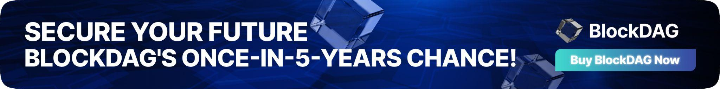
Our Quality Assurance (QA) team is diligently testing these updates, and their initial efforts have already uncovered and addressed several minor bugs. This meticulous testing process underscores our dedication to providing a stable, efficient, and reliable application. We are eager to deploy these improvements to all users, ensuring they benefit from a more refined and optimized interface.

Significant Advancements in BlockDAGScan
Parallel to the updates made to the X1 app, significant enhancements have been made to BlockDAGScan, particularly with the addition of the UTXO explorer. This new feature enhances the transparency of the platform and provides users with deeper insights into their transaction history, thereby simplifying the management of unspent transaction outputs.
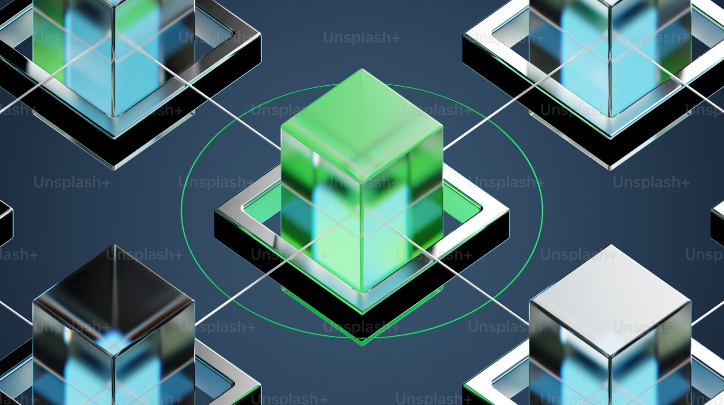
The UTXO explorer plays a crucial role in offering users detailed insights into their transactions. Addressing the technical challenges associated with ensuring real-time synchronization with the blockchain, our team has developed a combined approach of streaming live data while periodically verifying data accuracy. This method ensures that the UTXO data is both current and reliable, enhancing user trust and satisfaction.

Introducing the BlockDAG Team
The effective implementation of these updates reflects the expertise and dedication of the BlockDAG team. Antony Turner, our CEO, has been pivotal in steering the company with his extensive experience spanning two decades in Fintech, EdTech, and cryptocurrencies. His strategic leadership is instrumental in establishing BlockDAG as a leader in blockchain technology.
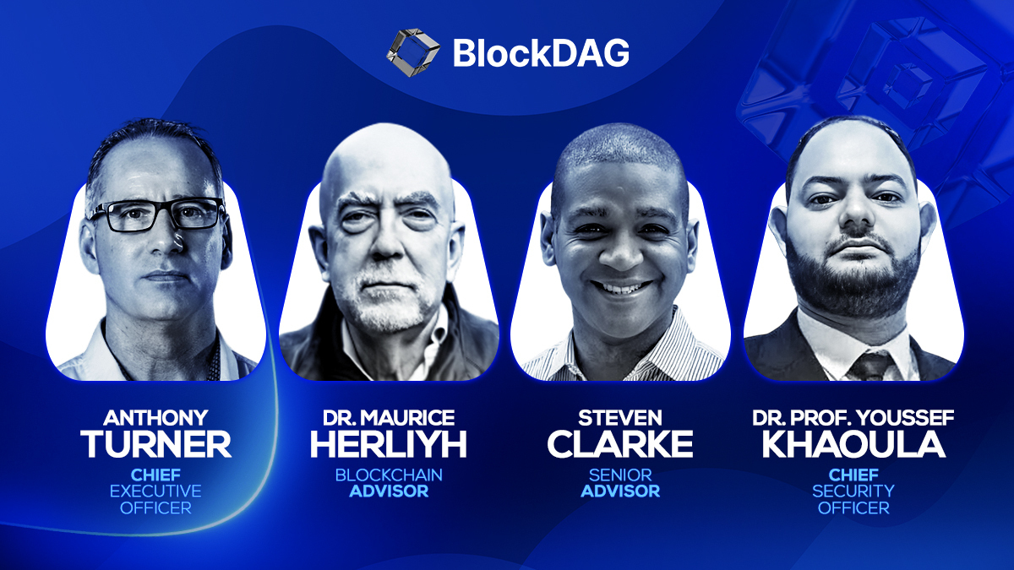
Our Chief Security Officer, Youssef Khaoulaj, with his robust background in Smart Contract Auditing and Red Team Hacking, plays a vital role in ensuring the security and reliability of the BlockDAG infrastructure. His contributions are essential in maintaining a secure and stable platform for all users.
Our developers and QA teams work in concert to fine-tune our systems, ensuring that each release not only meets but exceeds our high standards for quality and user experience.

Vision for the Future and Presale Success
Imagine a blockchain platform that is not only user-friendly but also technologically advanced, where state-of-the-art solutions are readily accessible, and where your investments grow with a pioneering company. BlockDAG is realizing this vision. With the ongoing presale now in Batch 21, priced at $0.017 per coin and having raised $66.2 million, achieving a growth of 1600% since the first batch, BlockDAG is at the forefront of revolutionizing the blockchain industry.
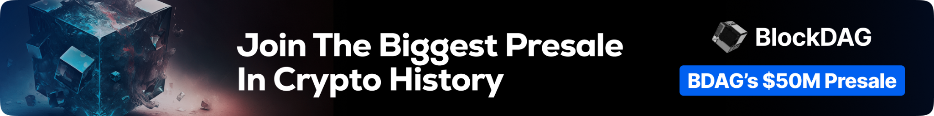
This latest development update demonstrates our team's relentless commitment to excellence and innovation. Built on a strong foundation and guided by visionary leadership, BlockDAG is well-positioned to drive significant advancements in the blockchain industry, leading the way to a more digitally efficient and accessible future.
Join BlockDAG Presale Now:
Website: https://blockdag.network
Presale: https://purchase.blockdag.network
Telegram: https://t.me/blockDAGnetworkOfficial
Discord: https://discord.gg/Q7BxghMVyu

