WienerAI Price Drop

Title Tag: BlockDAG Emerges as a Steady Option Following WienerAI's Steep Decline

Meta Description: Uncover why savvy holders are gravitating towards BlockDAG for its stability and potential for substantial growth following the turbulent launch and price drop of WienerAI. Explore BlockDAG's distinctive features.

Following WienerAI’s 86% Tumble, Presale Buyers Flock to BlockDAG for Massive ROI

The cryptocurrency market is a whirlwind of activity, continually introducing new projects as holders seek out those with real staying power. WienerAI recently stirred the pot with its meteoric rise and rapid descent, prompting questions about its future viability.

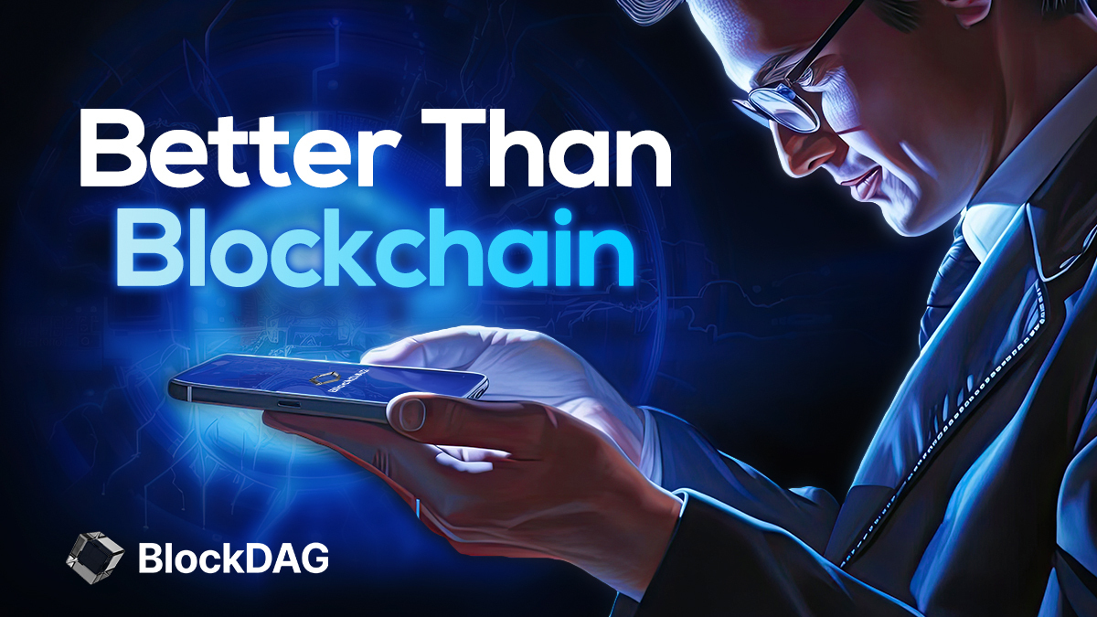

In contrast, BlockDAG positions itself as a more secure and promising choice for those eyeing long-term value in the crypto arena, underscored by a robust $66 million amassed during its presale.

WienerAI’s Eventful Journey

WienerAI clinched the spotlight as one of 2024's most successful crypto presales, securing over $8 million and drawing significant interest. Yet, its journey has been far from smooth. On August 5, 2024, a market downturn sent Bitcoin's value tumbling, erasing more than $360 billion from the crypto market, with WienerAI taking a significant hit.



Following its market debut, WienerAI's value plummeted by 86%, signaling a broad investor retreat. Despite a brief resurgence to its peak of $0.0008, this recovery proved fleeting, and WienerAI now trades at approximately $0.00045. Although still above water for early holders, this volatility has sparked concerns over its long-term steadiness.

Why presale holders Are Flocking to BlockDAG After WienerAI’s Tumble

While WienerAI’s fluctuations might tempt those hunting for swift gains, BlockDAG proposes a more grounded, enduring pathway in cryptocurrency. Here’s why BlockDAG stands out as a superior option:

Trustworthiness and Safety

Unlike WienerAI, which saw its price nosedive soon after launching, BlockDAG is built on a foundation of trust and safety. Its sophisticated blockchain technology emphasizes quick transactions, robust security, and decentralization, minimizing the risk of sudden price drops and enhancing confidence.



Functional Applications

WienerAI may play to the gallery with meme culture, but BlockDAG extends its reach with practical applications. It's a comprehensive platform that fosters the development of decentralized apps (dApps). Its intuitive low-code/no-code setup makes it simple for developers and companies to create utility tokens, meme tokens, and NFTs, ensuring BlockDAG's relevance and appeal, even when the market wobbles.

Community Engagement and Expansion
While WienerAI has amassed over 17,000 followers on X/Twitter, its expansion is tethered to the unpredictable meme coin community's whims. BlockDAG, on the other hand, has laid a solid groundwork for sustainable growth, boasting nearly 114,000 X/Twitter followers. Its anticipated mainnet launch in the upcoming months is set to enrich its ecosystem and draw a wider array of users and developers.

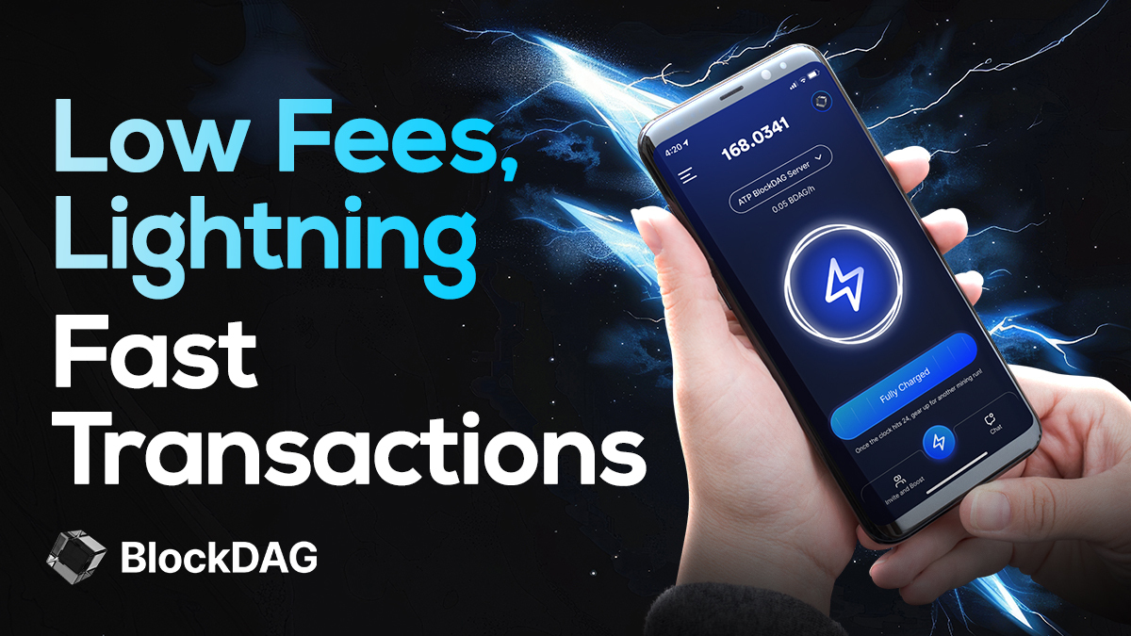

Market Resilience
WienerAI’s recent decline underscores its vulnerability in a capricious market. BlockDAG, by contrast, is engineered to better withstand such conditions with its Directed Acyclic Graph (DAG) architecture, enabling faster transactions and superior scalability, thus bolstering its resilience in downturns.

Future-Oriented Technology
BlockDAG is crafted with the future in mind. Its focus on scalable, decentralized applications positions it ideally for enduring success. As blockchain technology advances, BlockDAG’s infrastructure is designed to evolve and expand, keeping it at the forefront of the industry. WienerAI, while popular now, may struggle to adapt if it continues to bank solely on meme coin trends.

The Case for BlockDAG
While WienerAI’s swift ascent and fall may attract those after quick profits, BlockDAG offers a more robust and sustainable opportunity. With its commitment to stability, real-world utility, and long-term growth, BlockDAG is poised to become a key player in the future of blockchain technology.

holders seeking a reliable and innovative project would do well to consider BlockDAG, especially in a market known for its unpredictability. It’s clear that projects like BlockDAG, which deliver genuine value and practical applications, are set to stand the test of time in the competitive crypto landscape.


Join BlockDAG Presale Now:
Website: https://blockdag.network
Presale: https://purchase.blockdag.network
Telegram: https://t.me/blockDAGnetworkOfficial
Discord: https://discord.gg/Q7BxghMVyu

