Top 11 Free Crypto Mining Apps for Android in 2024
Mobile mining is gaining really great popularity. Starting mining straight from your smartphone is now simpler than it has been before. This is due to the increasing number of android crypto mining apps that are accessible nowadays.
Some of the greatest free crypto mining apps for android will be shown to you here in this article. I will point out the most reliable ones. I will give also you tips on how to make the most of mobile crypto mining. This article is useful for both expert and newbie miners.
So, why wait? Let’s begin this journey!

Understanding Mobile Crypto Mining
It's important to understand mobile crypto mining before I talk about the top free crypto mining apps for android.
Mobile crypto mining app enables individuals to mine cryptocurrency using their cell phones. It is not like conventional mining, which requires strong hardware and plenty of power.
Please keep in mind that mobile mining is an easier approach for newbies to use in the realm of cryptocurrencies, but it cannot provide the same rewards as conventional mining.

Why Choose Android for Crypto Mining?
Since Android is open-source—that is, anybody may use and modify—it is the preferred tool for mobile cryptocurrency mining.
Android has multiple apps for mining, and the versatile operating system lets creators of apps easily mine cryptocurrency.
For those who want to begin mining on their phones, Android is an excellent choice because of this.

Top Free Crypto Mining Apps for Android
Please check below our compilation of Crypto Mining Apps. You can use these apps to mine cryptocurrency on your phone free of cost.

1. MasHash- Cloud-Based Mining App
Established in 2019, MasHash leads in cloud mining industry. They want everyone to have simple access to cloud mining. Using their newest hardware system, you may mine cryptocurrencies like Litecoin, Ethereum, and Bitcoin anywhere in the globe. They provide users with reliable and trustworthy cloud mining services. They offer affordable cloud mining plans.
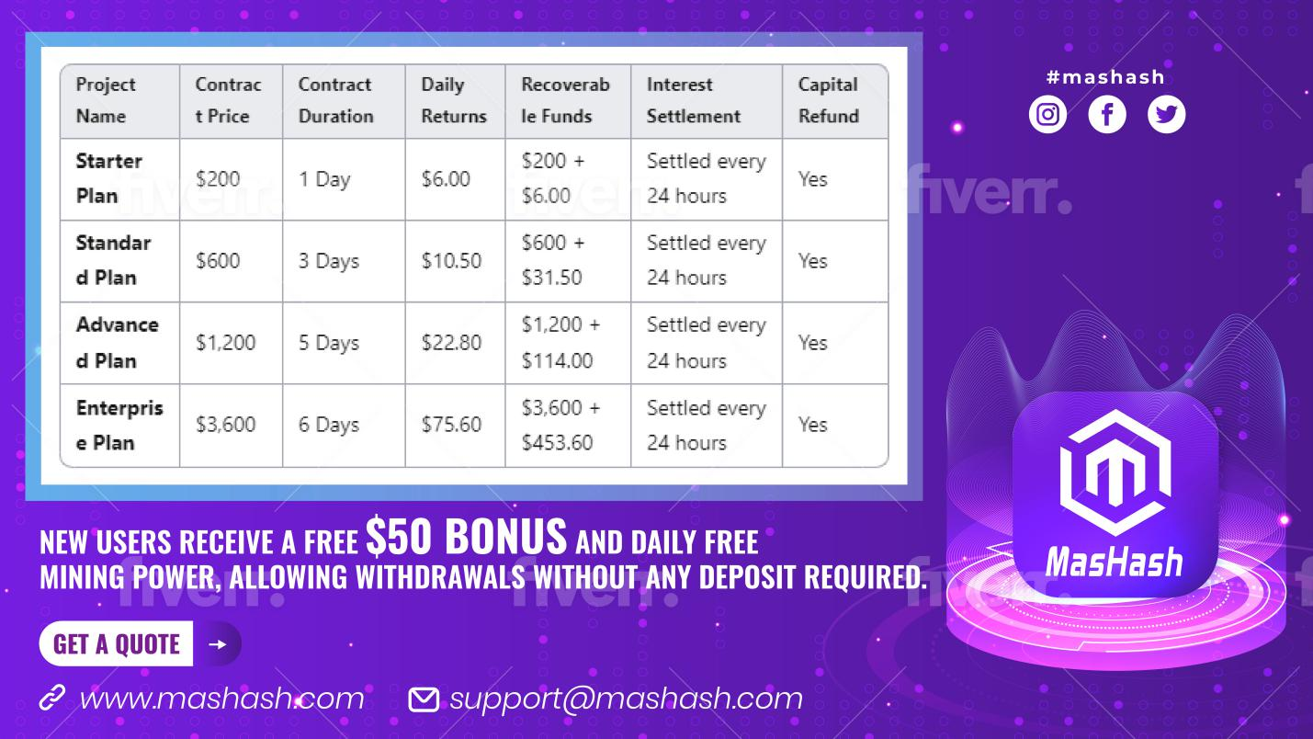
Pros:
- Eco-friendly mining operations.
- The app has a user-friendly interface.
- They pay daily rewards and payouts.
- They have strong money security.
- They offer 24/7 customer support.
- They have an automated earning feature.
- Their mining process is efficient.
- They have newest & latest hardware for mining.
- They have professional mining team.
Cons:
- No Physical Ownership of Hardware
- Limited Cryptocurrency Options

2. ECOS
Using ECOS, a cloud mining platform, you may mine cryptocurrency without requiring any actual mining gear. Rather, you rent mining capability from the cloud. If you buy cloud mining contracts, you can mine Bitcoin and other coins. The tool is easy to understand and use. ECOS is well-known for its transparency. Thus, you may observe exactly how your mining is doing.

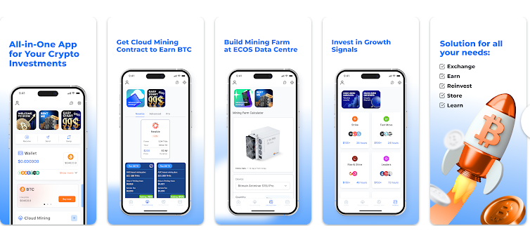
Pros:
- Cloud mining removes the need for physical hardware.
- User-friendly interface, ideal for beginners.
- Transparent mining process with detailed statistics.
- A low minimum investment is required.
- No need to pay for electricity or maintenance.
Cons:
- Requires upfront purchase of mining contracts.
- Earnings depend on market conditions and the specific contract.
- Withdrawal limits may delay access to earnings.

3. Hashshiny
You can mine many cryptocurrencies including Bitcoin, Ethereum, and Litecoin with the cloud mining tool Hashshiny. Their smartphone app let you control your mining operations anywhere, at any moment.
Good rates and the ability to mine numerous cryptocurrencies at once let Hashshiny help you. Many people choose it because of its reliability and simplicity of usage.
Whether your knowledge of mining is fresh or not, Hashshiny offers a seamless and quick approach for becoming engaged in cloud mining.

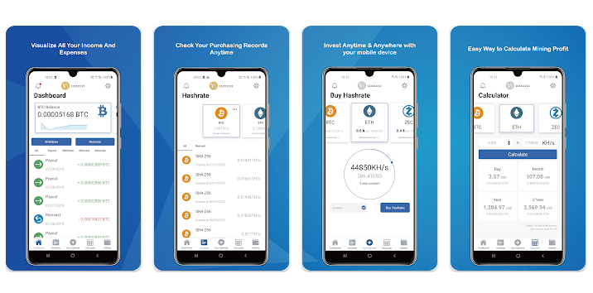
Pros:
- Supports mining of multiple cryptocurrencies.
- Low fees, helping you maximize your earnings.
- Easy-to-use mobile app for managing mining activities.
- Real-time monitoring of mining performance.
- Allows diversification by mining different cryptocurrencies.
Cons:
- Requires purchase of cloud mining contracts.
- Profitability can fluctuate based on market conditions.
- Limited control over the mining operations since it’s cloud-based.

4. Binance
Binance is one of the great cryptocurrency exchanges. It was founded in 2017 and is known for its trading services.
Besides its core trading services, Binance is operating a cloud mining service called Binance Pool. The product offers a route through which Bitcoin and other leading cryptocurrencies are mined upon joining mining pools.
Seamlessly integrated with the trading environment offered by Binance, Binance Pool will let users send their mined coins to their trading accounts easily.


Pros:
- Well-established and trusted platform in the crypto industry.
- Integrated with Binance’s trading ecosystem for easy transfer of mined coins.
- High mining power leads to potentially better earnings.
- Transparent fee structure.
- Secure environment for mining.
Cons:
- Requires a Binance account to participate in mining.
- Primarily focused on Bitcoin, limiting cryptocurrency options.
- It may be complex for beginners to navigate.

5. NiceHash
Popular site NiceHash lets you sell the power of your computer to others hoping to mine cryptocurrency. This market allows one to purchase and sell hash power. This implies you may mine Bitcoin and other cryptocurrencies without requiring any particular tools. NiceHash is a wonderful choice for everyone who want to begin mining because it is simple to use.

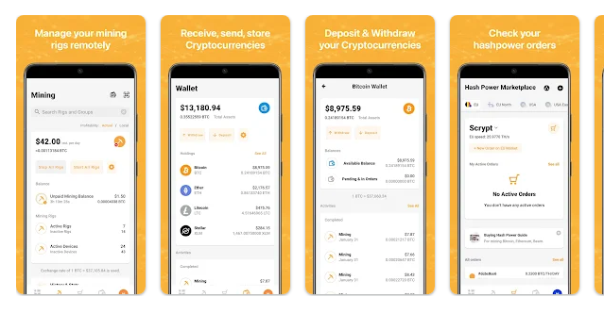
Pros:
- Flexible earnings by selling hash power to other miners.
- A simple setup process with minimal technical knowledge is required.
- Supports multiple cryptocurrencies for diversified mining.
- Automated payouts in Bitcoin.
- The marketplace model offers versatility in earning potential.
Cons:
- Earnings can be volatile and unpredictable.
- High transaction and withdrawal fees.
- Limited control over which cryptocurrencies are mined.
- Past security breaches raise concerns about fund safety.

6. CryptoTab Browser
One well-known free Android crypto mining tool is CryptoTab Browser. Acting as both a mining tool and a web browser, it lets consumers mine Bitcoin while they browse the internet.
The software operates in background without using too much of your device's power thanks to a built-in mining algorithm and is simple to use. Getting referrals and buying upgrades can help you to boost your mining speed as well. Newbie miners looking to start mining Bitcoin on their phones will find CryptoTab to be an excellent choice.
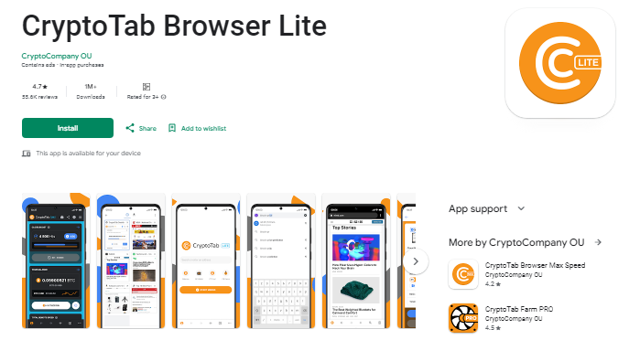
Pros:
- It has an easy Switch option.
- Chrome extension support is also available.
- Cross-Device Compatibility.
- It has better security.
- It has a referral program.
- It has a Cloud. Boost Feature.
Cons:
- You might earn less compared to dedicated mining rigs.
- It may affect your device’s performance and power consumption.
- There are concerns about the anonymity of the browser’s founders.
For those who want to mine cryptocurrency while browsing the internet, CryptoTab Browser is an intriguing alternative overall.

7. Pi Network
Pi Network is popular among unique smartphone apps for mining cryptocurrencies. Pi Network does not deplete your battery or use a lot of computing power, unlike traditional crypto mining. Rather, one may get Pi coins with just one daily button clicks.
Anyone who wants to start mining without shelling out money for costly equipment will find the app to be a perfect choice because it is straightforward to operate. Though Pi Network is still in its early years, it may turn out to be a useful bitcoin in future.
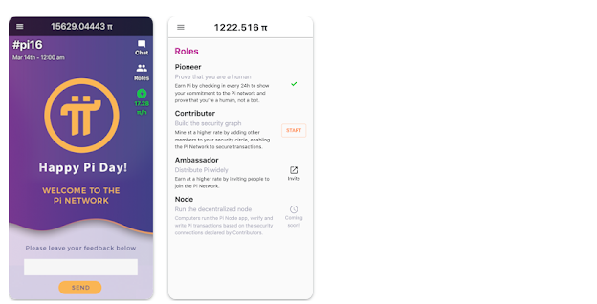

Pros:
- It doesn’t require much processing power or battery. It is ideal for older or less powerful devices.
- It is simple to use with a daily tap to earn Pi coins.
- The app encourages user engagement and community building.
Cons:
- Pi coins cannot be traded on exchanges yet, meaning there’s no immediate monetary value.
- The future of Pi Network is uncertain, as it's still in the development phase.

8. StormGain
One cloud mining tool called StormGain allows you to mine Bitcoin without relying on your device's electricity. This best Android crypto cloud mining software offers you free Bitcoin and has a simple design.
StormGain's cloud mining capability is perfect for individuals wishing to mine Bitcoin without compromising the speed or battery life of their smartphone. For someone interested in cryptocurrencies, the app is also a helpful tool as it has trading elements.
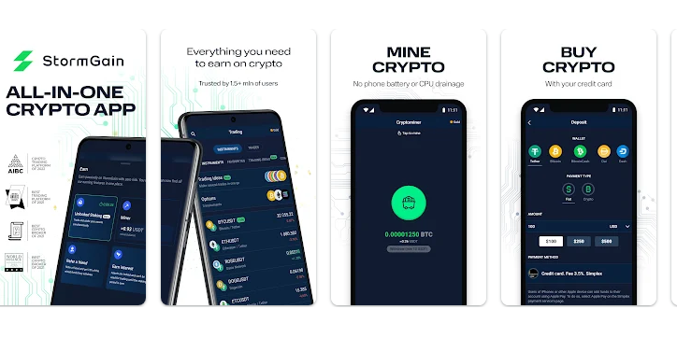
Pros:
- User-friendly design with advanced charting tools
- Free cloud mining service, no hardware required
- High-leverage options for experienced traders
- Islamic accounts available, compliant with Sharia law
Cons:
- Limited choice of cryptocurrencies for direct purchase (only 9 coins)
- Not available in the US and some other countries
- Unregulated platform, which may pose risks for traders
- Higher maker/taker fees compared to some competitors

9. MinerGate Mobile Miner
Strong tool MinerGate Mobile Miner lets you mine many cryptocurrencies like Monero and Bitcoin. With a simple interface and thorough mining statistics, the application is meant for both novice and expert miners.
MinerGate's built-in wallet, which allows you to save the cash you find securely, is rather outstanding. Anyone wishing to mine many cryptocurrencies on their phone will find this reliable free crypto mining program for Android perfect.
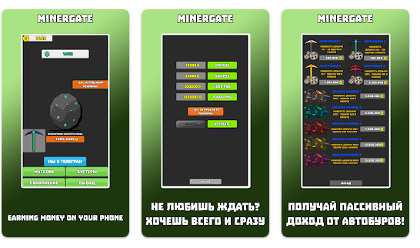

Pros:
- It supports the mining of multiple cryptocurrencies, including Bitcoin and Ethereum.
- User-friendly interface, suitable for beginners.
- Built-in wallet for storing mined coins securely.
- Allows background mining while using other apps.
- Detailed mining statistics and performance tracking.
- No need for expensive hardware.
- Active community and support for troubleshooting.

Cons:
- Lower mining efficiency compared to dedicated mining rigs.
- Earnings are limited due to the processing power of mobile devices.
- Drains battery life quickly.
- It can cause overheating of the mobile device during prolonged use.

10. AA Miner
AA Miner is a well-known free crypto mining app for Android. It can mine Ethereum, Litcoin, and Bitcoin among other over fifty other coins.
There is no specific hardware required for the simple to use software. For individuals who want to mine many cryptocurrencies on their Android smartphones, AA Miner is an excellent option because it is easy and performs well.
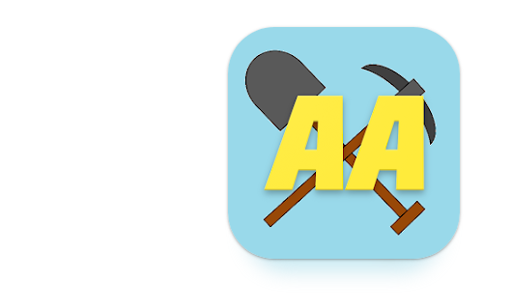

Pros:
- It supports the mining of over 50 cryptocurrencies, offering extensive flexibility.
- No advertisements, providing a smooth user experience.
- Simple and minimalistic interface, easy to navigate.
- No need for any registration or sign-up.
- Allows users to set custom mining algorithms.
- Runs in the background without interrupting other apps.
Cons:
- It is not as feature-rich as other mining apps.
- Limited community support and updates.
- High battery consumption and potential overheating issues.
- Does not include a built-in wallet, requiring users to have an external wallet for payouts.

11. Crypto Miner
Crypto Miner lets consumers earn digital money. It uses many mining techniques, so you can mine several kinds of cryptocurrency, such as Bitcoin, Litecoin, and Dogecoin.
The program allows you to experiment with many mining setups in flexibility. Though it may be a little more complex than some other applications, it enables you to personalize your mining experience and offers thorough data.
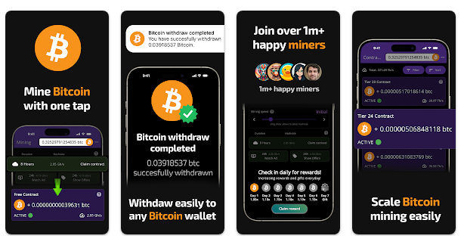

Pros:
- Supports various mining algorithms, including SHA-256 and Scrypt.
- Lightweight app with a straightforward setup process.
- Allows users to join different mining pools for better earnings.
- Customizable settings to optimize mining performance.
- Works with various cryptocurrencies, providing diversification.
- Low hardware requirements, making it accessible for most Android devices.
Cons:
- Requires manual configuration. It can be challenging for beginners.
- Lacks a built-in wallet, necessitating an external wallet for earnings.
- Limited customer support and updates.
- It may cause significant battery drain and device overheating.
- Slower mining rates compared to more powerful hardware solutions.

Legit Crypto Mining Apps for Android | Checking the legality of a mining app:
For picking legit crypto mining apps for Android, some tips are given below to help you spot legit mining apps:
Check Reviews and Ratings: On the Google Play Store, look for apps with positive reviews and high ratings. It will help you check out app’s reliability and how happy other users are.
Research the Developers: Know who the application creator is. Why? Most genuine applications are usually created by well-known companies or individuals with a good record of reliable software production.
Beware of Scams: Be careful of apps that ask for upfront fees. Real crypto mining apps shouldn’t require big investments to start.
Community Feedback: Join online forums and groups where people talk about their experiences with different mining apps. This can help you find which apps are legit and which ones to avoid.
By following these techniques, you can find and use legit crypto mining apps for android free of cost for best mining.

Best Crypto Cloud Mining App for Android
Cloud mining is a great option for those who wish to mine cryptocurrencies without bothering with apparatus. The best crypto cloud mining apps for Android are MasHash and StormGain.
The best miner app for android is MasHash which allows you to mine Bitcoin utilizing cloud technologies. It has 1.7 million downloads with 860,000 followers. It offers more than 20 mining plan contracts to consumers in over 100 countries across the globe.
StormGain also provides a smooth experience with its simple interface and extra trading features, making it a top pick for cloud mining on Android devices.

Mining Cryptocurrency on a Phone: Is it worth it?
There are pros and cons of mining cryptocurrency on phone. While it is an easy way to make cryptocurrency without having to pay high prices for equipment, the profit might not be very significant. Due to their weakness, you wouldn't be able to mine as much Bitcoin using a phone compared to dedicated mining rigs.
Mobile mining is a way for those who want to start without large upfront investments. It may also turn out to be an interesting and educational way to familiarize themselves with cryptocurrencies.

Best Phone for Mining Crypto
Mining cryptocurrency on your phone requires decent performance and battery life of a mobile phone. Some qualities to look for in the best phone for mining crypto are given below:
1. Your phone should have a Powerful Processor to tackle mining operations more efficiently.
2. Your smartphone should have a large battery capacity for long and better mining.
3. Your mobile should have an efficient cooling system.
4. Lastly, your cellphone should have ample storage to store mining programs and mined bitcoin.
Top phone brands for crypto mining on phone include Samsung, OnePlus, and Xiaomi. These phones offer the power and functionality required for successful mobile mining.

Android Crypto Mining: Tips for Maximizing Earnings
To get the most from your android cryptocurrency mining, follow these tips:
1. First tip is that you need to use multiple apps. Why? Because this lets you mine various cryptocurrencies and can boost your overall earnings.
2. You have to optimize app settings to find the best balance between mining speed and battery life.
3. You should join mining pools. You will have a better chance of earning rewards by combining your mining power with others
4. Keep your apps up-to-date. Using the latest and most efficient mining algorithms will help you earn rewards.
5. Monitor your Performance Regularly. Check if it's not overheating or draining the battery too fast.

Conclusion
In short, android crypto mining is an easy way for users to start mining cryptocurrencies without needing costly equipments. The convenience and simplicity of these apps make it a great choice for beginners and enthusiasts but the earnings might be lower compared to traditional mining.
Reputable free crypto mining apps for android, like MasHash, CryptoTab Browser, Pi Network, StormGain, and others listed in this guide, are best for you to begin mining today on your phone. Keep an eye on your device performance and settings, and update your apps regularly to maximize your earnings.
Whether you are mining Bitcoin, Monero, or other options in the global coin list, the right apps and devices can make a big difference. Start exploring mobile crypto mining today!

Frequently Asked Questions (FAQs)
Q. Are free android cryptocurrency mining apps safe to use?
Many free crypto mining apps for Android are safe; it's important to choose apps from reliable developers and examine user comments before downloading. Apps that demand big upfront investments or offer unrealistically high returns should be avoided since they might be frauds.
Q. Is it possible to mine Bitcoin on my Android phone?
Yes, it is possible to mine Bitcoin on Android phones via such apps as CryptoTab Browser or StormGain. Since mobile devices are not designed for this kind of computation, the potential profit from mining will be very low compared to regular mining activity.
Q. How much can I earn through mining cryptocurrency on phone?
The earnings from mining on a phone are generally low because of the limited processing capacity of mobile devices. The type of cryptocurrency, the difficulty of mining, and the software chosen will all impact how much you make.
Q. Do crypto mining apps drain my phone’s battery?
Yes, since mining involves many resources, crypto-mining apps can be a little draining on your phone's battery. Some apps, like the Pi Network, run in the background and use fewer resources to preserve battery life.
Q. Is cloud mining better than traditional mining on Android?
Since cloud mining doesn't utilize resources from your smartphone, it might be more practical than conventional mining on Android. MasHash and other apps provide cloud mining choices so you may mine coins without compromising the speed of your phone.
Q. Can I mine multiple cryptocurrencies on my Android phone?
Yes, apps like MinerGate Mobile Miner and AA Miner let you mine many coins with the same tool by supporting mining several cryptocurrencies.
Q. What should I do if my phone overheats while mining?
For overheats problem, it is advised to stop mining and let the gadget cool down. To avoid overheating, think about reducing the mining intensity or running less power using programs.
Q. Can I mine Ethereum with my Android smartphone?
Although Ethereum mining requires more resources than other cryptocurrencies, several platforms, such as MinerGate Mobile Miner and AA Miner, enable mining Ethereum on Android smartphones. The phone's low processing capability might, however, result in very little returns.

