Keywords: TRON Transactions, Polkadot (DOT) Price, top crypto gainers
Meta Title: BlockDAG Surges 1600% Amid TRON Transactions & Polkadot Dip
Meta Description: Explore how BlockDAG's coin value soars 1600% with Dev Releases. Analyse why TRON transactions rise while Polkadot price declines, shifting investor focus to BlockDAG.

The Tech Savvy Head To BlockDAG: Coin Value Up by 1600%, While TRON Transaction Surges & Polkadot Price Drops
Between the millions of daily transactions offered by Tron (TRON) and the lowest activity levels experienced by Polkadot (DOT), crypto enthusiasts undergo constant confusion upon choosing the top crypto gainers. Tron transactions are efficient and cost-effective, attracting a growing number of users.
In contrast, the decline in Polkadot price indicates decreasing investor interest, reflecting challenges in maintaining engagement. Here, crypto enthusiasts and tech freaks are attracted towards the innovative upgrades offered through BlockDAG’s Development (Dev) Releases. Constant updates about innovation positions BlockDAG coin value in a significant hike, marking a 1600% surge from the initial batch price.
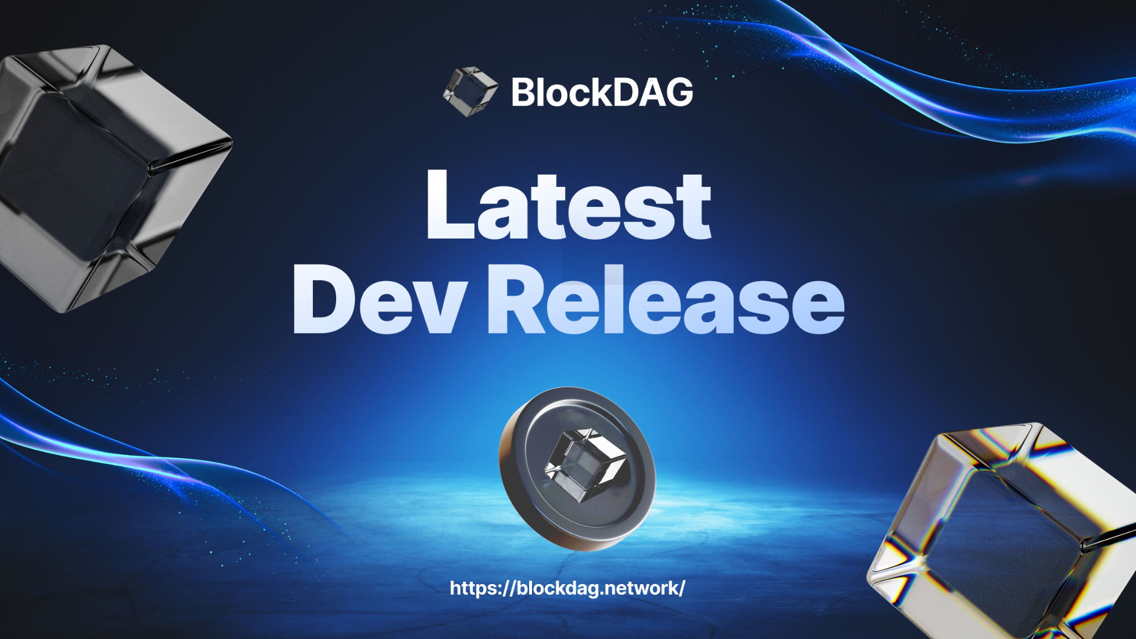

Tron Transactions Lead in Crypto Revenue
Tron transactions have recently surpassed many other networks, showcasing its efficiency and popularity. The platform now handles millions of daily transactions, highlighting its growing use in gaming, entertainment and decentralised applications. This increase in Tron transactions has positioned the network as a leader in revenue generation within the crypto industry. Tron's fast, affordable transactions have attracted many developers and users. As Tron transactions grow, the network becomes a prominent player in the evolving blockchain landscape.


Polkadot Price Dips Amid Low User Engagement
Polkadot's price has faced challenges recently, ending July on a bearish note due to decreased user engagement. The network has experienced its lowest activity levels of the year, impacting Polkadot prices negatively. The reduced participation suggests a shift in user interest, which may influence future Polkadot price trends. Despite these challenges, on-chain indicators show some investor optimism, as many continue to hold onto their tokens, hoping for a potential recovery. This scenario underlines the importance of increased activity and engagement in positively affecting the Polkadot price moving forward.
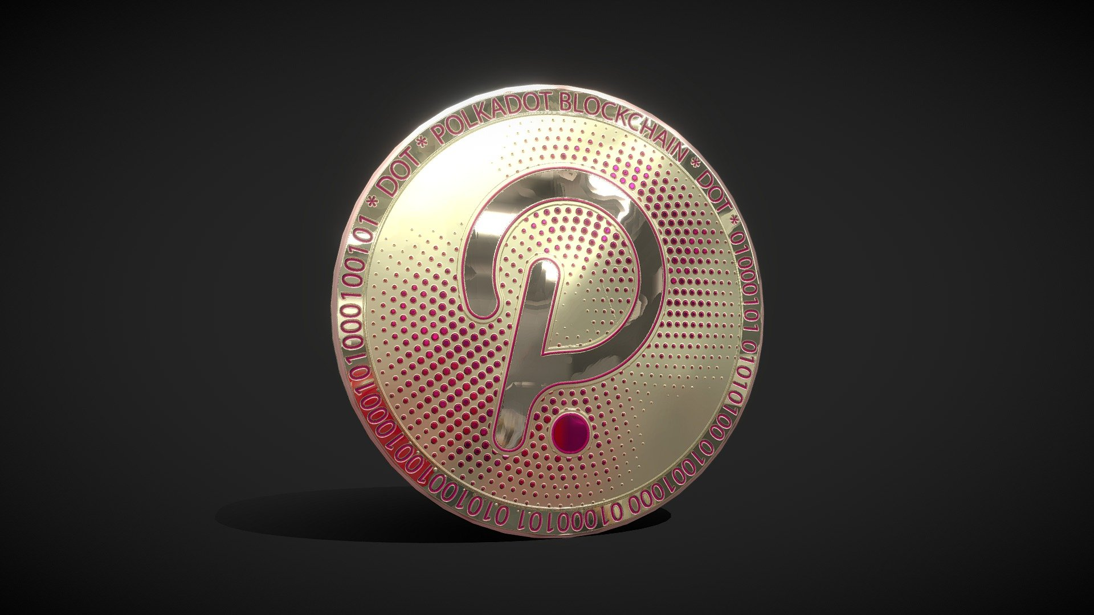

BlockDAG Regular Updates Fuels Presale: 12.5B Coin Sale
BlockDAG’s regular DEV releases highlight the latest innovations and tech improvements to investors. Each release goes into specific mechanics or features, offering fintech enthusiasts a clear understanding of the network's enhancements. These updates highlight the technical strength of BlockDAG and serve as a transparent communication channel, ensuring that the community remains well-informed about the network's progress and future direction.
BlockDAG CEO during an AMA session mentioned, “BlockDAG has taken a smart approach to integrating the existing technologies – the blockchain and DAG – to avoid major technical challenges”, showing the extensive vision of technological prowess.
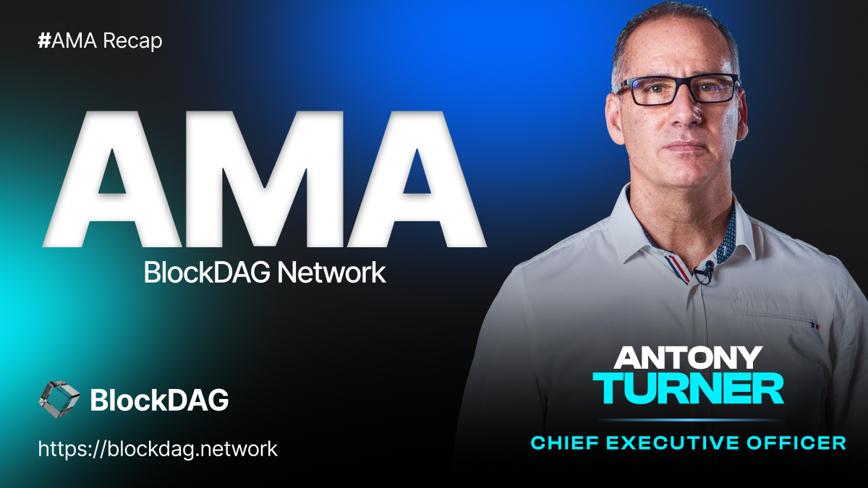
BlockDAG’s regular updates to keep investors and the crypto community informed have made more people interested in the network. As these development releases provide insights into BlockDAG’s latest upgrades, they have driven a surge in coin value. Between Batch 1 and Batch 21, the value of BlockDAG's coin has skyrocketed by 1600%, illustrating the market's positive reception to the network's consistent growth and innovation.
Batch 21 of the BlockDAG presale has priced the coin at $0.017. BlockDAG has achieved $65.2 million in revenue and sold over 12.5 billion coins. This financial milestone reflects the network's robust growth trajectory and its ability to capture the interest of a diverse range of investors.

BlockDAG: Crypto Innovation Reveals
BlockDAG’s Dev Releases have successfully captured the attention of potential investors and the crypto community by providing detailed updates on network innovations. The crypto community, enlightened by the technological revolution, prefers the BlockDAG network over the increased momentum in Tron transactions.
Further, the investors searching for top crypto gainers are also relieved by the opportunity BlockDAG offers to escape from the volatile Polkador price trends. This focus on continuous innovation and clear communication has fueled a 1600% surge in BlockDAG’s coin value since the initial batch.
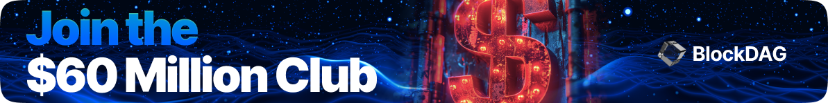
Invest in the BlockDAG Presale Now:
Presale: https://purchase.blockdag.network
Website: https://blockdag.network
Telegram: https://t.me/blockDAGnetwork
Discord: https://discord.gg/Q7BxghMVyu

