IMAGE ALT: AI News and Impact on Crypto
IMAGE TITLE: Altcoin AI News: BTC, ETH, XRP, More
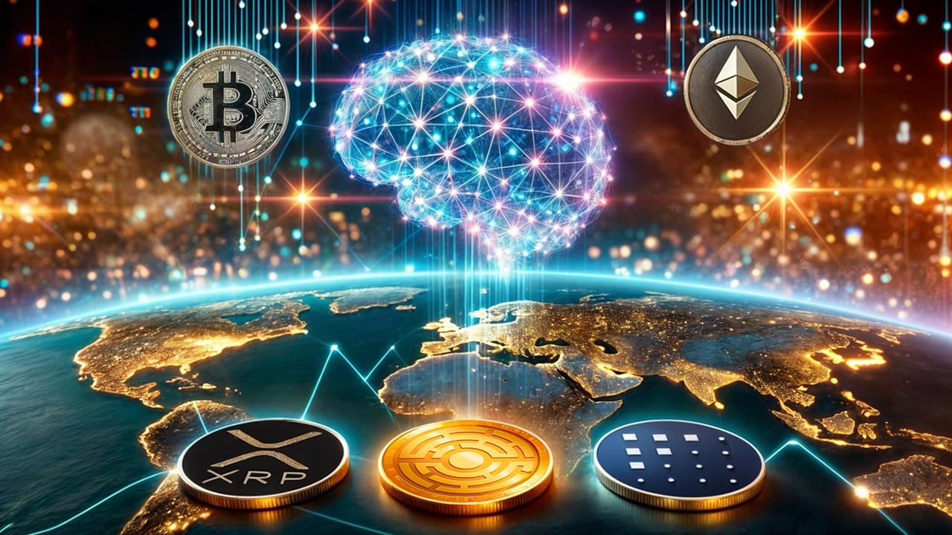
Title: Estonia’s AI Tech: Impact on US Policy and Crypto Assets
Description: Explore how Estonia's innovative AI-powered technology is set to transform US policy and elevate cryptocurrencies like BTC, ETH, XRP, FET, and MTAUR.

Estonia's AI to Transform US Policy and Boost BTC, ETH, XRP, FET & MTAUR
Estonia has become a digital leader by using AI-powered decentralized networks to reform its government and improve its economy. The United States now faces a similar chance. AI could reshape US policy and influence global markets, especially in cryptocurrency. If the US follows Estonia’s example, it could cause big price changes for cryptocurrencies like Bitcoin (BTC), Ethereum (ETH), Ripple (XRP), Artificial Superintelligence Alliance (FET), and MTAUR.
Will the US adopt AI as Estonia has? And if so, how will it affect the value of these cryptos against the US dollar? Read on to find out.

Minotaurus ($MTAUR): A Blockchain Gaming Presale with Explosive Potential
The first contender on our list to benefit from these exciting developments is Minotaurus ($MTAUR). This blockchain-powered project is now in its early stage, offering everyone a chance to jump on board early. With tokens priced at just $0.00005959, you can reap a 70% cut from the future listing price of $0.00020. If you act today, you’ll see a potential boost of around 236%. The total growth during the presale could reach 400%.
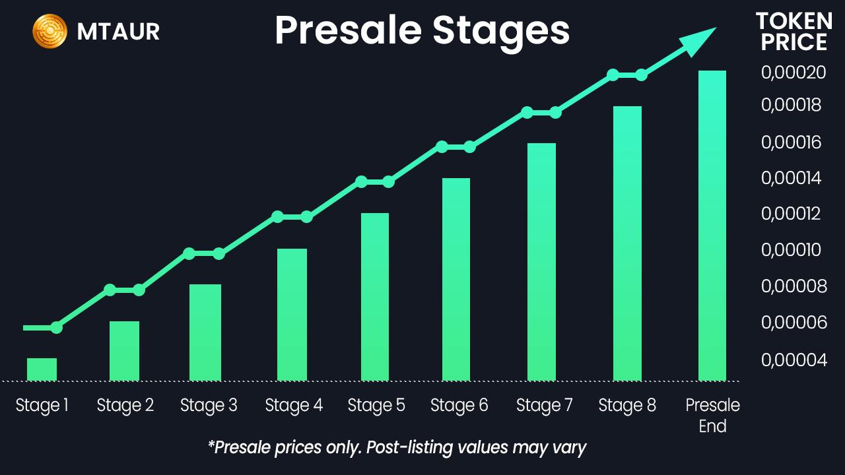
The utility of $MTAUR in the Minotaurus game is impressive. Players can use tokens for avatar customization, access to exclusive zones, power-ups, and more. With the casual gaming market valued at nearly $15 billion and growing by about 9% each year, $MTAUR taps into a thriving industry.

Moreover, there are advantages for holders, such as referral bonuses and a vesting program with additional benefits. The project’s smart contract is audited by SolidProof and Coinsult, adding security to your participation. So why wait? The community is already pumped about this presale, and the low-priced tokens are selling fast. Grab yours now and witness the Minotaurus progress firsthand.


Bitcoin (BTC): Aiming for the Next Big Move
Bitcoin, the largest cryptocurrency by market value, has been rising strongly in recent weeks. Right now, BTC USD is priced between $64,196.13 and $66,000.44. This shows optimism in the market and greater acceptance of decentralized technologies. Estonia’s early use of AI and decentralized networks gives a plan that could change how the US runs things. If the US uses similar AI-friendly policies, Bitcoin could become even more important as a hedge against traditional financial systems.The Bitcoin USD pair has been enjoying a three-week winning streak, with bulls aiming for the $75K mark.

Bitcoin dollar price has been hitting a resistance level at $66,498, with another key level at $74,028. If the US policy shifts toward AI, Bitcoin price could push toward $75,000 or more. However, delays or problems in adopting AI policies could make the BTC price drop to $50,507, a key support level. Estonia’s success with AI and digital governance shows how the US could benefit from similar changes. This could also drive a long-term rise in Bitcoin price USD.
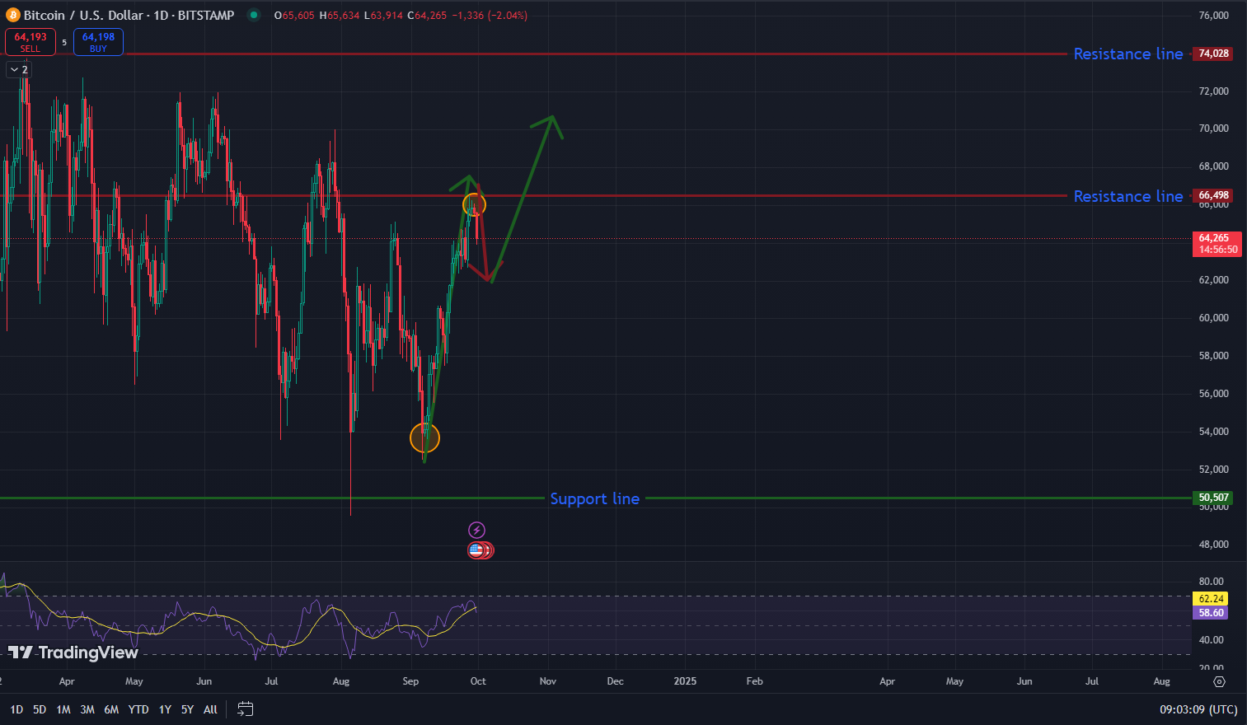
Bitcoin’s technical indicators, like the Relative Strength Index (RSI) of 60, show a balance in the market. This means Bitcoin might keep rising. Estonia’s example of digital governance could encourage the US to unlock Bitcoin’s full potential. This could lead to more adoption of BTC as a decentralized asset. Holders need to stay aware of policy changes in the US. The connection between AI and the future of crypto could play a key role in Bitcoin’s dollar value.

Ethereum (ETH): Poised for a Rebound
Ethereum (ETH), the second-largest cryptocurrency, has also been active lately. The current ETH USD price is between $2,604.81 and $2,670.98. It has fallen slightly by -0.6% over the past week. However, Ethereum is still a leader in decentralized finance (DeFi) and smart contracts. Despite recent whale sell-offs, Ethereum continues to maintain its position above $2,600, which highlights its resilience. Estonia’s success in building a decentralized digital society through AI fits well with the goal of Ethereum coin: supporting decentralized apps. If the US takes a similar path, Ethereum USD could grow quickly as decentralized networks drive new ideas in governance and finance.

Ethereum dollar price is near a resistance level of $3,132.5. It could rise higher if the US follows Estonia’s lead in using AI in policy. But if the US does not act, Ethereum price could test a support level at $2,002.6. Estonia’s example of decentralized technology and governance shows that Ethereum could see big price growth if the US adopts AI. The ETH coin has an RSI of 56.6, suggesting that the market is neutral but with space for growth.
The ETH USD price could rise significantly as AI becomes more important to global development. Estonia’s AI success shows how Ethereum could play a key role in future technology advancements. Pairings like ETH USDT on exchanges are showing steady volumes. This suggests continued confidence in the coin’s long-term value.
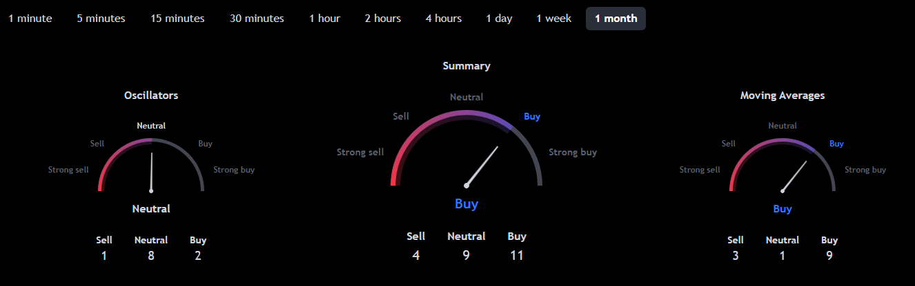

Ripple (XRP): Positioned for a Breakout
Ripple (XRP) has been one of the strongest performers recently. Its XRP USD price has risen between $0.6121 and $0.6613. This is an 8.9% rise over the last week. Estonia’s focus on using advanced technology for governance connects with Ripple’s goal of improving cross-border payments. Ripple is closely tied to changes in financial technology. Estonia’s AI-powered approach could push the US to innovate in similar ways. According to The Crypto Basic, some developers believe XRP could eventually skyrocket to unprecedented levels if broader adoption occurs.
Ripple is getting close to a resistance level of $0.66508. It could break through to $0.76387 if market conditions remain positive. Estonia’s success with decentralized technologies shows how modern solutions can improve financial systems. If the US adopts similar policies, Ripple could see increased demand for faster cross-border payment methods. But, without clear US regulations, XRP could drop to a support level at $0.44975, especially if global markets remain careful.
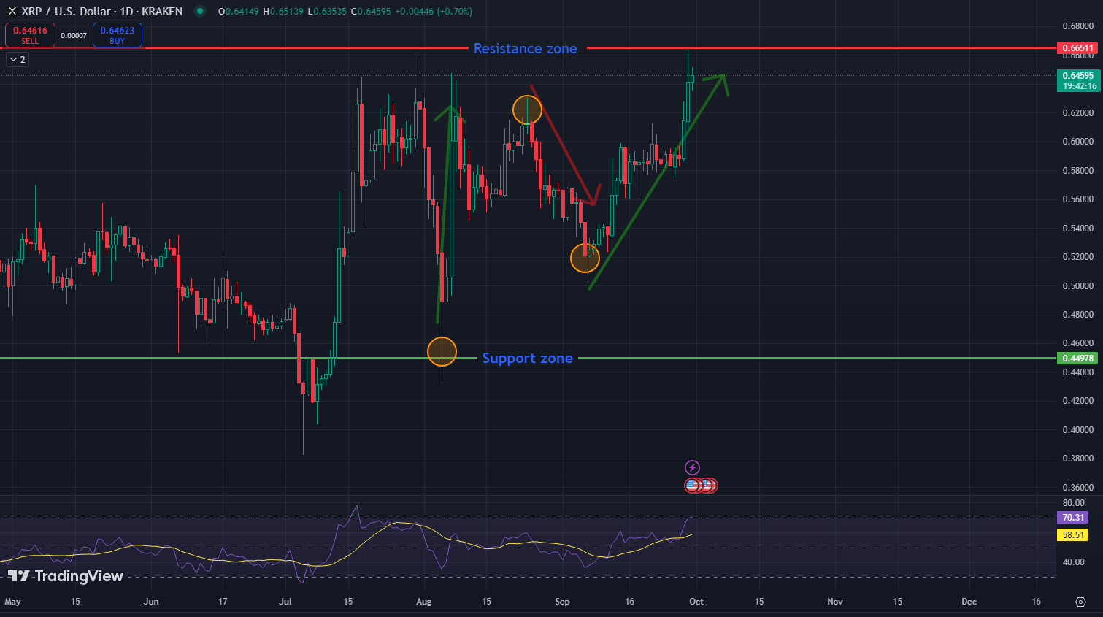
Ripple’s RSI of 70.174 shows that the asset may be nearing overbought conditions. This could cause a short-term price pullback. However, the long-term outlook for XRP remains good, especially if AI use continues to grow. Estonia’s creative use of decentralized networks could help Ripple become stronger in financial technology. As more people use crypto XRP, Ripple’s demand could increase in an increasingly digital world. Recent crypto news also highlights Ripple’s resilience, which boosts its positive outlook.

Artificial Superintelligence Alliance (FET): AI-Driven Growth Potential
Artificial Superintelligence Alliance (FET) has a unique role in the market. Its FET coin is closely tied to AI use within decentralized networks. Estonia’s AI-powered decentralized governance offers a model for how countries can grow using technology. FET USD has been worth between $1.53 and $1.64, with a 4.9% decline in the last week. FET is showing strong momentum and could experience a rally of up to 173% if favorable conditions align. However, if the US adopts AI policies like Estonia’s, the FET price prediction suggests a notable uptick.
FET is close to a resistance level of $1.8773. If the US adopts AI policies like Estonia’s, the FET AI project could break through this resistance and reach new highs. If AI adoption is slower, FET could drop to its support level of $1.5036. Estonia’s success with AI shows how FET could grow, especially as the US looks at the future of AI in government. The latest FET news will be important to watch for clues about how the FET coin might move.

FET’s RSI of 61.1 shows that the market is getting energy. But caution is still needed. Estonia’s AI success shows how decentralized networks can change industries. FET is a leading coin in the AI space. If the US follows Estonia’s steps, the price prediction indicates strong growth. The future of FET AI looks promising, but it depends on how fast AI-driven policies are adopted around the world.
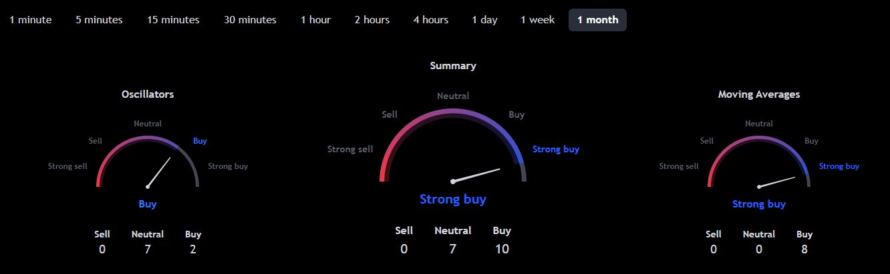

Conclusion
Estonia’s use of AI-powered decentralized networks shows how technology can change governance and boost economies. If the United States adopts similar AI policies, the crypto market could see big price jumps across coins like Bitcoin, Ethereum, Ripple, FET, and $MTAUR.
Among these, $MTAUR seems to be a standout. The tokens are now a steal, and the upside potential is huge. For those who haven’t jumped on board yet, now might be the best moment.

Learn more about Minotaurus:
Website: http://minotaurus.io/
Announcements: https://t.me/minotaurus_official
Chat: https://t.me/minotaurus_chat
Twitter: https://twitter.com/minotaurus_io

