Spotting The Next 100x Memecoin
The rise in the popularity of memecoins has definitely been fueled by community engagement, celebrity endorsements, and retail investor excitement. They have rapidly moved from being niche internet jokes to becoming some of the most popular assets in the crypto ecosystem. In fact, currencies like $DOGE, which emerged in 2013, and others including Shiba Inu (SHIB), Pepe (PEPE), Floki (FLOKI), and Bonk (BONK) have already hit massive market caps and turned into multi-billion-dollar assets. And it’s just the start. Floki has achieved over 620% gain in the last one year whereas BONK has had over 1200% gain in one year.
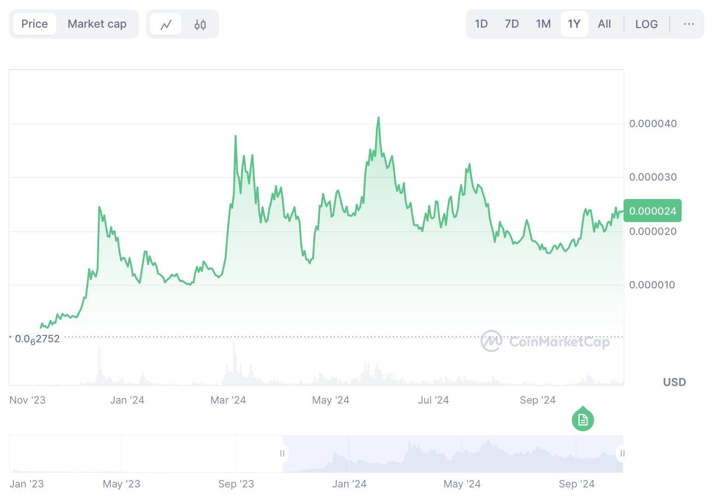
In addition to this, the total market capitalization of the memecoin market is over $50 billion according to CoinMarketCap, compared to the total crypto market cap of over $2.21 trillion.
However, just as quickly as they gain popularity, many memecoin projects often disappear. Industry testimonies show that several projects rely solely on hype and social media buzz without having real utility or fundamental value. Reports highlight that, on average, over 2,000 memecoins disappear monthly. In fact, it is reported that two-thirds of all memecoins ever created have already vanished. A report from Chainalysis shows that over half of all memecoins are deemed malicious, and one-third of investors have reported losses due to scam tokens.
Identifying Winning Memecoins
As per a crypto expert on the X platform, the memecoin trend is just expanding, and this discussion has attracted the attention of Anatoly Yakovenko, co-founder of Solana. He highlighted that the previous cycle was "90% meme and 10% product." He further emphasized that this cycle drove other cycles like DeFi Summer and noted that now every new product has to succeed purely based on value.
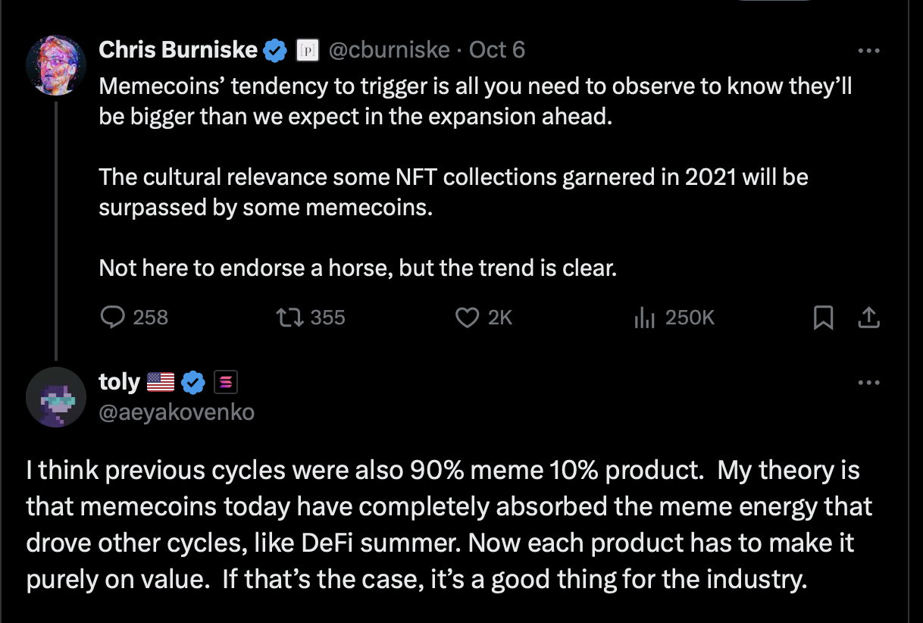
In fact, a report highlighted that nearly all memecoins have crumbled after Q1 2024, as many were built purely on community hype without any true product or inherent value. It has also been reported that a staggering 97% of memecoins will have failed by the end of 2024, with many of these tokens surviving for just about one year.
To truly spot the next 100x memecoin, understanding what separates successful projects from fleeting ones is essential. Marketing plays a pivotal role in determining whether a memecoin succeeds or fails. According to Alvin Kan, COO of Bitget Wallet, “pump-and-dump” memecoins often engage in viral marketing campaigns that are flashy but these tactics might involve low-quality media coverage or bot-driven social media activity, which can lead to a temporary spike in interest followed by a rapid decline. In contrast, successful memecoins build long-lasting engagement by fostering genuine community participation and leveraging organic marketing strategies that resonate with their target audience.
According to Kan, “If you look at the top-performing tokens of this year, such as BONK, FLOKI, or SHIB, they all have an extensive ecosystem that creates a broader utility for the token. Developers who value long-term success ensure their meme coins have a strong distribution layout and they engage in discussions with key opinion leaders, host AMA sessions with the developers, and promote the project through partnerships and collaborations.”
In addition to utility, successful meme coins often have tokenomics that prioritize long-term value. Coins that are designed with mechanisms to prevent inflation, reward early holders, and maintain a healthy supply-demand balance are better positioned for sustainable growth. However, one of the biggest risks in the memecoin market is the prevalence of scams and rug pulls. Alarming statistics reveal that about 55.24% of memecoins are classified as malicious.
This high prevalence of fraudulent projects emphasizes the need for diligent research. Investors need to be cautious and vet projects thoroughly before investing to avoid falling victim to these scams.
Finding the Next 100x Memecoin
Despite the volatile market, traders and early investors have turned into millionaires almost overnight. This surge in some of the valuable memecoins is largely driven by memecoin launchpads that help these tokens with their first big push into the market. Particularly, launchpads like FOMO.fund help these memecoins reach the masses.
With Bitcoin hitting the mark of $68K at press time, it seems that a new bull market might be just on the horizon, and it's time to find the next 100x memecoin with insider tips from some of the top memecoin launchpads such as FOMO.fund, which lists non-scammy projects with due diligence.
Platforms like FOMO.fund list legitimate projects. Built on the TON blockchain, FOMO is a gamified memecoin marketplace, which blends tap-to-earn clicker games with ease of one-click token deployment. The platform understands that users prefer easy, no-fuss access to token earnings. By simplifying the process and providing clear market signals, FOMO.fund gives investors an edge.
With the memecoin trend continuing to evolve, the key to spotting the next 100x token lies in understanding both market dynamics and community signals. While hype and engagement can create short-term success, only platforms like FOMO.fund, which emphasize transparency, simplicity, and market validation, offer a reliable path for finding the gems amidst the noise. With the right tools and insights, early investors can capitalize on these explosive opportunities while navigating the risks that have already led many projects to failure. As the market grows, staying informed and using platforms like FOMO.fund may just lead to the next big win in the memecoin space.

