How to make money online, AEON MINING teaches you how to make $2,000 a day

In the fast-paced world of cryptocurrency, simplicity and profitability are key. For beginners seeking an attractive option to earn a steady income with minimal effort, cloud mining offers an appealing alternative. In this article, we’ll explore the concept of cloud mining, with a particular focus on AEON MINING as the leading platform to help you begin your journey to earning $2,000 or more per day.
The Allure of Cloud Mining
Cloud mining has long been a favorite among cryptocurrency enthusiasts because it’s easy to use and accessible. Unlike traditional mining, it doesn’t require expensive hardware, technical expertise, or constant monitoring. Cloud mining simplifies the process, allowing anyone, regardless of experience, to participate in the cryptocurrency revolution. Instead of investing in expensive mining equipment and managing a complex setup, users can rent mining power from a remote data center and receive a portion of the profits generated.
AEON MINING: A Combination of Laziness and Profits
AEON MINING takes the simplicity of cloud mining to a new level, making it ideal for beginners. The platform’s user-friendly interface ensures that even cryptocurrency newbies can navigate with ease. For AEON MINING, laziness is not a drawback; it’s a path to success. As a pioneer in providing cloud mining services, AEON MINING has multiple mining facilities around the world and has won the trust of more than 6.3 million users worldwide with its stable income and security. AEON MINING relies on renewable energy such as solar and wind power to power its cloud mining operations, greatly reducing mining costs and integrating surplus electricity into the grid. This means that you can get a lot of mining power without the hassle of expensive hardware or dealing with noise and heat at home. All you need is your computer or mobile phone to sign a mining contract and start reaping the rewards. The profit potential is beyond imagination.

Unimaginable money-making model
What makes AEON MINING different is its extraordinary daily income potential. AEON MINING offers the opportunity to earn $500 or more every day, allowing users to turn their dreams of getting rich online into reality. Imagine earning a considerable income without constant effort or complex settings - this is what AEON MINING has achieved.

Security and Reliability
In the world of cryptocurrency, trust and security are crucial. AEON MINING knows this well and puts user safety first. AEON MINING is committed to transparency and legality, ensuring your investment is protected so you can focus on earning returns.

How to get started on your road to wealth:
Starting your cloud mining journey with AEON MINING is a simple process. Follow these simple steps to start earning passive income:
Sign up: Create an account on the AEON MINING platform.
Choose a plan: Select a mining plan that matches your goals.
AEON MINING: Start mining immediately and let the powerful hardware of Simple Miner work for you.
Receive daily payments: Enjoy the convenience of daily payments, providing a stable source of income.
Additional rewards:
Sign up bonus: Get an instant bonus of $10.00 when you sign up and start mining income.
Invite income: Increase your mining income by inviting friends. Get ongoing rewards of 3%-4.5% for mining activities.
AEON Miner Contracts:
The contracts offered by AEON MINING are not only simple but also varied, providing you with a variety of options to meet your investment needs. They provide stable and risk-free fixed income.
AEON MINING Customized Cloud Mining Packages:
Explore Tailored Cloud Mining Options
BTC Entry-Level Computing Power
Investment: $10.00
Guaranteed Return: $10.00, plus $0.50 Daily Bonus
Get daily login bonuses to steadily increase your mining earnings.
BTC Increased Computing Power
Investment: $100.00
Guaranteed Return: $100.00, plus $6.6
Designed for those who crave more powerful computing power and stable profits.
BTC Premier Computing Power
Investment: $500.00
Guaranteed Return: $300.00, plus $10.35
Optimize your potential income with our powerful cloud mining solutions.
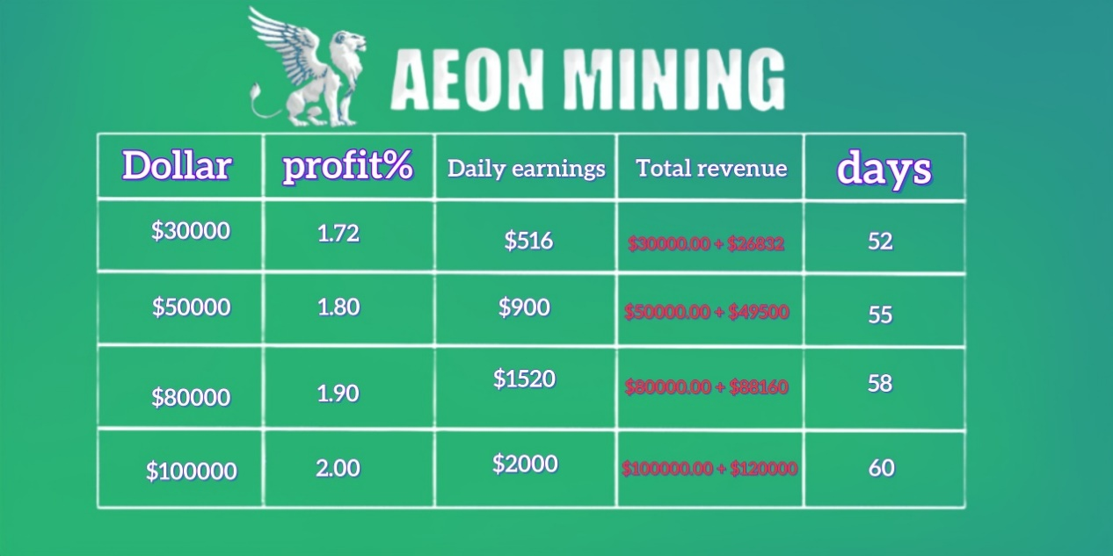
Join the Laziest Path to Riches
As the cryptocurrency market continues to evolve, AEON MINING remains a pioneer in the field, offering an easy path to profitability. Whether you are an experienced cryptocurrency enthusiast or a complete newbie, AEON MINING welcomes you to join the ranks of easy passive income.
All in all, AEON MINING proves the power of simplicity in the world of cryptocurrency. It emphasizes user-friendliness, security, and the potential to earn excess income every day, providing unique opportunities for beginners and experts alike. Join AEON MINING today and embark on the easiest yet most rewarding journey to wealth online. Official website: https://aeonmining.com

