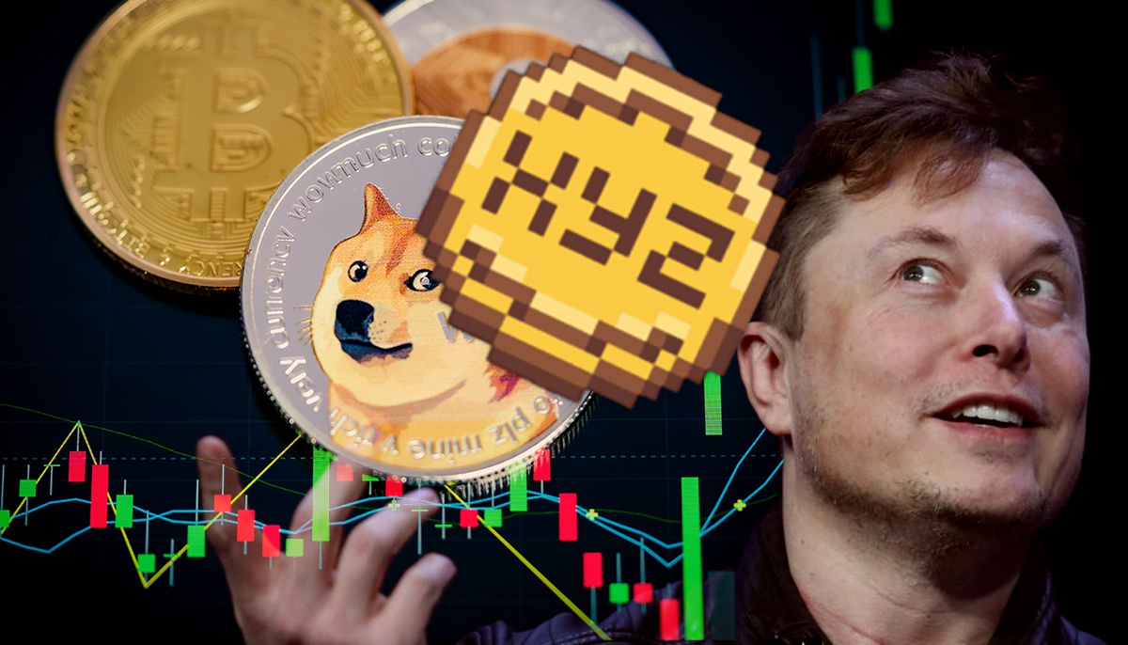Dogecoin Kenara Çekilsin—Bu Yeni Token Elon Musk’ın Bir Sonraki Tweet’iyle 1 Doları Görebilir
A new cryptocurrency is catching attention and could soon make a big splash. With Elon Musk's influence known to shake up markets, his next tweet might just propel this token to the coveted $1 mark. Investors are watching closely, wondering if this could be the next big thing to surpass Dogecoin's success. Excitement is building as anticipation grows.

Demand for $XYZ Surges As Its Capitalization Approaches the $15M Milestone

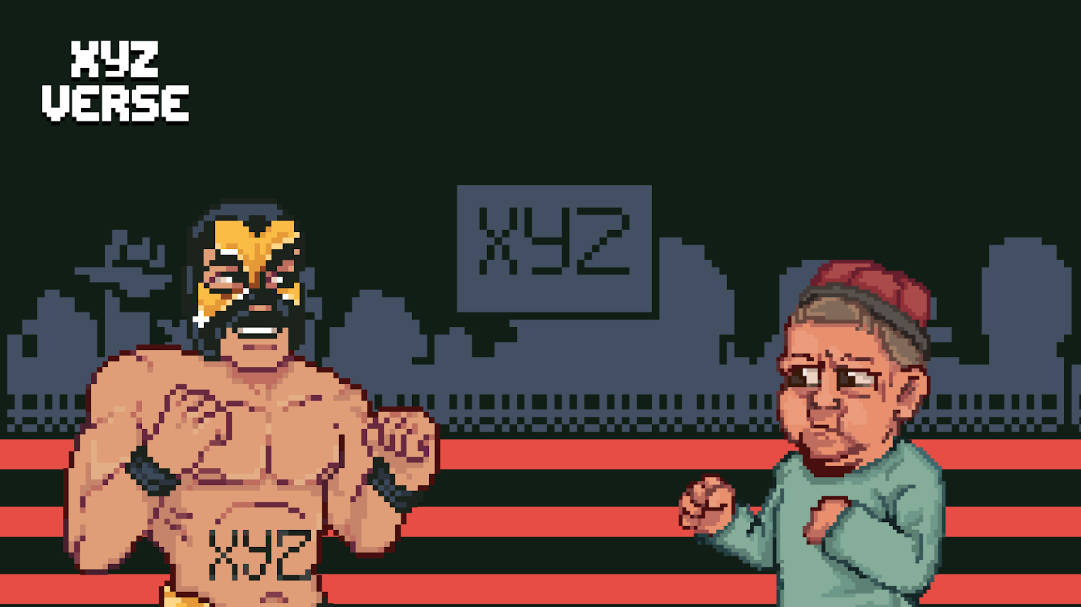

The XYZVerse ($XYZ) project, which merges the worlds of sports and crypto, has attracted significant investor interest. Unlike typical memecoins, XYZVerse positions itself as a long-term initiative with a clear roadmap and an engaged community. The project was recently recognized as Best NEW Meme Project, further solidifying its appeal.

Price Dynamics and Listing Plans
During its presale phase, the $XYZ token has shown steady growth. Since its launch, the price has increased from $0.0001 to $0.003333, with the next stage set to push it further to $0.005. The final presale price is $0.02, after which the token will be listed on major centralized and decentralized exchanges.

The projected listing price of $0.10 could generate up to 1,000x returns for early investors, provided the project secures the necessary market capitalization.

So far, more than $10 million has been raised, and the presale is approaching another significant milestone of $15 million. This fast progress is signaling strong demand from both retail and institutional investors.

Champions Get Rewarded
In XYZVerse, the community calls the plays. Active contributors aren’t just spectators—they’re rewarded with airdropped XYZ tokens for their dedication. It’s a game where the most passionate players win big.

The Road to Victory
With solid tokenomics, strategic CEX and DEX listings, and consistent token burns, $XYZ is built for a championship run. Every play is designed to push it further, to strengthen its price, and to rally a community of believers who believe this is the start of something legendary.

Airdrops, Rewards, and More - Join XYZVerse to Unlock All the Benefits

Dogecoin: The Meme Coin That Took the World by Surprise
Dogecoin started in 2013 as a joke. Its creators used a popular meme of a Shiba Inu dog for its logo, aiming to create a fun alternative to traditional cryptocurrencies. Unlike Bitcoin, which is scarce, Dogecoin is plentiful. There’s no maximum supply, and 10,000 new coins are mined every minute. Despite its playful beginnings, Dogecoin’s value soared in 2021. Fueled by social media buzz and tweets from Elon Musk, it became one of the top ten cryptocurrencies, reaching a market value over $50 billion. This rise showed the power of community and social media in today’s financial world.

Now, people are curious about Dogecoin’s potential. It’s built on technology similar to Litecoin, allowing for fast transactions with low fees. This could make it useful for everyday payments. While it lacks some advanced features of other coins, its strong community support is a big plus. In the current market, cryptocurrencies are gaining more attention and acceptance. Whether Dogecoin will continue to make waves depends on ongoing community enthusiasm and real-world uses. From a simple joke to a notable digital currency, Dogecoin has shown it can’t be ignored.

Conclusion
While tokens like DOGE have excelled, XYZVerse (XYZ) uniquely merges sports and memes, aiming for massive growth and strong community engagement—positioning itself as the next standout memecoin.

You can find more information about XYZVerse (XYZ) here:

Site, Telegram, X

