IMAGE ALT: Bitcoin forecast and new crypto contender
IMAGE TITLE: Bitcoin $1M prediction and Minotaurus rise

META TITLE: Crypto Predictions: Bitcoin Supercycle & New Coins Rising
META DESCRIPTION: Bitcoin could hit $1M, say Kiyosaki and Saylor. Dive into crypto news, bold predictions, and new crypto coins like Minotaurus making waves today.

Billionaire Confidence: Kiyosaki and Saylor Forecast a Bitcoin Supercycle to $1M
Bitcoin is back in the spotlight. Robert Kiyosaki, author of “Rich Dad Poor Dad,” believes BTC will hit $1 million by 2035. At the same time, Michael Saylor plans to buy another $2 billion worth of Bitcoin for MicroStrategy.

These big statements come during a time of rising global debt and falling trust in regular currencies. Could these moves mark the beginning of Bitcoin’s biggest growth phase yet?

Kiyosaki’s $1 Million Prediction: A Signal in Tough Times
Robert Kiyosaki has warned before. He predicted the 2008 crisis years in advance. Now, he says the world is close to a “Great Depression,” and he believes Bitcoin will play a key role in helping people stay protected. He explains that assets like gold, silver, and Bitcoin are no longer just smart choices — they are needed for people to survive future problems with funds.

He expects Bitcoin to hit $1 million by 2035. Gold could rise to $30,000 and silver to $3,000. He says these levels are realistic because the U.S. debt is growing fast, and inflation is weakening the dollar. In his words, “It will be the easiest money you ever made.” Other experts agree with him. Jack Dorsey has made similar statements, and Cathie Wood believes Bitcoin could even reach $1.5 million by 2030. The message from all of them is clear — Bitcoin is no longer just a hope, it’s becoming a must-have.

Michael Saylor’s $2 Billion Plan: Bitcoin Beats Big Tech
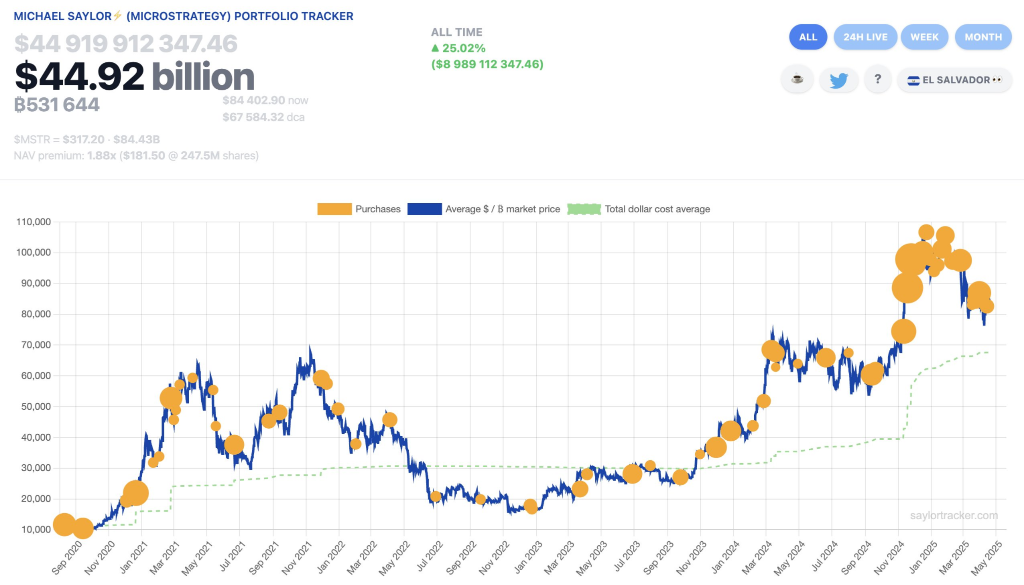

Michael Saylor has been buying Bitcoin since 2020. His company MicroStrategy now holds billions in BTC. Since they started this strategy, the value of their Bitcoin portfolio has grown by over 2,400%. That’s better than the growth of Apple, Google, or Tesla. This performance helped prove to many that Bitcoin is not just hype — it’s working better than most big tech stocks.

Now Saylor is getting ready to add another $2 billion worth of BTC. Just last week, he reportedly bought $285.8 million more. He believes Bitcoin is the only asset where people can truly control their funds. He says it’s free from middlemen and offers protection no other asset can give. MicroStrategy’s tracker shows that the average buying cost is getting more stable while Bitcoin’s price continues rising. For Saylor, this is not a guess — it’s a long-term plan he’s already acting on.

Minotaurus (MTAUR): The Quiet Contender…
While everyone’s waiting on Bitcoin, smart crypto fans are using this window to scout early-stage opportunities. Which ones are favored by growth-oriented holders?
Most presales peak in week one and fade into silence, but Minotaurus (MTAUR) has done something rare—it’s still growing, and more people are noticing.
MTAUR started at just 0.00004 USDT and now is available for 0.00010965. That’s over 170% growth—and there’s still room ahead with the listing pegged at 0.00020. Meanwhile, over 1.97 million USDT has already been recorded in token purchases, even as competing projects freeze up.
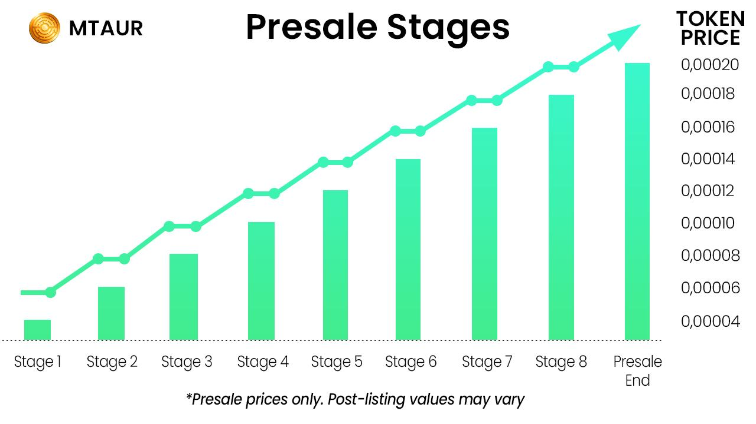
What’s fueling that momentum? A game-first vision. Minotaurus is building a blockchain-powered maze experience where MTAUR is the fuel. You won’t just hold it—you’ll use it to level up, unlock paths, and stand out.
And the structure? It’s solid:
- Only 2% of tokens go to the team
- A full 10% is locked in for community use
- Vesting incentives add more for long-term players
- Referral program gives you and your friends bonuses
- A 100K USDT giveaway gives participants a chance to win big
- Smart contracts fully audited by SolidProof and Coinsult
- Built on Binance Smart Chain for speed and savings
- 20,000+ members already exploring the ecosystem
Most projects stall. Minotaurus is still gaining traction. Grab your spot before it hits the next gate.

What Comes Next for Bitcoin?
Robert Kiyosaki and Michael Saylor are not talking about short-term growth. They believe Bitcoin is part of a major shift happening over the next decade. With growing debt, high inflation, and weak currencies, they see BTC as the only strong option for the future.
Holding out for a Bitcoin breakout? You’re not alone—but in the meantime, early-stage projects like Minotaurus (MTAUR) are giving holders something to be excited about right now. Want something solid to diversify into? Start here.

