BTCC Exchange Appoints Dan Liu as CEO Ahead of 14th Anniversary Milestone

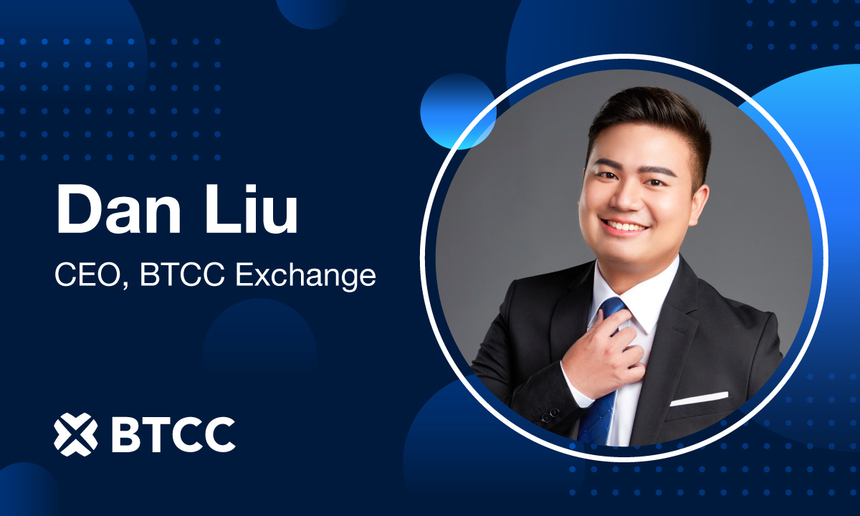

VILNIUS, Lithuania, May 21st, 2025, Chainwire

BTCC, one of the world's longest-serving cryptocurrency exchanges, today announces the appointment of Dan Liu as its new Chief Executive Officer. Liu, who previously served as Chief Research Officer at BTCC, brings extensive expertise in both traditional finance and cryptocurrency markets to his new role.
As BTCC approaches its 14th anniversary in June, Dan Liu's appointment as CEO marks a new chapter for the exchange. Under his leadership, BTCC aims to build upon its legacy as the world's most established crypto exchange while pursuing sustainable growth. This vision will carry BTCC confidently into the future, elevating the platform beyond traditional security to drive meaningful industry evolution.
From Research Visionary to CEO
Since joining BTCC in 2019, Liu has been instrumental in the exchange's rapid growth and innovation in the cryptocurrency space. As a dynamic young leader, he previously served as Chief Research Officer at the exchange. With his strategic vision over the years, BTCC expanded its services to users from over 160 countries and significantly enhanced its product offerings in both futures and spot trading markets while maintaining high security standards.
Liu's forward-thinking approach to market dynamics has made him a sought-after and respected voice in the cryptocurrency space, with regular features in prominent crypto media outlets including Cointelegraph, Markets Insider, and Japanese publication Monthly Digital Assets.
"I am deeply honored to lead BTCC Exchange at such a pivotal time for both our platform and the broader cryptocurrency ecosystem," said Liu. "My crypto journey began back in 2013, and that early passion has only grown stronger over the years. As we celebrate our 14th anniversary this year, I'm excited to combine my background in traditional finance with my love for blockchain innovation. We remain committed to bridging these two worlds, continuing to build trust within the community while accelerating our global expansion."
Building on Legacy, Focused on Future
Since joining BTCC in 2019, Liu has guided the exchange through various market conditions while driving innovation and growth. His leadership has positioned BTCC as an industry pioneer across multiple market cycles.
One of Liu’s most notable contributions was leading the launch of Tokenized Futures, an innovative financial product rarely seen in the industry. This bold step bridged the gap between traditional finance and blockchain technology and positioned BTCC as a forward-thinking exchange.
Additionally, under Liu's strategic guidance, BTCC launched its highly successful Copy Trading feature, which has received exceptional user engagement and positive feedback. This feature provides an accessible entry point for those exploring cryptocurrency markets, aligning perfectly with BTCC's mission of making digital asset trading more inclusive.
With his academic background in conventional markets, Liu brings valuable analytical skills to the evolving cryptocurrency space. His leadership represents a new approach where trust, transparency, and blockchain technology work together.
Looking ahead, Liu's focus is on global expansion while navigating increasingly diverse regulatory standards across markets. "One of my most important missions is educating the general public about cryptocurrency and making trading accessible to everyday users," Liu explains. To support this vision, he plans to deepen BTCC's community connections by attending global industry events and creating direct dialogue with users and partners across different markets—insights that will help shape the platform's future and inform regional strategies.
Under Liu’s leadership, BTCC Exchange is poised to continue its legacy as one of the most trusted, secure, and innovative cryptocurrency exchanges globally.
About BTCC
Founded in 2011, BTCC is one of the world's longest-serving cryptocurrency exchanges, offering secure and user-friendly trading services to millions of users globally. With a commitment to security, innovation, and community building, BTCC continues to be a trusted platform in the evolving cryptocurrency landscape.
Website: https://www.btcc.com/en-US
X: https://x.com/BTCCexchange
Contact: press@btcc.com

Contact
Aaryn Ling
BTCC Exchange
press@btcc.com

