Title Tag: While XRP and SEI Rally, BlockDAG Pays Out Millions to Users!
Meta Description: Explore why SEI is up 70%, XRP crosses $2.20, and how BlockDAG’s quest-based 100M airdrop gives users a chance to earn up to 10.1M BDAG right now.

SEI Climbs, XRP Bullish, & BlockDAG Pays Out Millions in BDAG! Explore the 100M Airdrop Everyone’s Watching in 2025
SEI is climbing fast, with a 70% jump in less than two weeks. It gained momentum from increased wallet activity and a major spike in DeFi TVL. Meanwhile, XRP crossed $2.20 after renewed buzz from co-founder Arthur Britto and strong chart signals. Both cryptos are gaining traction, but neither is handing out rewards just for taking part.
That’s where BlockDAG stands out. It has rolled out an airdrop that rewards users for being active. BDAG isn't just distributed randomly; users complete missions, run testnet nodes, install apps, and refer others to earn. The top 100 contributors win huge BDAG payouts, and the first-place spot alone grabs 10.1 million.
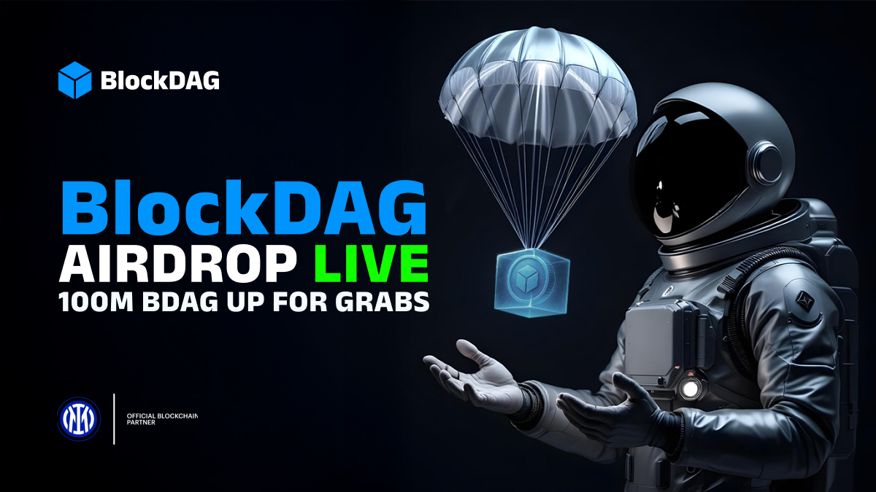
It’s not just hype, it’s hands-on progress. BlockDAG’s approach flips the norm. Instead of waiting for gains, participants earn BDAG while helping shape the ecosystem. This airdrop is more than a giveaway; it’s a reward system built for action-takers.

10.1M BDAG Up for Grabs in Latest 100M Airdrop
BlockDAG is changing how airdrops work. Instead of giving away coins to passive holders, it rewards people for helping build the network. That means completing quests, running testnet tools, downloading apps, sharing the project, and more.
Those who put in the effort rise up the leaderboard. The top 100 performers earn large BDAG amounts, and the number one spot receives 10.1 million. Quests are split into four areas: testnet, social, referral, and presale. Each one adds points and boosts the rank. Every three months, the leaderboard resets, giving new users a chance to compete. This keeps the system fresh and active.

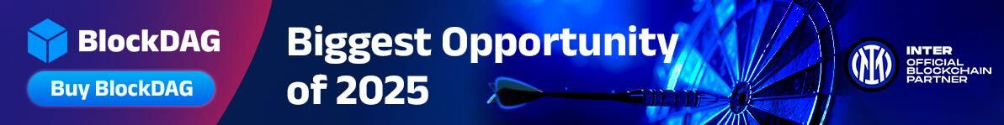
The presale is also picking up speed. BlockDAG is currently offering a special limited-time price of $0.0030. However, in less than 12 hours, the coin will jump to $0.0080. Already, 23.3 billion BDAG have been sold, and $324 million raised.
The total presale target stands at $600M. With a launch price set at $0.05, buyers could see gains of over 16x. Add to that a mining app with over 2 million users, upcoming shipments of hardware units, and confirmed listings on BitMart, CoinStore, and MEXC, and BlockDAG is growing quickly.

SEI Price Soars on DeFi and Upgrades
SEI’s recent run has turned heads. It soared more than 70% in under 14 days. The move came after it broke above resistance levels, including $0.27 and the 200-day EMA. RSI and MACD are signaling more upside, even with some risk of short-term dips. One big driver is SEI’s DeFi TVL, which rose over 25% in just 24 hours to pass $535 million. Wallet addresses now exceed 8.1 million, ranking second among EVM chains.
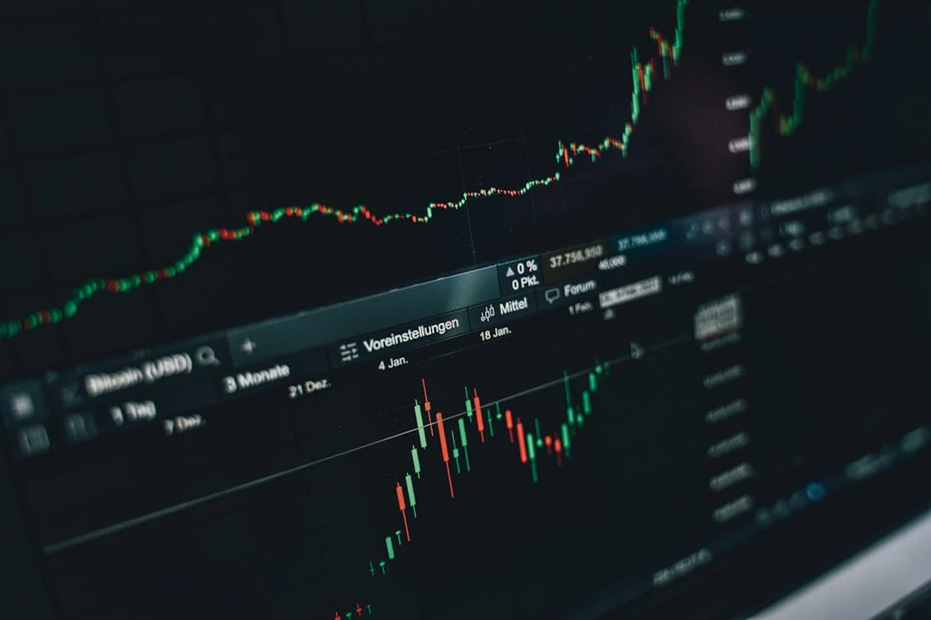
Fueling this rally was the announcement from the Wyoming Stable Token Commission naming SEI as a potential chain for its Weiss stablecoin pilot. SEI also teased its “Giga” upgrade, promising speeds over 5 Gbps and sub-400 ms finality.
SEI saw over $3 million in inflows recently, while Solana experienced net outflows. The data supports SEI’s current rally, and with upgrades on the way, the buzz looks real.

XRP Clears $2.20 With Strong Momentum
XRP is back in the spotlight. After gaining 9–12%, it crossed above $2.20 and cleared resistance at $2.10. This came after co-founder Arthur Britto made a public appearance, sparking a fast rally. Indicators like the Parabolic SAR and MACD suggest strong short-term potential.
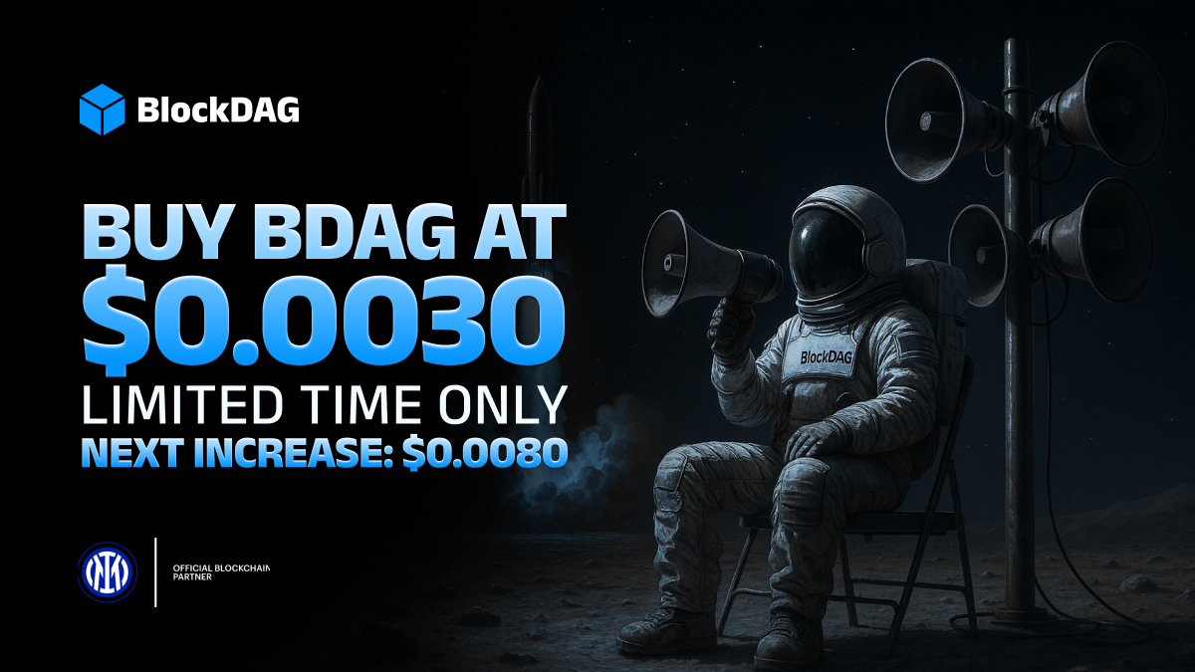
Market sentiment also got a boost from Middle East peace developments, helping lift the broader crypto market. However, caution signs are flashing. Reports show over $68 million in daily XRP sales by large holders. If this trend grows, the price may fall toward $1.35–$1.60.
Still, Ripple’s upcoming escrow unlock on July 1 might not flood the market, as most of the 1 billion coins could stay locked. Some believe XRP can reach $2.48 soon, while others suggest it could even push toward $5–$7 before the year ends.

Final Thoughts
SEI has strong momentum thanks to technical upgrades and rising on-chain data. XRP is holding firm above $2.20 with support from community buzz and bullish charts. But what sets BlockDAG apart is how it rewards people for actually doing something.
Instead of only relying on price moves, BlockDAG pays users for being part of the project. From testnet quests to referrals, it’s all about action. The top 100 users take home serious BDAG stacks, with the leader earning 10.1 million.
For anyone looking to get into a crypto that values participation, BlockDAG is worth watching. It’s not just another launch; it’s a system that rewards builders. Early participation isn’t just encouraged, it’s rewarded.

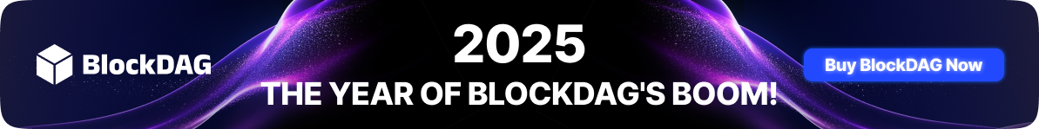
Presale: https://purchase.blockdag.network
Website: https://blockdag.network
Telegram: https://t.me/blockDAGnetworkOfficial
Discord: https://discord.gg/Q7BxghMVyu

