Keywords: SUI, BGB, VET, top altcoins to buy
Title Tag: 4 Top Altcoins to Buy This Quarter: BlockDAG, Sui, BGB & VET
Meta Description: Discover why BlockDAG, Sui, Bitget Token, and VeChain rank among today’s top altcoins to buy. See their real-world growth stories and long-term ROI potential.

4 Top Altcoins to Buy Before the Floor Drops: BlockDAG, Sui, Bitget Token, VeChain Are Moving Fast!
Crypto lists are usually a rinse-and-repeat of yesterday’s hype. This one isn’t. BlockDAG (BDAG), Sui (SUI), Bitget Token (BGB), and VeChain (VET) are four names that have carved their space for reasons more interesting than a random green candle. Some are quietly solving problems most chains pretend don’t exist, and others are turning slow-moving industries into testbeds for real blockchain use.
The market’s noisy, narratives are fickle, but a few projects keep showing up in serious conversations for good reason. If you’ve been wondering which names actually deserve a second look, here’s a closer take on the top altcoins to buy right now.
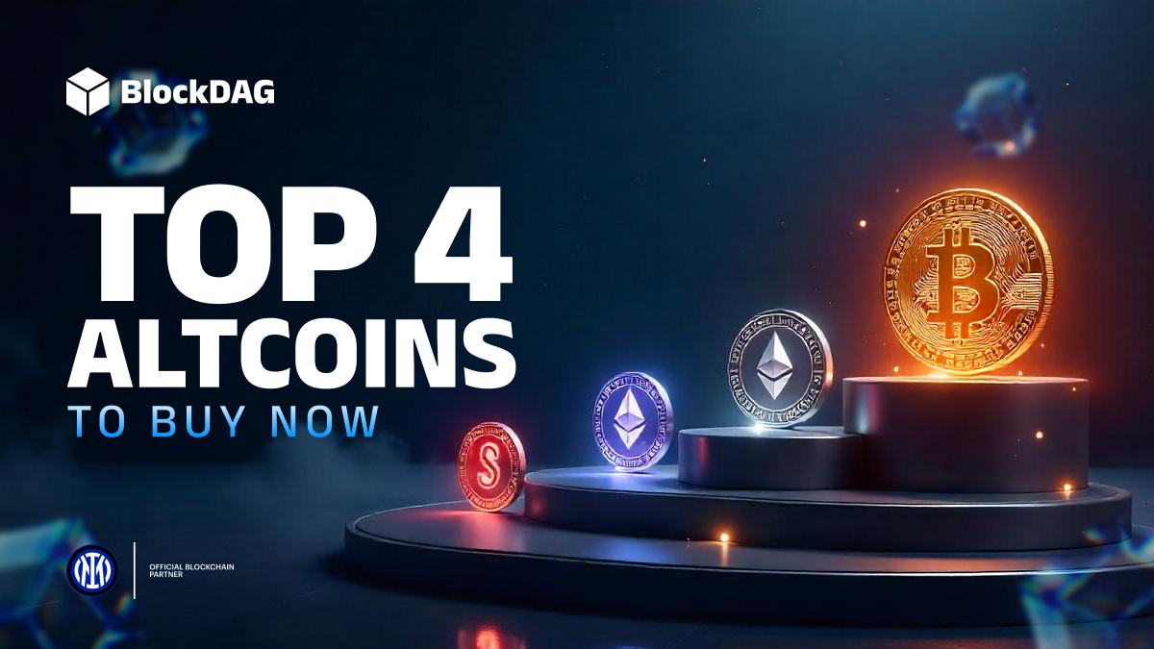

1. BlockDAG: Expanding Ecosystem Signals Massive Profit Potential
Some projects talk about adoption. BlockDAG is already living it. Over 2.5 million people mine BDAG daily through the X1 app, while 200,000+ unique holders are steadily building long-term positions. Behind the scenes, 4,500 developers are preparing more than 300 Web3 projects for the BlockDAG network.
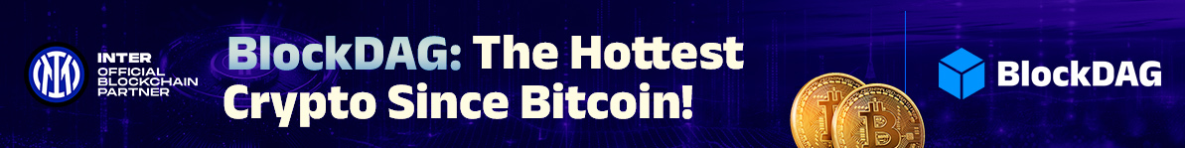
Despite this scale, access remains surprisingly cheap. The upcoming GLOBAL LAUNCH Release allows entry at just $0.0016 per coin until August 11, even though the launch price is expected to open at $0.05. That translates to a 3,025% return from day one of trading for those who secure their share before the ongoing BEAT VESTING pass expires on August 11.
The broader market is beginning to recognize what these numbers mean: strong community activity, expanding infrastructure, and a foundation that could support future price levels of $1, $10, or even $20. With over $356 million already raised and 24.5 billion coins sold, BDAG remains one of the top altcoins to buy this quarter. For those who wait, the opportunity for entry is closing just as quickly as the potential for higher profits is opening.

2. Sui: Scalability at Speed
Sui has been making noise for reasons beyond hype. Built by ex-Meta engineers, its architecture doesn’t follow the old, congested blockchain playbook. Instead, it uses an object-centric data model and parallel transaction execution to handle a high volume of activity with minimal delay.
This means real-world applications like DeFi platforms or on-chain gaming can scale without the usual bottlenecks. The network’s near-instant finality makes it a rare Layer-1 capable of handling enterprise-level demand. Price-wise, SUI has been relatively steady despite market swings, holding ground as it builds a bigger ecosystem.

3. Bitget Token: Utility That Follows Exchange Growth
Bitget Token (BGB) is tied to the rapid climb of its parent platform, one of the busiest names in derivatives trading. The token’s utility stretches far beyond fee reductions, giving access to exclusive launches, staking pools, and loyalty benefits that appeal to active traders.
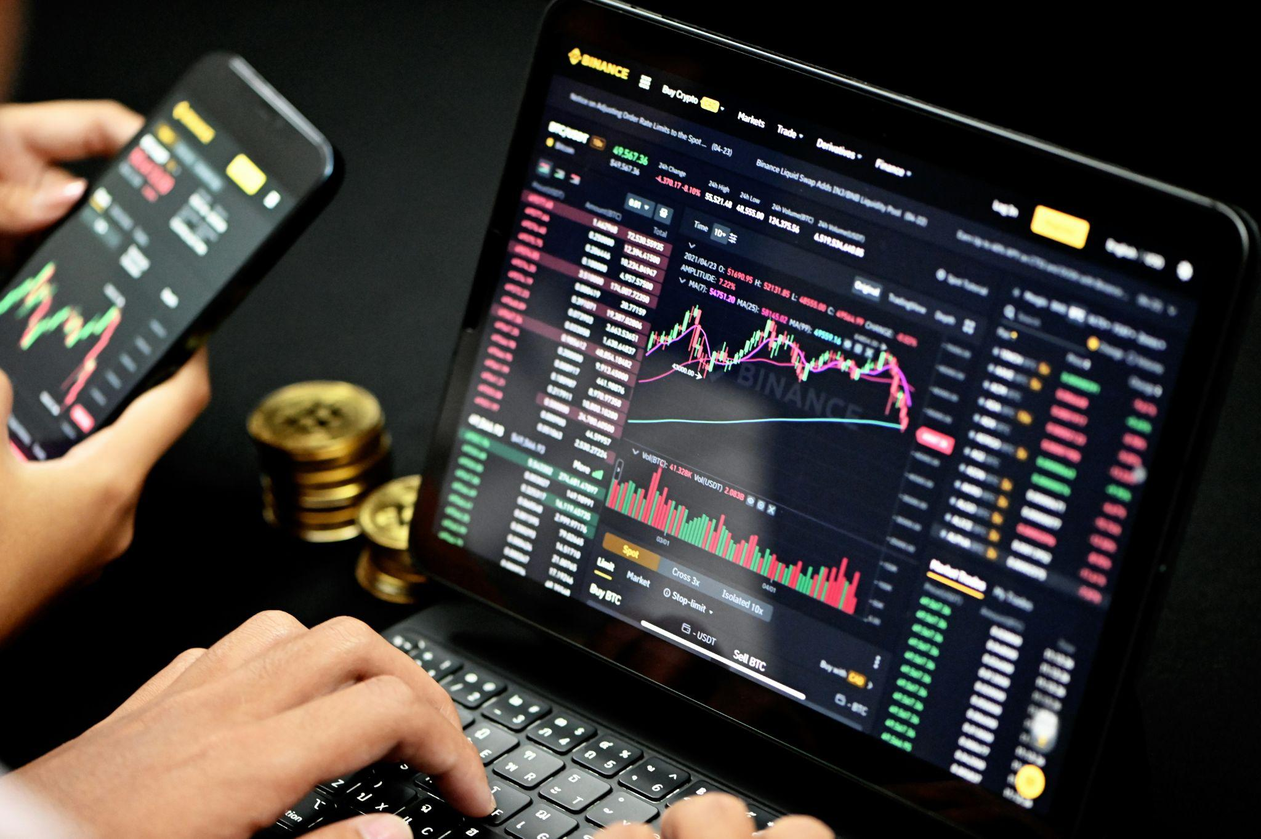
As the exchange scales globally, BGB’s use cases multiply in lockstep, making it less a speculative punt and more a functional asset. With other exchange tokens like BNB proving long-term potential in this sector, BGB has carved out a space as one of the top altcoins to buy for those seeking a more practical growth story tied directly to platform adoption.

4. VeChain: Enterprise-Grade Blockchain With Real-World Reach
VeChain (VET) remains one of the few projects that regularly finds a seat at the table with major global corporations. Its focus on supply chain tracking and data integrity has seen it work with the likes of BMW, PwC, and Walmart China. The dual-token system keeps transaction costs predictable, which is exactly what large-scale businesses need to adopt blockchain at scale.
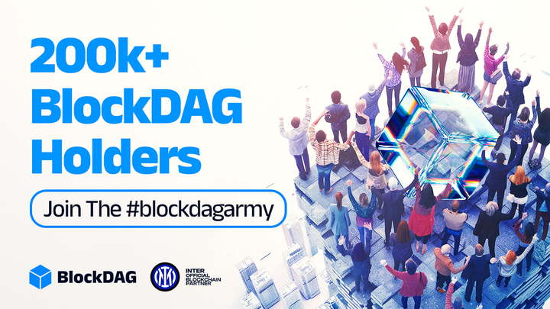
While VET’s price hasn’t exploded like some speculative assets, its fundamentals are among the most solid in the space. It’s a coin that trades more on enterprise utility than hype cycles, making it one of the top altcoins to buy for those who value real adoption over charts that swing wildly.

In a Nutshell
After sifting through the daily chaos of price swings and promises, these four stand out for what they’re building, not just what they’re charting. VeChain’s corporate alliances speak louder than marketing, Sui’s tech chops push transaction limits, and Bitget Token grows in sync with its exchange.
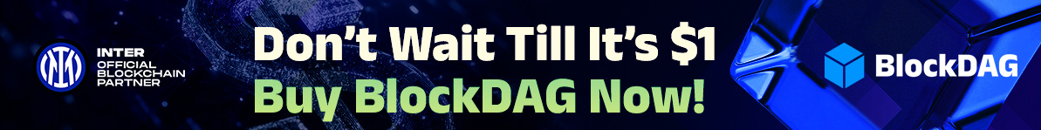
BlockDAG is the outlier: it already counts millions of daily miners, thousands of planned projects, and a fixed entry price mapped to a potential 3,025% ROI. In a market where most names trade on sentiment alone, these remain among the top altcoins to buy!

