Crack the XRP Profit Code — How Invro Mining Turns Every Coin into Daily Earnings

Introduction: The Shift Toward Passive Crypto Income

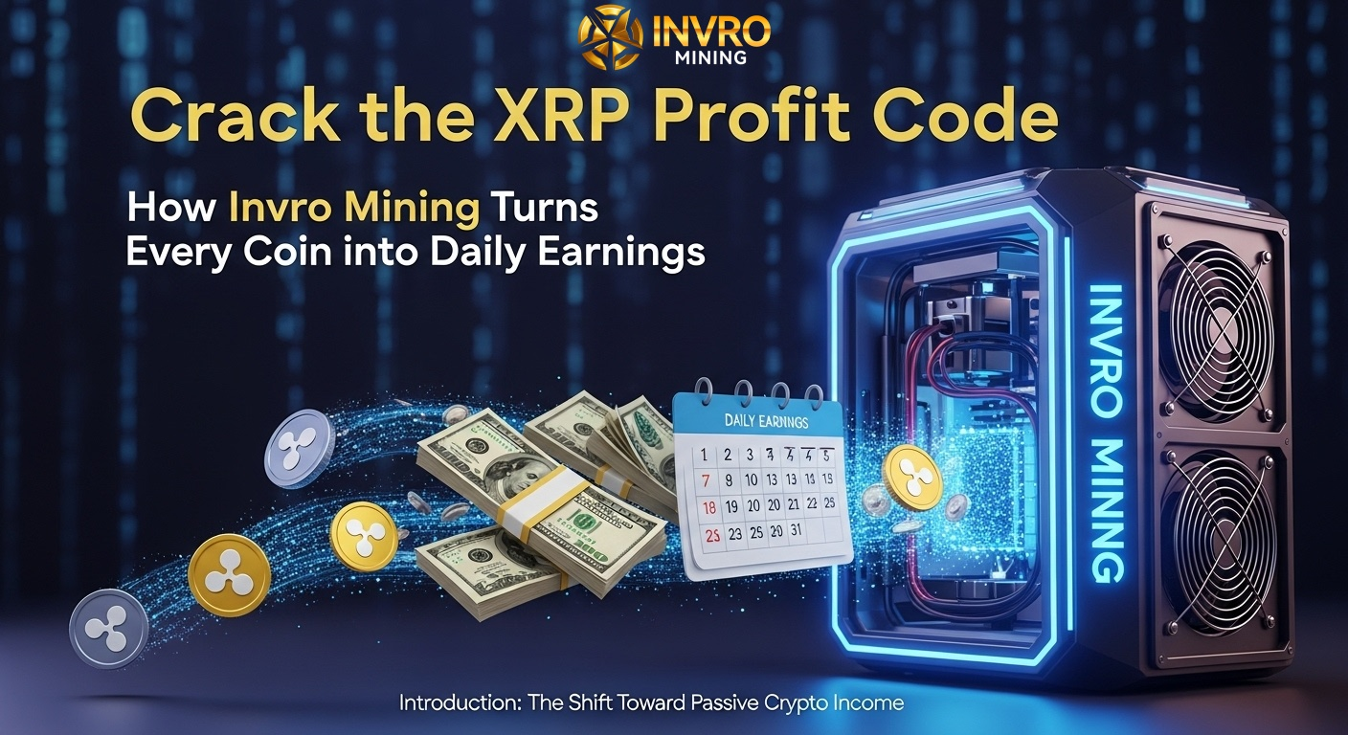
Although cryptocurrency opens up new possibilities for wealth creation, the volatility of cryptocurrency and its highly speculative nature, combined with your own pressure to trade, can create unnecessarily stressful trading circumstances. XRP is really one of the better-known cryptocurrencies. It is liquid and fast, but even with XRP's fast-paced trading, its volatility will certainly test reasonable people's demeanor and proficiency. This is why many people are working on passive income strategies - like Invro Mining- where you can grow your XRP into a daily income stream by generating, you guess it, passive daily profits. All this without the headaches of day trading!

Why Passive Income is a Smart Choice for Crypto Investors
Many investors prefer passive income because it offers stability in a market known for rapid price swings. Instead of buying and selling XRP daily, users of Invro Mining simply start a contract and let the system handle everything. The result is predictable earnings without the need for constant monitoring or market analysis.
- Trading complexity avoided — The XRP market is active but volatile, making it challenging for average investors to make consistent gains.
- Effortless earnings — With Invro Mining, daily profits arrive automatically without manual intervention.
- Stress-free investment — Investors can grow their portfolios without the emotional highs and lows of day trading.

Invro Mining: Automating Your XRP Earnings
Invro Mining makes XRP cloud mining easier by introduced artificial intelligence to the process. After completing registration and selecting a plan, the system will operate through autopilot. The AI technology will study the XRP market trends, adjust cloud miners mining schedules, and optimize their strategies for maximum usage. At this level of automation, you can earn while concentrating on other things.

Green Mining for a Sustainable Future
Invro Mining uses renewable energy sources such as wind, solar and hydro power or "clean" electricity to offset the environmental impact and to reduce the overall depletion of finite resources. Traditional mining generally uses large quantities of electricity to mine, therefore Invro Mining helps to reduce the burden on imported hydrocarbons. Besides lessening harm to the environment, the use of renewable energy resources can also drive operational costs down; on the whole, users will expect Invro Mining to provide reliable returns with no energy price increase.

How to Start Earning with Invro Mining
Getting started is quick and beginner-friendly:
- Register a Free Account
Visit Invro Mining’s official website and sign up. New users receive a trial bonus to test the system risk-free.
- Select a Mining Contract
Choose from a range of investment options tailored to different budgets:
  - Starter Plan — $15 for 1 day, expected return: $15.60
  - Stable Growth Plan — $3,000 for 15 days, expected return: $3,652.50
  - Gain Plan — $5,000 for 20 days, expected return: $6,550
  - High Yield Plan — $10,000 for 30 days, expected return: $15,100
- Activate and Earn Automatically
Once activated, mining begins instantly. Earnings are credited daily without needing to track the market.

Earnings Potential and ROI
Profit expectations are clearly outlined. For example:
- A $3,000 contract over 15 days generates $652.50 in profit.
- A $10,000 contract over 30 days can yield $5,100 in profit.
Users have full control over their income — withdraw anytime or reinvest to take advantage of compounding returns.

Extra Income Through Referrals
Invro Mining rewards users for inviting others to join. By sharing your unique referral link, you can earn a commission on your referrals’ mining profits. This creates an additional passive income stream without any extra investment.

Security and Transparency at Every Step
The platform prioritizes user trust with:
- Advanced encryption to protect personal data and transactions.
- Real-time profit tracking so you always know your earnings.
- Fast withdrawals to ensure quick access to your funds.

Why XRP Mining is a Strategic Move Now
XRP is getting traction in the market on the basis of its fast transfers and is being adopted by bigger banks and financial institutions more regularly. With more attention on XRP now than ever, getting a few now or mining it could yield you returns for years to come. Invro Mining allows users the capability to build up XRP using mining over time with little risk, guaranteeing that you won't find yourself with your pants down in a bad trade.

Conclusion: Turning XRP into Daily Profit
Invro Mining offers a potent solution with AI-effective efficiency, green energy and flexible financing. Invro Mining makes mining XRP that is efficient, profitable and sustainable, whether you're beginning with $15 or scaling it up to $10,000. Invro Mining is an excellent option for people wanting to earn cryptocurrency, while eliminating the stress of buying, trading and speculation.
For media inquiries or further details, contact: info@invromining.com
Visit the official website: https://invromining.com

