Title Tag
Best Altcoins 2025: BlockDAG, AVAX, POL, and ADA Show Strong Surge Potential
Meta Description
Discover the best altcoins in 2025. Explore BlockDAG’s presale buzz, AVAX growth, POL’s shift, and ADA’s ETF catalyst to see which projects are worth watching.

Best Altcoins 2025: BlockDAG, AVAX, POL, and ADA Show Strong Surge Potential
The crypto market is heating up again, and investors are asking the same question: which projects will deliver the strongest returns as we approach the next bull cycle? While Bitcoin and Ethereum dominate headlines, real opportunities often sit in altcoins that are building traction, locking in adoption, and creating buzz in both retail and institutional circles. Picking the best altcoins is about looking beyond hype and finding projects with proof of delivery.
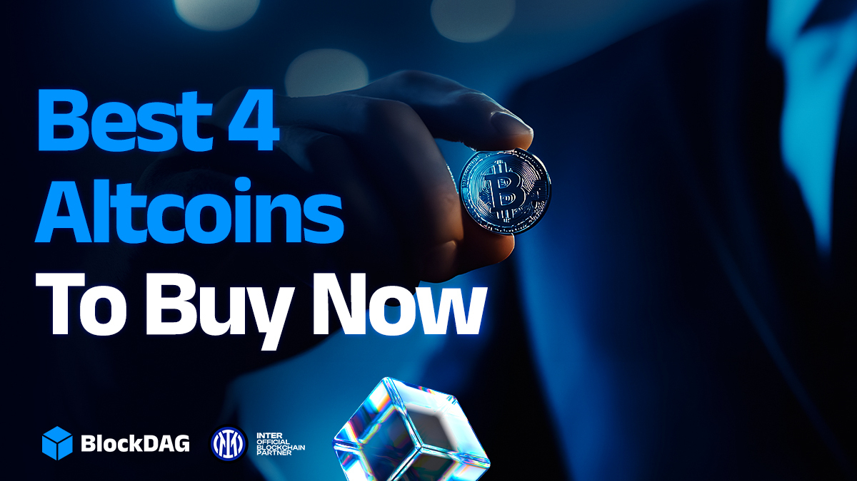
Today, we’ll focus on four names showing serious strength, BlockDAG, Avalanche (AVAX), Polygon’s POL token, and Cardano’s ADA. Each offers its own angle, whether it’s technology, partnerships, or investor momentum. Let’s break down why these coins are making noise and why they belong on your radar right now.

1. BlockDAG Takes Center Stage
BlockDAG is making one of the boldest moves of 2025, taking Platinum Partner status at Token2049 Singapore on October 1–2. With over 25,000 attendees expected at Marina Bay Sands, including 7,000+ companies and 300+ speakers, the project is making sure every attendee sees its name and tech. A 72 sqm custom-built booth with live demos, dashboard simulations, and instant bonus claim stations means BlockDAG will dominate the venue. Add in a floor-to-ceiling banner outside the main stage and sponsorship of AFTER 2049, the biggest closing party, and the project has locked down complete exposure on one of crypto’s largest stages.


The presale has already surged past $387 million, with more than 25 billion BDAG tokens sold. The current batch 30 price is $0.03, up from just $0.001 in batch 1, which shows how much early buyers have gained. Two whales recently crossed holdings of $4.4 million and $4.3 million, fueling more FOMO among investors. With millions of app users mining BDAG through smartphones and X10 mining devices already shipping worldwide, this is not just hype, it’s real adoption.
BlockDAG has turned its presale into a global event. The 2049% bonus leading into Token2049 is designed to attract last-minute buyers and keep momentum strong. With major sponsorship announcements and a live AMA scheduled before the event, the project has perfectly timed its run-up. If you’re scanning the market for the best altcoins, BlockDAG is clearly one of the top picks, combining utility, adoption, and a presale frenzy that is setting new records.

2. Avalanche (AVAX) Shows Solid Growth
Avalanche has been one of the strongest performers in the altcoin sector this year. The project’s focus on scaling through its subnet architecture continues to attract developers and partnerships. Its unique consensus design allows near-instant transaction finality, which has made AVAX appealing for DeFi projects and enterprise solutions. While many networks are struggling with congestion, Avalanche has positioned itself as a scalable and efficient choice, keeping it high on investor watchlists.
Price-wise, AVAX has shown stability and steady growth, maintaining strong support levels while pushing toward higher ranges. The network’s focus on interoperability and ongoing developer activity is adding confidence to its long-term prospects. As the market anticipates a broader bull run, Avalanche looks ready to capitalize on its momentum. For those considering the best altcoins to buy before the market heats up further, AVAX remains one of the strongest options for both utility and community strength.

3. POL Pushes Polygon’s Transition
Polygon rebranded its MATIC token to POL as part of its long-term roadmap, making it the native gas and governance token for the network. This shift is part of Polygon 2.0, designed to unify scaling solutions like zkEVM and supernets under one ecosystem. POL is used for transaction fees, staking, governance, and funding development across Polygon’s expanding ecosystem, making it more versatile than its predecessor.
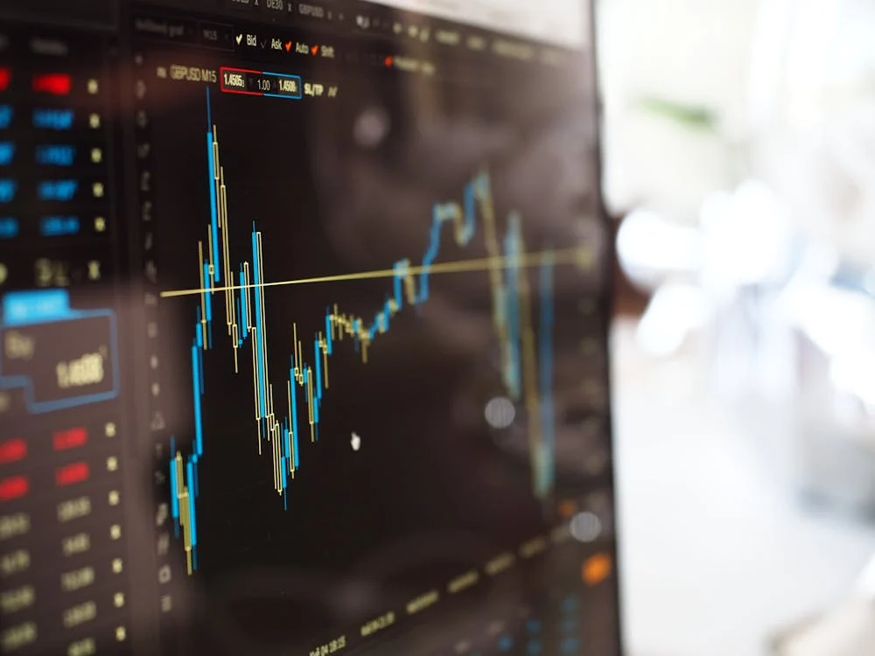
Currently, POL is trading around $0.26 after a 7–8% daily gain in late August 2025, with market capitalization sitting close to $2.7 billion. Technicals suggest strong support around $0.24 and resistance near $0.262, with momentum indicators showing potential for a breakout. Whale activity and trading volumes have also been positive, hinting at further moves. Polygon has consistently secured big partnerships, and with POL now powering its network, it’s gaining attention as one of the best altcoins to watch in this cycle.

4. Cardano (ADA) Eyes ETF Momentum
Cardano remains one of the most closely followed projects in crypto. ADA trades around $0.85, consolidating within a $0.82–$0.88 band, with support at $0.75–$0.77 and resistance near $0.95 and $1.00. On-chain accumulation has been notable, with $170 million in ADA withdrawn from exchanges in a week and whales adding 150–180 million tokens, reflecting confidence among larger holders despite slower overall network activity.
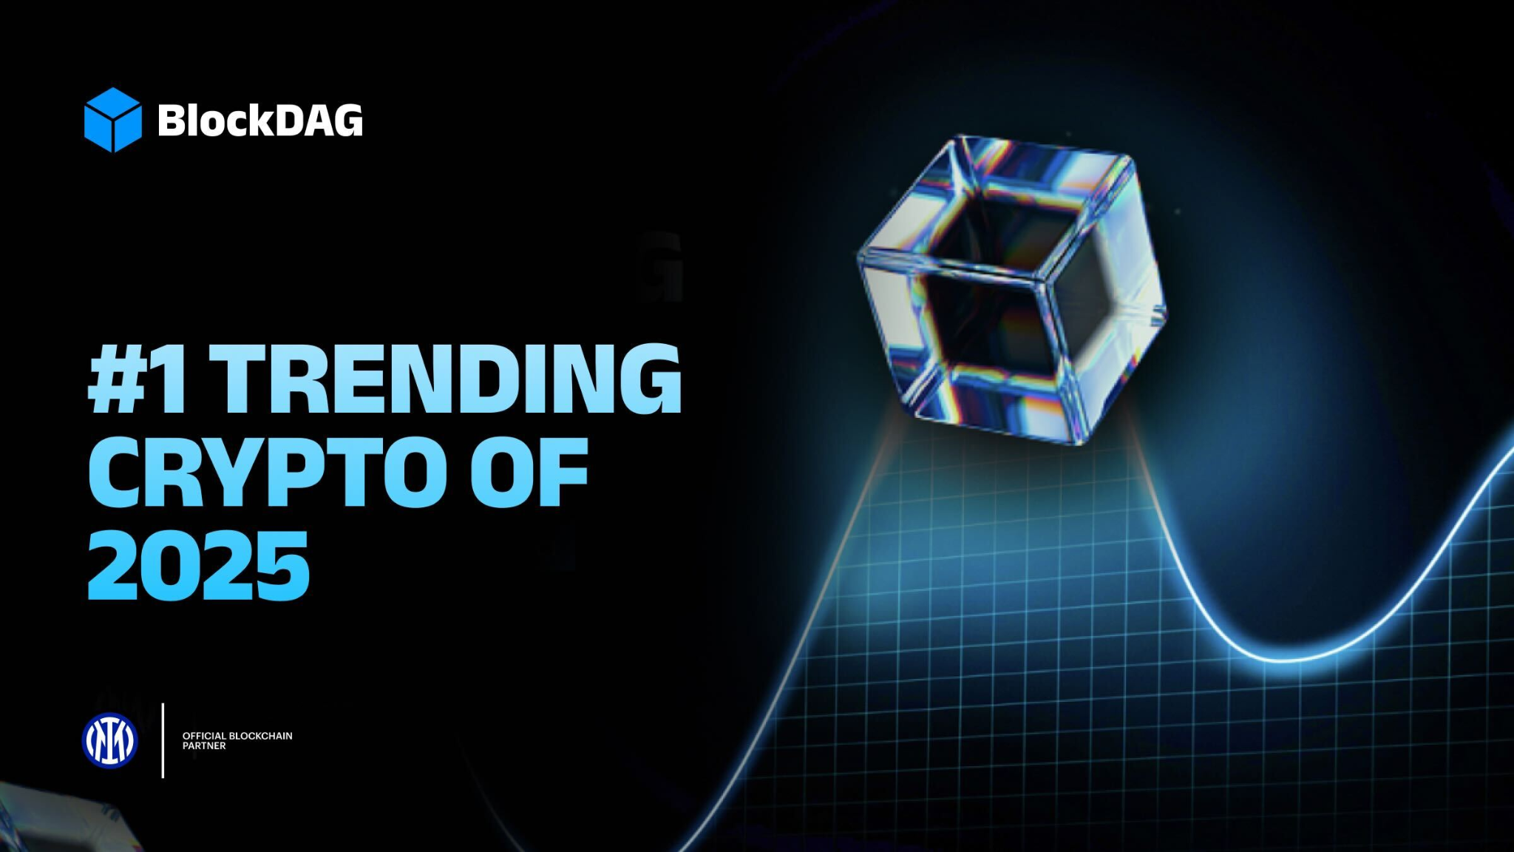
The main catalyst is regulatory. The SEC recently delayed its decision on a Grayscale spot Cardano ETF until late October 2025, but approval odds are around 83%. Such a move could attract institutional flows similar to Bitcoin and Ethereum ETFs. Alongside this, upcoming developments like the Midnight privacy sidechain and Glacier token airdrop add to its outlook. As part of the best altcoins list for 2025, ADA combines steady accumulation with strong speculative and fundamental drivers.

Summing Up
The race to find the best altcoins comes down to timing, momentum, and fundamentals. BlockDAG is grabbing attention with its Token2049 presence, record-breaking presale, and a growing ecosystem that links mobile mining with physical devices. Avalanche continues to prove its place as a practical scaling solution, while POL is driving Polygon’s network through its next stage of growth.
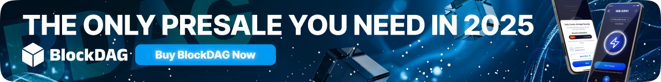
Cardano stands out with strong whale accumulation and the potential of an ETF approval that could unlock new institutional demand. Each of these coins offers a unique angle, but together they show how altcoins remain a major opportunity for investors. From presale excitement to ecosystem upgrades and regulatory catalysts, these four highlight where focus is shifting in 2025.

