Meta Title: BlockDAG’s $415M Presale and BWT Alpine F1® Deal vs Toncoin & Hedera
Meta Description: Read how BlockDAG raises $415M & locks BWT Alpine F1® sponsorship. Compare it with Toncoin’s institutional bets and Hedera’s ETF potential to spot the biggest ROIs.

BlockDAG’s BWT Alpine F1® Deal and $415M Presale Put It Ahead of Toncoin’s Institutional Bets and Hedera’s ETH Potential
Toncoin has faced an 8.8% weekly decline in late September 2025, despite institutional groups securing large holdings, while Hedera saw a 9% monthly drop to around US$0.24 under selling pressure. These figures highlight a contrast in market confidence compared to BlockDAG, which has surged ahead with over $415 million raised in its presale, 26.5 billion coins sold, and an ROI of 2900% since batch one.
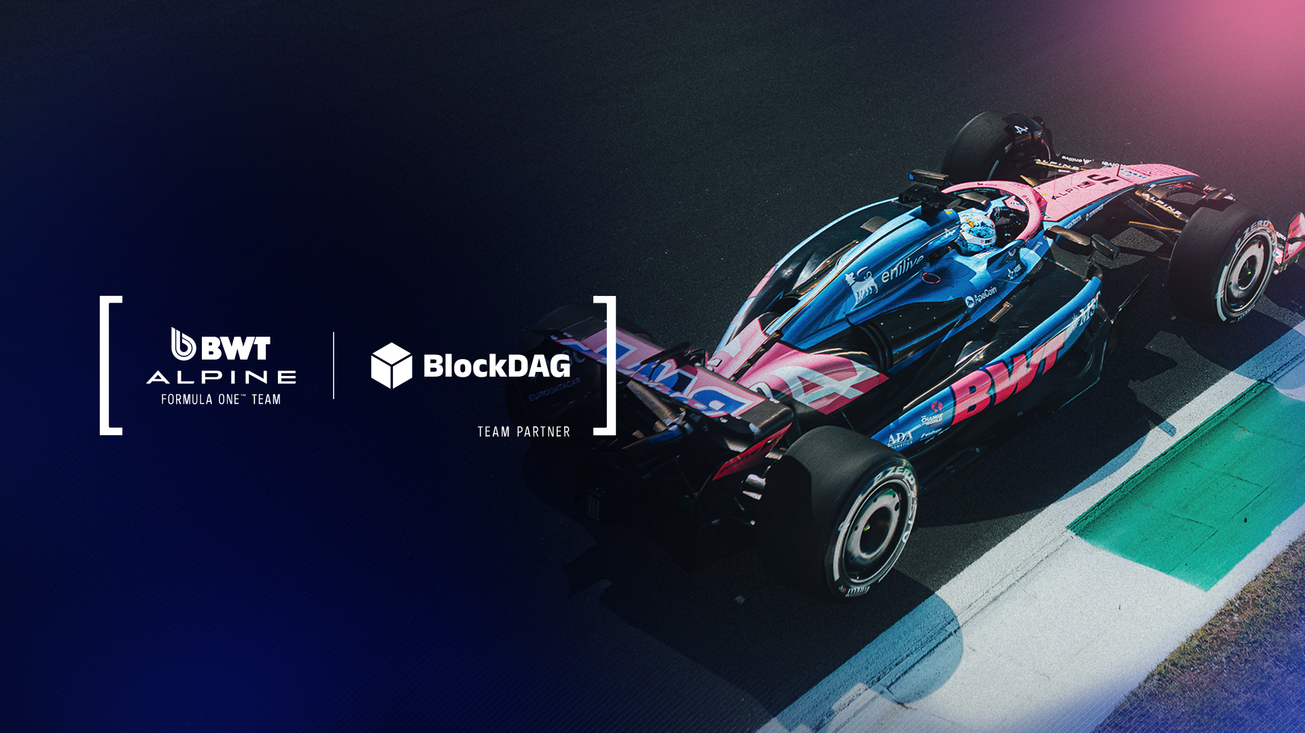
Its presale is in batch 30 at $0.03, yet early buyers can still secure allocations at $0.0013 for a limited time. BlockDAG’s momentum is reinforced by its multi-year partnership with the BWT Alpine F1® Team, which provides unmatched exposure through Formula 1® branding, fan simulators, and developer hackathons.

BlockDAG: Motorsport Branding Meets Web3 Integration
BlockDAG’s strategic decision to align with BWT Alpine F1® Team places it on a global stage that blends performance, speed, and mainstream culture. As the exclusive Layer-1 blockchain partner for BWT Alpine across multiple F1® seasons, BlockDAG integrates both fan-facing and developer-focused initiatives.
On-track interactive zones, simulators, and curated fan experiences highlight its ability to deliver tangible connections between blockchain and mainstream sports audiences. For developers, collaborative hackathons and digital/Web3 integrations offer direct participation in building out their ecosystem.
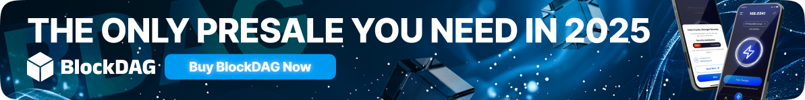
These activations go beyond speculative narratives. By presenting itself to F1®’s audience of hundreds of millions worldwide, BlockDAG builds credibility with institutions looking for real-world usage.
Combined with its presale success, over $415 million raised, 26.5 billion coins sold, and the price advancing to $0.03 in batch 30, BlockDAG is demonstrating both financial momentum and cultural presence. With a presale ROI of 2900% since batch one, yet entry points still available at $0.0013, it continues to stand out in discussions around what crypto to invest in.
By launch, the BDAG is also set to hit $0.05 per coin. Compared to today’s limited-time entry of just $0.0013, that’s an ROI of over 3,000% for anyone who manages to join the presale now!

Toncoin: Institutional Accumulation with Market Pressure
Toncoin’s recent performance has been characterized by both large-scale institutional interest and noticeable price volatility. A major milestone came with Verb Technology’s rebrand as TON Strategy Co., committing approximately US$558 million to accumulate around 5% of TON’s circulating supply. This level of institutional backing is significant and reflects confidence in the asset’s long-term role within Web3 ecosystems.
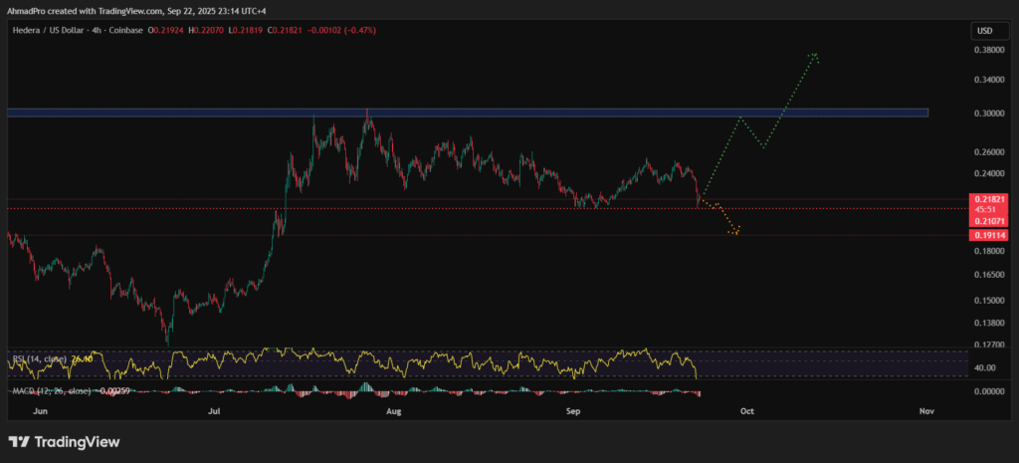
However, Toncoin has underperformed in short-term market action. The \~8.8% weekly decline in September underscores the tension between institutional accumulation and market-driven sentiment. While large holders may stabilize TON in the longer term, retail investors remain cautious. For those scanning top crypto gainers, Toncoin’s price trajectory has yet to match the scale of institutional commitments. Its ability to rebound depends on whether integration and adoption can keep pace with capital inflows.

Hedera: Institutional Narrative with Price Setbacks
Hedera has similarly faced short-term challenges while strengthening its institutional story. In September 2025, HBAR traded around US$0.24 after a \~9% decline, with selling pressure curbing short-term enthusiasm. This has made retail investors cautious, especially those seeking consistent returns.
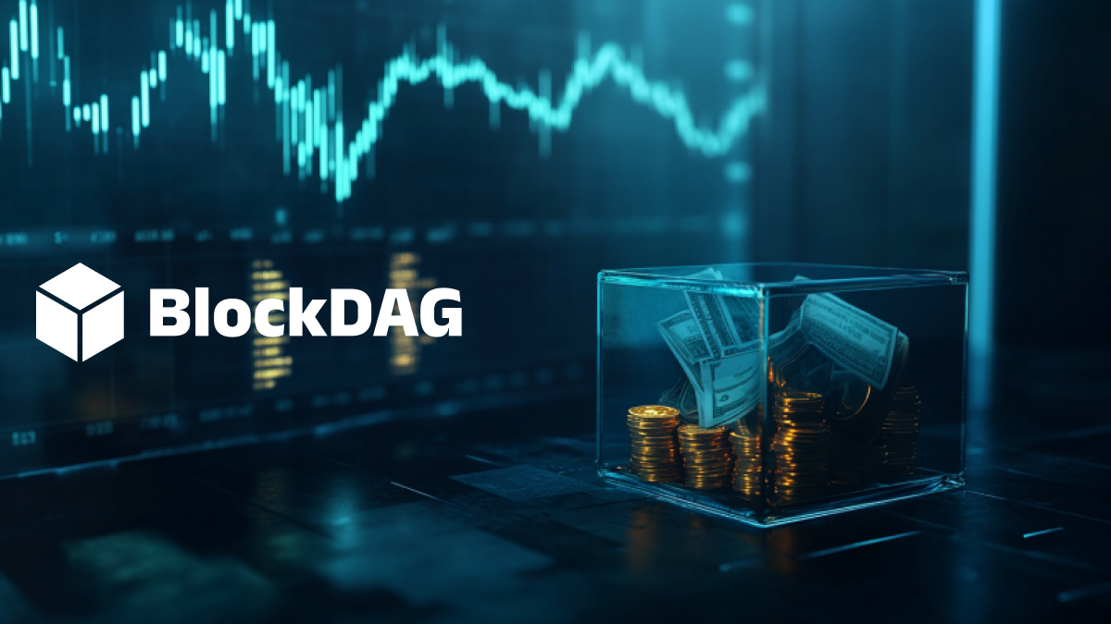
On the positive side, Hedera’s institutional profile is improving. It has been included in tokenized credit fund launches and is increasingly discussed in the context of ETF eligibility. These moves signal a shift toward regulatory recognition and long-term financial integration. Still, for immediate visibility among top crypto coins 2025, Hedera struggles to compete with projects like BlockDAG that tie token utility to mainstream cultural and sporting partnerships.

Comparative Outlook: Exposure vs Institutions
BlockDAG, Toncoin, and Hedera each present distinct cases for investors deciding what crypto to invest in. Toncoin and Hedera both lean heavily on institutional adoption and regulatory alignment. Toncoin’s large-scale accumulation and Hedera’s inclusion in tokenized financial instruments highlight a path defined by institutions rather than cultural engagement.
BlockDAG, on the other hand, has chosen visibility and real-world connection. Its partnership with BWT Alpine F1® Team makes blockchain tangible to a global sports audience, while its developer hackathons ensure technical growth continues behind the scenes.
When coupled with presale fundraising exceeding $415 million and ROI growth of 2900% since inception, BlockDAG builds both retail excitement and institutional interest. For many holders, this dual track strengthens its case as one of the top crypto gainers and a standout among the top crypto coins 2025.
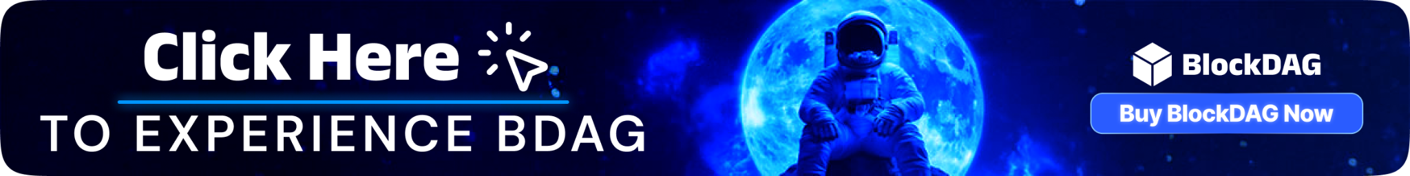
Presale: https://purchase.blockdag.network
Website: https://blockdag.network
Telegram: https://t.me/blockDAGnetworkOfficial
Discord: https://discord.gg/Q7BxghMVyu

