Join FiveCrypto and complete the AI Training Model to Get 0.1 ETH Reward

No longer is Artificial Intelligence and blockchain technology in different worlds. FiveCrypto is integrating them to a coherent, profitable novelty whereby normal users can participate in training AI models and get crypto in real-time. The platform also proves high-level computing to be accessible, transparent, and also rewarding instead of an expensive setup.
AI model training is now easier and more rewarding.
Everything that is based on AI training includes image generation, or predictive analytics. Previously these systems could only be operated in institutions that had costly infrastructure. FiveCrypto is transformed to have a distributed cloud network that eliminates the barriers of hardware and simplifies the process of involvement.
Users require no servers, GPUs or expertise. The service provides the AI tasks, and the participants provide some computing resources by the cloud. The revenue is then divided based on the use by the users.
This way enables any person to participate in the development of AI and receive a passive reward in crypto.
New User Incentive upon earning 0.1 ETH Fast.
FiveCrypto has also implemented a launch program to attract new members by providing first time users with 0.1 ETH upon finishing a short task of training an AI model. This is done within a few minutes and shows how an earning is made and a credit is done in real time.
As soon as the reward has landed on the wallet, the user is able to withdraw it, or purchase AI computing contracts with the help of it. This instant bonus provides novices with a personal feel of the income system of the platform without having to invest in it.
An AI and Blockchain Global Cloud Network.
FiveCrypto has a distributed infrastructure, which runs on green energy plants in Iceland, the UAE, Canada, and the UK. These data centers have the support of the AI Distributed Processing Network of the platform and provide high performance using low carbon production.
The ecosystem is beneficial to people, research laboratories, DeFi, and metaverse developers. It provides a marketplace where everyone can earn through supporting AI development because it provides all participants with flexible access to computing.
Daily Rewards Strikes A deal with AI Computing.
Those people who prefer constant incomes are able to become members with the help of AI computing contracts. These contracts enable automatic engagement in training work and have a daily profit, which is accrued every 24 hours.
This is what is appealing about the system:
· None of the ownership or repair of devices.
· Automatic settlement of big cryptocurrencies.
· Adaptable levels of contracts that have scaled returns.
· Capital returned when the contract period is over.
The participants are able to invest profits to access new levels and increase the long-term earnings.
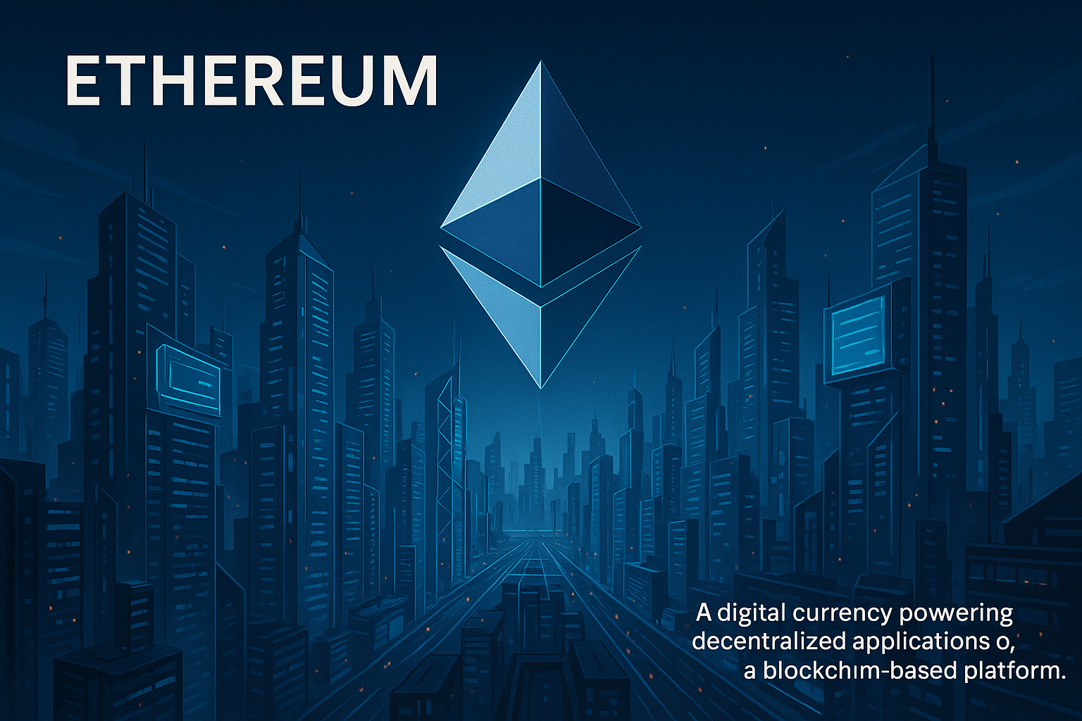
The FiveCryptos Most Potent Competitive Strengths.
FiveCrypto is a company that has a stronger technical advantage and user-friendly business.
1. Worldwide Computing Nodes
Multi-region centers are guaranteed with good uptimes and speedy task execution, both of which are supported by wind, hydro, and solar power.
2. Real-Time AI Scheduling
A smart system of allocation balances the workloads, gives the maximum speed, and the maximum use of the energy.
3. Instant On-Chain Settlement
The records of daily rewards are stored and verified by blockchain smart contracts, and no manual issue and delays.
4. Security APS.
Wallets and data are protected through the use of encryption (SSL), cold storage and multi-signature custody and risk is monitored in real time by AI.
5. Trust and regulatory Compliance.
The under-pinnings of licensing under UK MSB and GDPR compliance is to make sure that the user is operating within a defined legal framework and that they handle their data responsibly.
6. Collaboration in the Industry and Long-term Growth.
Collaborations with technological alliances and blockchain entities facilitate the mission of the platform which is to provide standard access to AI computing.
The Core of Security and Compliance.
The model of FiveCrypto includes safety as one of its pillars. Any profit information is kept on-chain, and risk controls exist on several levels, and platforms are ESG sustainable. There is no risk to the security of assets and transparency and verifiability of operations.
A Vision of AI Inclusion When it Participates.
FiveCrypto believes that AI computing power is one of the new forms of digital resources and should not be limited. The platform is building energy efficient infrastructure and expanding to global partners to expand participation. The goal is to ensure that AI income streams are accessible to anyone irrespective of their technical expertise.
The target of the long-term mission is to make intelligent computing available to all and share the benefits of digital innovation.
Create an Account and Earn Your Reference Rewards.
The first opportunity to make money with the help of AI models training is to join FiveCrypto. A basic task but with a bonus of 0.1 ETH is rewarding and informative experience.
The users can become farmers and earn through AI transformation, rather than being spectators. FiveCrypto is a convergence of finances, state-of-the-art infrastructure, and safe technology to create a prosperous AI economy with tangible returns to players all over the world.
Passive revenue, rewarding contracts, and growing an ecosystem: The platform provides you with a clear way to start, regardless of your goals.
Official Website:https://www.fivecrypto.com/.
Contact: info@fivecrypto.com

