Meta Description: See how Dogecoin nears breakout, Polygon rebounds to $0.35, and BlockDAG’s $430M presale and F1® deal push it as 2025’s next crypto to explode.

Dogecoin Holds Strong, Polygon Rises, BlockDAG Races Ahead with $430M+ Presale, Binance AMA & F1® Alliance
Recent action on the charts has everyone talking. Dogecoin (DOGE) shows a tightening setup that hints at a possible breakout. Polygon (POL) is bouncing from key support and regaining energy after a slow phase.

Both coins are showing different moods: DOGE is holding firm, and POL is turning upward. Yet, the main curiosity lies beyond them. Many now wonder if the next crypto to explode could be something newer, faster, and more ambitious.
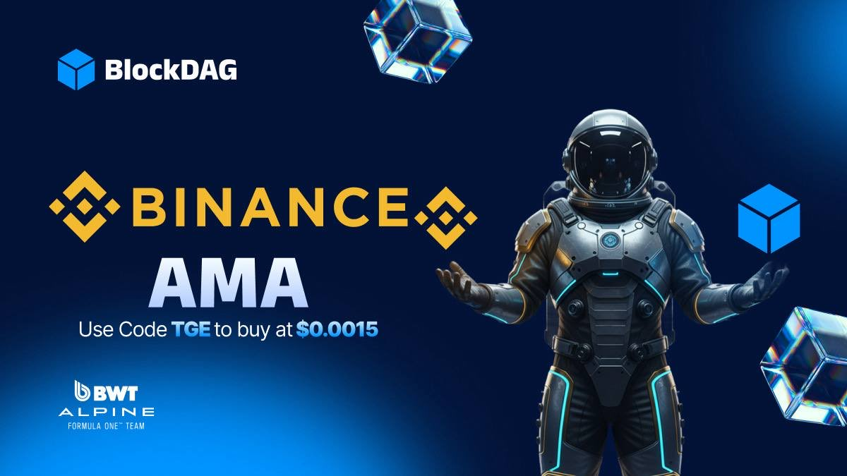
That’s where BlockDAG (BDAG) comes into focus. The project links progress with performance, aligning itself with champions. Through its major tie-up with the BWT Alpine Formula 1® Team, BlockDAG is stepping into elite territory.

Racing to the Top: BlockDAG’s F1® Deal
Partnerships tell what a project stands for, and BlockDAG’s bond with the BWT Alpine Formula 1® Team shows its drive for accuracy, speed, and victory. Formula 1® is known for its perfect engineering, where milliseconds count.

This isn’t just a deal for publicity, but it’s proof of shared goals. Just as F1® machines are tested under pressure, BlockDAG’s hybrid setup mixing Proof-of-Work with DAG design handles heavy loads while keeping performance smooth. Its “Awakening Testnet” already runs at 1,400 transactions per second and supports EVM developers worldwide, proving its readiness for scale.

Community trust is clear, too. BlockDAG has now raised $430M+, sold 27 billion+ coins, distributed over 20K+ miners, and reached 312K+ BDAG holders. The special price of $0.0015 in batch 31 is available for only a short time, giving early buyers a rare chance before launch. Add 3.5M+ X1 users, and it’s clear why many call BlockDAG the next crypto to explode.

Its strong presale and proven utility show why it’s gaining this much traction. By linking with a global F1® brand, BlockDAG positions itself for the podium, standing out as the top bullish coin of 2025 for those ready to move first.
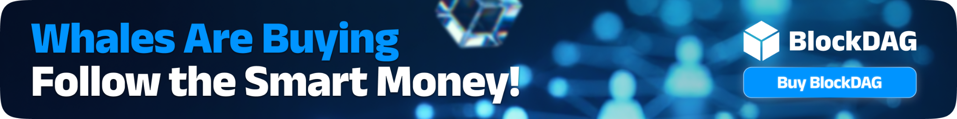
Adding to this momentum, BlockDAG is also set to go LIVE on Binance for an exclusive AMA this Friday, October 24 at 3PM UTC, marking one of its biggest global appearances yet. The session will feature insider updates, new roadmap reveals, and major insights ahead of Keynote 4: The Launch Note and GENESIS DAY. This is the moment the crypto world will be watching closely as BlockDAG takes the stage with Binance to unveil what’s next for its $430M+ ecosystem. Investors are urged to use code “TGE” to maximize their earnings before the dashboard upgrade and price increase, with BDAG still available at $0.0015 in Batch 31. The clock is ticking; secure your position before this milestone event ignites the next major wave of momentum.

Dogecoin (DOGE) Holds Near $0.23 as Traders Await
The Dogecoin (DOGE) pattern is tightening around the $0.20–$0.23 zone, showing calm before possible movement. Many see this as the setup before a breakout. Chart watchers note that while prices eased a bit, momentum indicators like RSI are climbing. This usually hints that sellers are losing control.

If DOGE can push past the $0.27–$0.29 range, analysts expect it to aim for $0.30–$0.35, a level that could renew faith in its upward strength. On the other hand, dropping below $0.23 might pull it back toward $0.22 before it tries again.
Overall, DOGE sits quietly but with energy building underneath. Traders know that such tightening phases often end with a strong move up or down. For now, the community waits to see which side breaks first.

Polygon (POL) Gains Energy with a Rebound Toward $0.35
Polygon’s (POL) chart has been shaping a symmetrical triangle pattern between $0.19 and $0.23, often a clue that a big shift is close. After several quiet sessions, POL surged about 12%, reclaiming the $0.20 mark and lifting optimism.
Analysts highlight stronger RSI readings and bullish MACD crossover signs that buying interest is growing again.

The Heimdall v2 upgrade, which shortened transaction finality to about five seconds, has added more confidence. This improvement supports faster DeFi actions and smoother on-chain activity. Still, the price must break past $0.23 with solid volume to confirm a real rally. If that happens, targets between $0.35 and $0.55 look achievable.

However, falling under $0.19 might drag the price near $0.16 again. With the POL transition replacing MATIC under the Polygon 2.0 roadmap, traders are closely tracking each move to see if this marks the start of a stronger cycle.

Why BlockDAG Leads as the Next Crypto to Explode
DOGE and POL show how crowd energy and ecosystem upgrades can shape price behavior. DOGE tightens near resistance, while POL regains momentum from technical strength. Each tells its own story of expectation and growth.

But BlockDAG is where attention truly shifts. Its F1® partnership, record-breaking $430M+ crypto presale, and powerful hybrid architecture underline a clear advantage. Backed by 27B+ coins sold, 20K+ miners, and 3.5M+ X1 users, BlockDAG’s community is expanding fast. Its goal isn’t just performance, it’s dominance.

The $0.0015 batch 31 offer gives one last window before the next phase. With speed, proof of real-world collaboration, and community energy, BlockDAG shows every sign of being the next crypto to explode, built for those who like to lead, not follow.

Presale: https://purchase.blockdag.network
Website: https://blockdag.network
Telegram: https://t.me/blockDAGnetworkOfficial
Discord: https://discord.gg/Q7BxghMVyu

