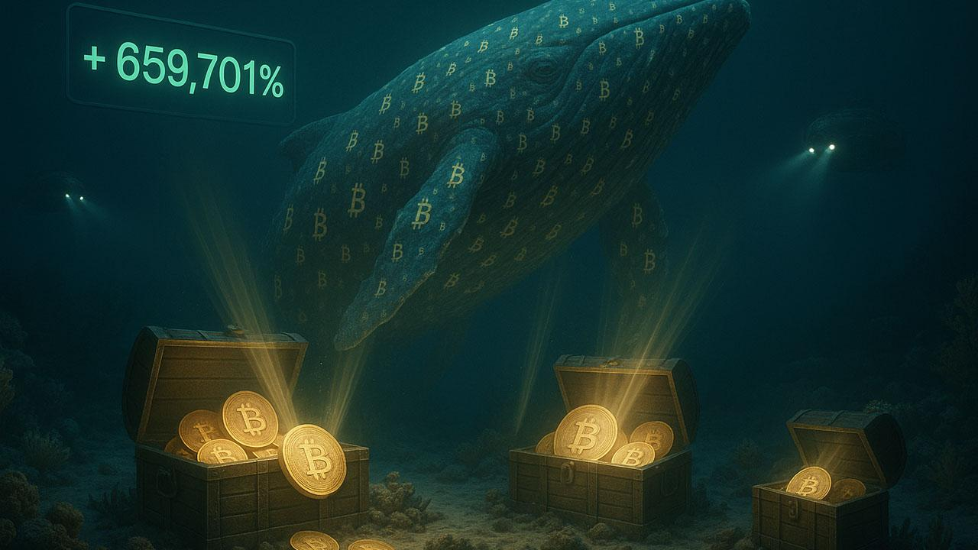$440 Million Bitcoin of Satoshi-Era Whale Awaken with Jaw-Dropping 659,701% Result
A Satoshi-era Bitcoin wallet has reawakened after more than 14.4 years of dormancy, moving 4,000 BTC worth $440 million into circulation. According to blockchain data from Onchain Lens, the coins were mined or accumulated when Bitcoin was sold for mere cents, meaning the anonymous whale is now sitting on a staggering 659,701% change compared to the original value.
The sudden reactivation got everyone talking across the market. The term "Satoshi-era" refers to the early days of Bitcoin, from January 2009 to December 2011, when its enigmatic creator was still active on forums. It doesn't confirm that the wallet belongs to Satoshi. But the sheer scale of the results and the reappearance of such an old stash has rattled some.
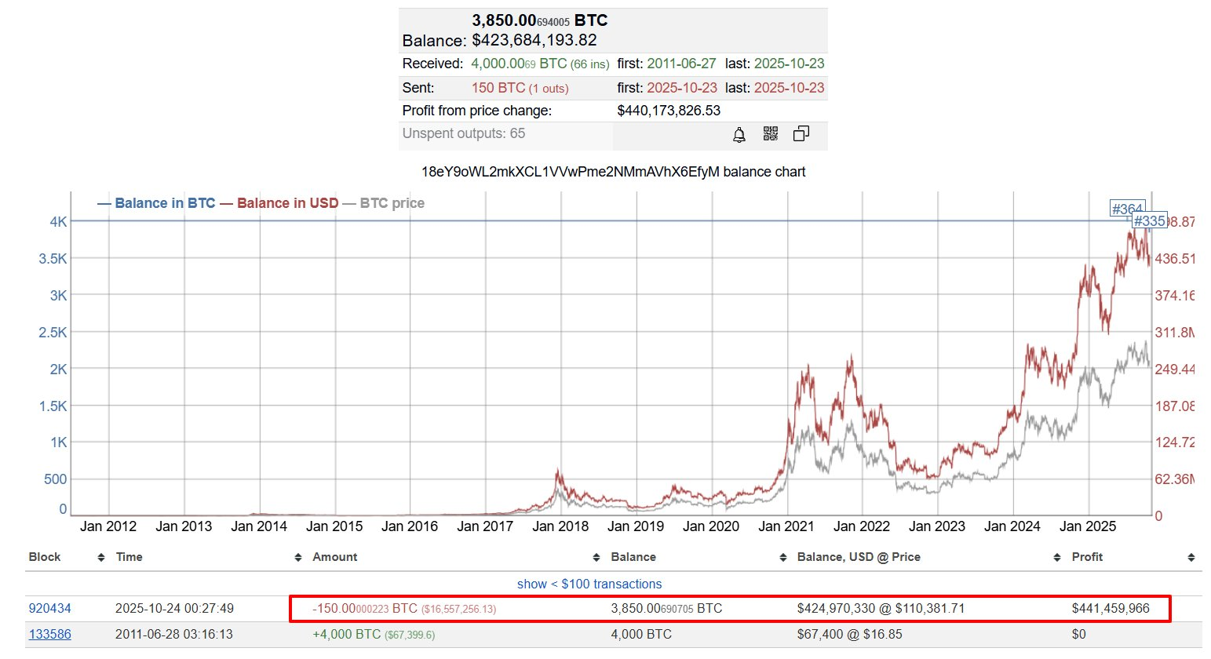
Reports say the whale has been selling coins bit by bit through a linked wallet that's already been credited with over 4,000 BTC. This is similar to what we've seen before, where OG holders are putting supply into the market. The timing has been tough on Bitcoin's price. Old sales are putting pressure on the price to go down, and BTC is having a hard time staying above $110,000. At the time of this writing, Bitcoin was selling near $111,260, according to CoinGecko.
James Check, an analyst, said that these old sell-offs might be the reason Bitcoin can't go higher. Meanwhile, the estimated fortune of Satoshi Nakamoto — who some say is no longer with us — has also taken a hit. His untouched holdings lost $20 billion in value during the most recent correction, showing that early supply still affects Bitcoin's market dynamics.

New Token Up 210% and Nears Halfway Mark to 6.44 Million USDT Goal
While whales move out old coins, new projects are attracting capital at scale. Minotaurus (MTAUR) has already surged from 0.00004 to 0.00012423 USDT during its presale — a 210% surge — with a confirmed listing price of 0.00020 USDT, leaving a 61% upside locked in for launch. At the current rate, 100 USDT secures 804,697 MTAUR, which will be worth significantly more once exchanges list the token.
The project has already accumulated 2,833,393 USDT out of a 6,440,000 USDT target, putting the project close to its halfway milestone. The live timer shows less than 13 hours before the price ticks up to 0.00014 USDT, narrowing the entry window at the current level. Unlike many presales, MTAUR is backed by a functioning product: a blockchain maze game where the token powers upgrades, consumables, and zone unlocks. Built on Binance Smart Chain, it offers low fees and instant confirmation times, vital for gameplay.
The structure is designed for long-term sustainability. Only 2% of supply goes to the team, 10% is allocated to the community through bonuses and referrals, and vesting plus cliff mechanisms prevent sudden dumps.
Independent audits from SolidProof and Coinsult verify security, while a 100,000 USDT giveaway fuels visibility. The community has already topped 20,000 members, signaling momentum that goes beyond speculation.

Could Minotaurus (MTAUR) create the next wave of millionaires?
At today’s presale price of 0.00012423 USDT, even modest allocations have asymmetric potential. If MTAUR mirrors the historic runs of XRP or ETH — with results exceeding 100,000% — then a 100 USDT entry could scale into six figures. Larger stakes of 1,000 or 10,000 USDT multiply those outcomes dramatically. With a working product, disciplined tokenomics, and rising adoption, MTAUR is shaping up as one of the rare presales where upside is defined not by old whale supply, but by new demand.
Buy MTAUR now or learn more at minotaurus.io.

