Ripple Enters Treasury Payments: Here’s XRP Price if It Gets 3% of This $120T Market
Ripple has announced the acquisition of GTreasury — a major treasury management firm serving global enterprises for over 40 years. This move gives Ripple direct access to the $120 trillion corporate treasury payments market, aiming to modernize how large companies manage liquidity and move capital globally.
According to Ripple CEO Brad Garlinghouse, today’s systems are slow and costly, while blockchain enables instant, low-cost value transfers. “Payments are where Ripple first began,” he wrote on X, confirming the company’s renewed focus on cross-border treasury flows.
If Ripple captures even 3% of this $120T market, about $3.6T in value could flow through its network. With XRP’s current market cap at $138.6B and price at $2.31, that would imply a theoretical price of around $62 per token — a massive leap illustrating XRP’s long-term upside.

Another Altcoin Heating Up: Minotaurus (MTAUR)
While XRP positions for trillion-dollar growth, Minotaurus (MTAUR) is building traction fast — already up by 3 times from its early price of 0.00004 to 0.00012472 USDT.
Why It’s Trending:
- Major exchange listing rumored
- Strategic gaming partnerships coming
- Short-term price target: 0.00124 USDT (≈10-fold potential)
Minotaurus is a Web3 gaming ecosystem inspired by Greek mythology, where players explore a labyrinth, battle mythical creatures, and accumulate in-game benefits. The project is fully audited by SolidProof and Coinsult, adding credibility to its growing hype.
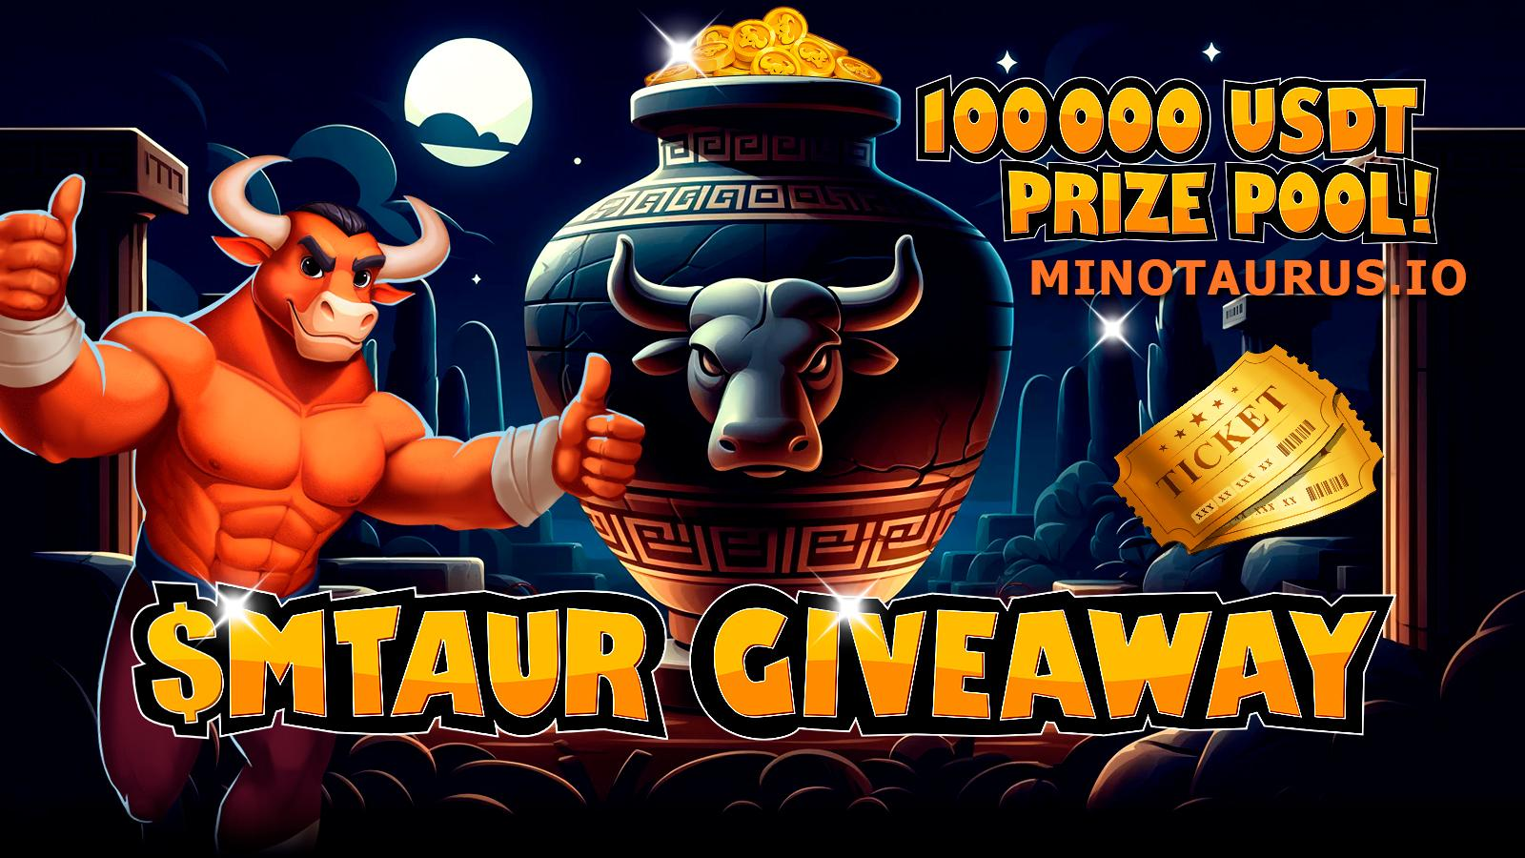

Conclusion: XRP Eyes the Trillions — MTAUR Could Be the Next 10-fold opportunity
Ripple’s move into corporate treasury payments opens a trillion-dollar potential for XRP. But for near-term excitement, MTAUR stands out as one of the most promising low-cap gaming tokens on the market.

