“Hold It Until It Reaches $1,000”: Crypto Founder’s Bold XRP Call as Analyst Signals a Bottom May Be Near
The XRP community is buzzing after EasyA co-founder Dom Kwok doubled down on his bold $1,000 price target, urging holders to remain patient. This audacious forecast comes just as a separate technical analyst, STEPHISCRYPTO, notes that XRP has entered a deeply "oversold" territory on its weekly chart—a setup that has historically preceded massive rallies.

The $1,000 Vision Meets "Oversold" Technicals
Kwok's comment came in a lighthearted X exchange where a user lamented that stores wouldn't accept his XRP. Kwok’s advice was simple: “Hold it until it reaches $1,000.” He and his brother have long defended this target, arguing that as institutional adoption expands post-regulatory clarity, billions in new demand could be unlocked.
This long-term bullishness is now meeting a short-term technical signal. Analyst STEPHISCRYPTO highlighted that the weekly Stochastic RSI has fallen into the "oversold" zone. The analyst’s chart showed how previous entries into this zone were followed by significant price appreciations, including moves of 94%, 110%, and even 600%. This suggests the current price near $2.45 may be in a bottoming phase.+
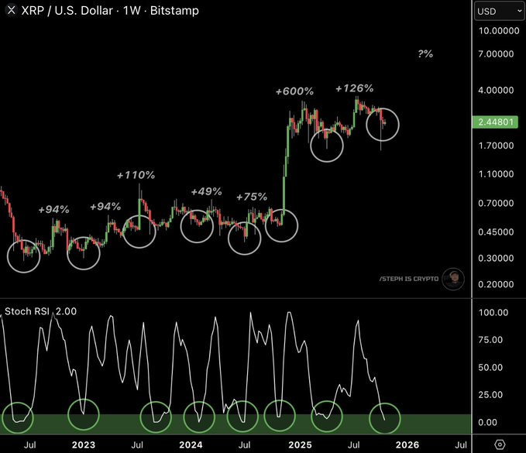

From 1,000 USDT Targets to Ground-Floor Structures: The Minotaurus (MTAUR) Narrative
The debate around XRP's potential highlights a market focused on long-term potential. This same search for foundational value is leading another segment of participants to new, low-cap projects like Minotaurus (MTAUR), which offers a completely different, ground-up model.
Minotaurus is a utility-first project on the BNB Chain, centered on a playable, mythology-themed game. Its credibility is reinforced by full audits from SolidProof and Coinsult, KYT verification, and a transparent tokenomics model.
The token sale is in a highly time-sensitive phase, with a live countdown showing just over 10 hours remaining. With over 2.84+ million USDT recorded in token sales out of a 6.44 million USDT target, the token is available at 0.00012475 USDT. The next stage price is 0.00014 USDT, and the planned listing price is 0.00020 USDT.
Here’s an illustration of the early-stage mechanics (purely illustrative, not a forecast):
- A 250 USDT allocation acquires roughly 2,004,000 MTAUR. If the token were to hypothetically reach 0.1 USDT after launch, that position could correspond to a notional value of around 200,400 USDT.
With a low initial market cap of 5.6 million USDT and a vibrant community of over 20,000 members, the project offers a compelling model.

