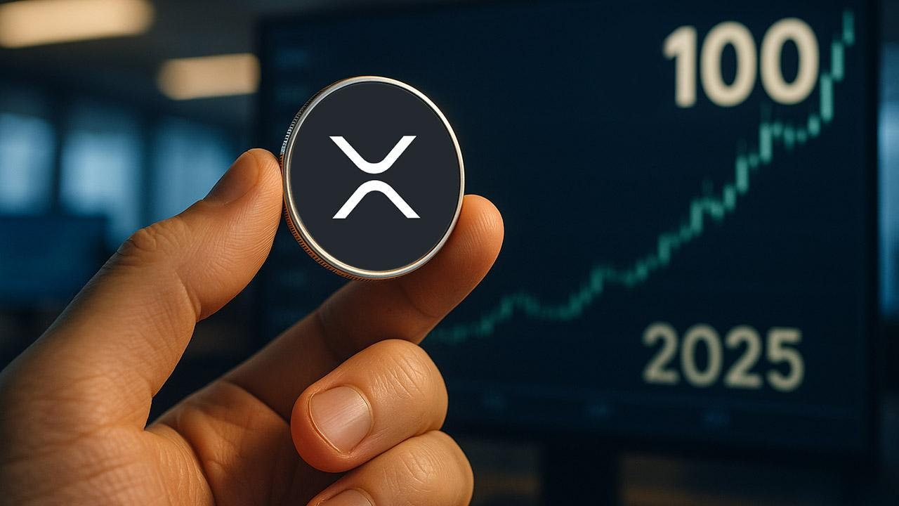Ripple News: XRP Price Could Hit $100 by End of 2025?
YouTuber Jake Claver has stunned the market with a bold forecast, saying XRP could reach $100 by the end of 2025 and even $1,500 in early 2026. His thesis rests on restructuring, ETF approvals, and institutional demand. Currently near $2.66, XRP is seen as preparing for a “supply shock.”
Claver highlights the XRP Ledger’s potential to modernize global payments, positioning it as a bridge for banks and corporations in instant cross-border settlement.
Skeptics argue that a $100 price requires a $6T market cap, but Claver points to a multiplier effect: $550B in fresh liquidity could drive leveraged demand, similar to Bitcoin’s early bull runs. Ripple’s $1.25B purchase of prime broker Hidden Road strengthens the case, giving giants like BlackRock regulated settlement access via XRPL.

Another High-Potential Token to Watch
While XRP eyes triple digits, Minotaurus (MTAUR) is quietly surging. The token has risen from 0.00004 to 0.00012476 USDT (+212%), with a 0.00020 USDT listing still giving 60% upside. Less than 9 hours remain before the next step to 0.00014 USDT. At today’s price, 100 USDT secures ~801,923 MTAUR.
Over 2,852,355 USDT has already been accumulated toward a 6.44M goal, backed by a working blockchain maze game, audits from SolidProof and Coinsult, and a 100,000 USDT giveaway.
See the live counter and join at minotaurus.io.

