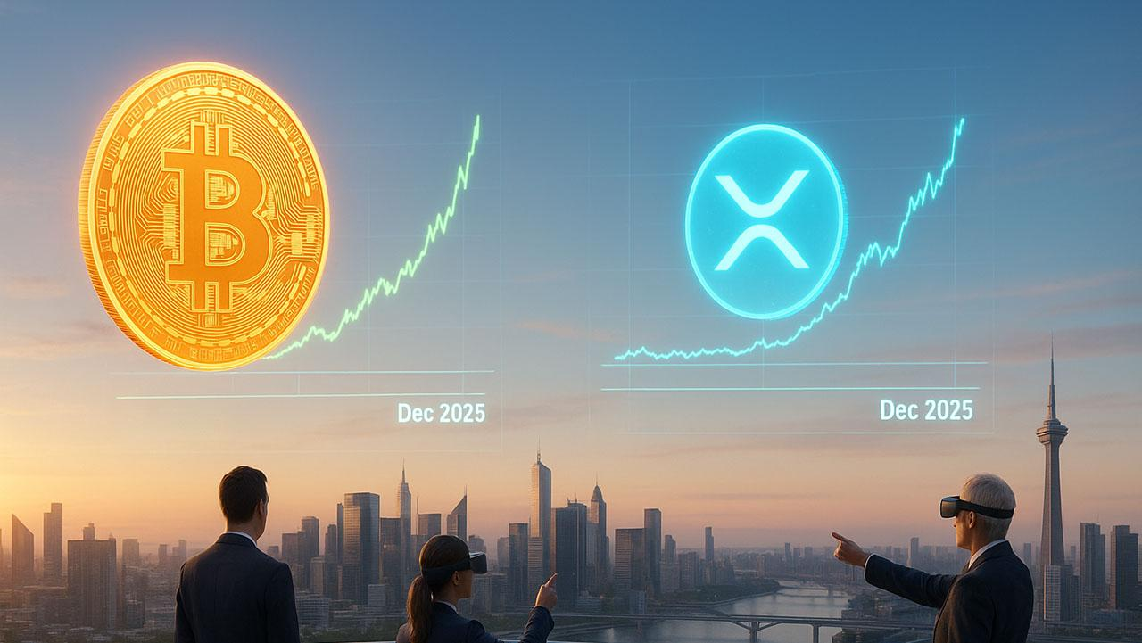Price Predictions: How High XRP and Bitcoin Could Go by December 2025
With Bitcoin briefly touching above $116,000 on Tuesday, analysts foresee a potential parabolic year-end rally. How top experts view Bitcoin and XRP by December.

Bitcoin To $200K by Christmas
MicroStrategy’s Michael Saylor expects Bitcoin to close 2025 above $150,000, citing accelerating institutional adoption. Fundstrat’s Tom Lee is more bullish, projecting $200,000 as ETF inflows, corporate demand, and post-rate-cut momentum fuel a holiday surge. Standard Chartered also forecasts $200,000 by year-end, calling this cycle institutionally driven.

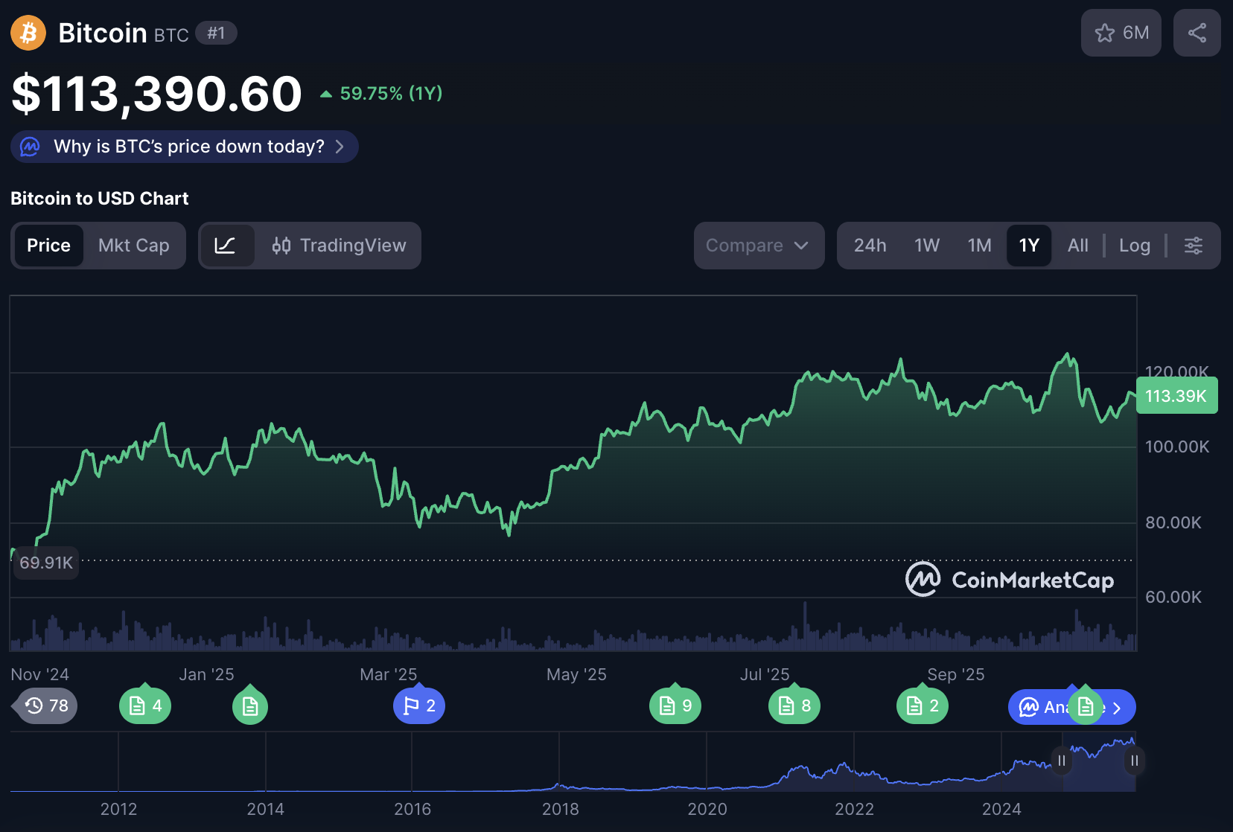

XRP to $50 with ETF Catalyst
Analysts like Zach Rector predict XRP could hit $5–$10 by year-end as real XRP ETFs launch, tightening supply and boosting demand. Influencers like Ash Crypto and Mario Nawfal see prices as high as $10, while optimistic forecasts suggest prices could reach $50.

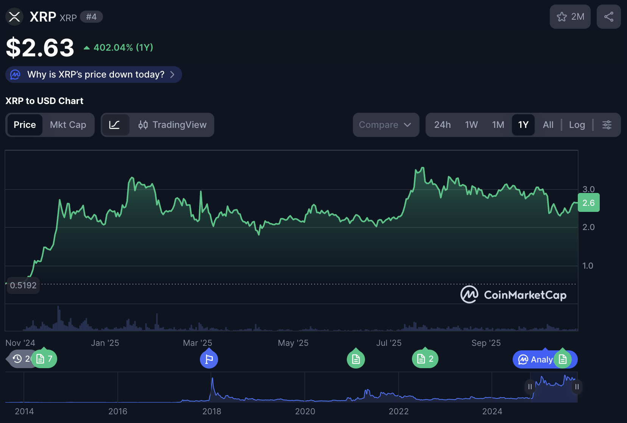

100x Coin for December 2025
Another coin with a promising outlook for December 2025 is Minotaurus (MTAUR). This blockchain gaming project has risen 250% in the past few months and sells at just 0.00012477 USDT. A 100 USDT stake buys over 800,000 tokens, which would be worth 10,000 USDT if MTAUR hits 0.0124.


Conclusion
Bitcoin could near $200K and XRP $15, but emerging tokens like Minotaurus may quietly deliver the year’s biggest percentage gains. Learn more from the official website.

