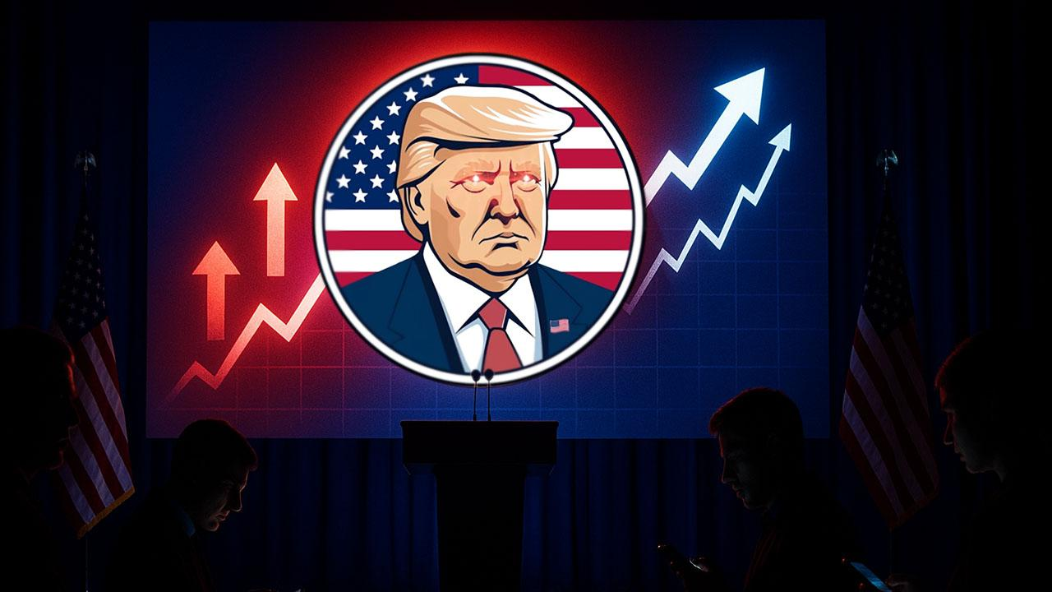The TRUMP Meme Coin Is Quietly Pumping—Why Is This Token Trending?
The OFFICIAL TRUMP token, a meme coin tied to US President Donald Trump, is quietly pumping. While other cryptocurrencies show price uncertainties, the token has attracted the attention of market participants, with its price following suit.
In the past 24 hours, TRUMP has risen by over 17%, outperforming all other assets in the top 55 of the cryptocurrency ranking by market cap. The token is also up a staggering 44% over the past 7 days, ranking as the top trending coin on CoinMarketCap for several consecutive days.

Why Is TRUMP in the Spotlight?
Positive sentiment is the major catalyst for this rally. Donald Trump recently pardoned Binance co-founder Changpeng “CZ” Zhao, a move that sparked bullish sentiment across the crypto ecosystem and also impacted TRUMP’s price trajectory.
Bullish sentiment from Trump’s dealings with China has also added to the allure, as sentiment holds that a positive outcome will be one less macroeconomic headwind to worry about. Also, whales bought TRUMP, moving their holdings from 3.97 million to 4.88 million tokens in the past few weeks.

Why Is This Token Trending?
Meanwhile, Minotaurus (MTAUR) is trending. Minotaurus’ perfect blend of blockchain technology and Web3 gaming, promising a niche and an exceedingly fair entry price, offers massive benefits for those who buy now.
For instance, the token sells at 0.00012478 USDT, and 1,000 USDT would buy you 8.06 million MTAUR. Let's imagine that it captures 10% of the $29 billion casual gaming sector projected by 2029; it would turn the 1,000 USDT into 51.78 million USDT.
Learn more at minotaurus.io.

