Bitcoin falls below $100,000, investors turn to Anchor Mining to earn $5,800 a day.

Early this morning, the price of Bitcoin fell below $100,000, triggering market panic. Many short-term investors cut their losses and exited the market, while some turned to a more stable strategy – Anchor Mining. Compared to frequently chasing highs and lows, steadily accumulating assets through long-term returns is more reliable. Cloud mining eliminates the need for purchasing and maintaining mining rigs, provides real-time computing power revenue, and is gradually becoming a new way to generate passive income from digital assets.



A New Era of Mining: Everyone Can Own "Computing Power Assets"
Traditional mining used to be a "game for tech enthusiasts," requiring expensive equipment, electricity costs, and complex blockchain configurations. Now, Anchor Mining is changing everything. Through cloud computing power + AI intelligent optimization systems, you don't need any equipment or technical expertise. Just a few minutes of registration is all it takes to start earning money with your computing power. Whether you're at work, resting, or on vacation, your earnings accumulate automatically. This is the power of "earning money with your time."

Three Steps to Start Your Automated Mining Journey
Step 1: Register and Receive $18 in Free Computing Power. Simply enter your email address to complete registration and immediately receive a $18 free computing power trial package. Experience real earnings without investment.

Step 2: Select a contract to lock in daily earnings. Anchor Mining offers flexible contract options to meet different funding needs and investment periods:

New User Agreement: Investment Amount: $100, Contract Term: 2 days, Total Profit: $100 + $6

Antminer U3S23 hyd: Investment Amount: $600, Contract Term: 6 days, Total Return: $600 + $48.6

Whatsminer M50: Investment Amount: $1,300, Contract Term: 12 days, Total Return: $1,300 + $218.4

Avalon Miner A1446-136T: Investment Amount: $3,300, Contract Term: 16 days, Total Return: $3,300 + $765.6

Whatsminer M60S: Investment Amount: $5,700, Contract Term: 20 days, Total Return: $5,700 + $1,710

ANTMINER S21 XP Hyd: Investment Amount: $9,700 Contract Term: 27 days Total Return: $9,700 + $4,190.4
After selecting the plan, the system will automatically run mining tasks in the background, with daily settlement and daily dividends.

Step 3: Earnings will be automatically deposited into your account. You can freely withdraw or reinvest them. When your account balance exceeds $100, you can withdraw it to your crypto wallet at any time, or reinvest it in higher-level contracts to achieve compound interest growth and multiply your earnings. Click to view detailed contract earnings.

Anchor Mining's Five Core Advantages
Global Trust, Compliant Operation: Legally operating in 180+ countries and regions worldwide, complying with international crypto asset compliance standards, ensuring the investment security and transparent returns for every user.

Bank-Grade Security System: Utilizing McAfee® security defense + Cloudflare® cloud firewall, a multi-layered encryption system ensures worry-free account and fund security.

Green Energy Driven, Low-Carbon Mining: All data centers utilize clean hydropower, wind power, and solar power, achieving a perfect balance between environmentally friendly mining and sustainable returns.

AI Intelligent Computing Power Scheduling: The platform's AI monitors market difficulty, electricity costs, and block rewards in real time, dynamically optimizing computing power allocation to ensure your mining profits are always at their highest.

Affiliate Program: Share computing power, share wealth. Through the Anchor Mining Affiliate Program, you can invite friends to register for mining and receive instant referral rewards + long-term profit sharing, unlocking up to $60,000 in affiliate bonuses.
Even without investing yourself, you can earn stable passive income through referral links.
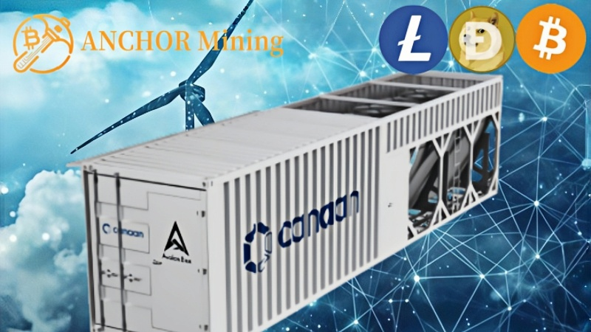
A Side Hustle Revolution of "Earn Money While You Sleep"
Anchor Mining allows ordinary people to enjoy institutional-level mining capabilities. It's not high-risk speculation, but a visible, controllable, and sustainable intelligent way to generate income. You don't need to stay up all night trading cryptocurrencies, you don't need to study candlestick charts, you just need to let AI computing power work for you—turning time itself into your cash flow.

Register now and receive $18 in free computing power to start your AI mining journey!
Website: anchormining.com
Email: info@anchormining.com
Anchor Mining – Making every second count.

