Solana ETFs Soar with $200M Inflows as U.S. Spot XRP ETFs Eye Mid-November Launch
Solana (SOL) ETFs have attracted $200 million inflows within days. Bitwise’s BSOL leads the charge, pulling in $197 million during its first week. On October 31 alone, it added $44 million amid strong confidence.
BSOL boasts a staking feature that gives 8% annually through Solana network validation. This gives Bitwise a notable edge over traditional crypto ETFs.
Meanwhile, Grayscale Solana ETF recorded $2.2 million in inflows since its debut, contributing to a combined Solana ETF valuation exceeding $500 million.

XRP ETFs Next
Following Solana, XRP is poised for its own spot ETF launch. Franklin, Bitwise, and Canary Capital are set for November 13 debuts.
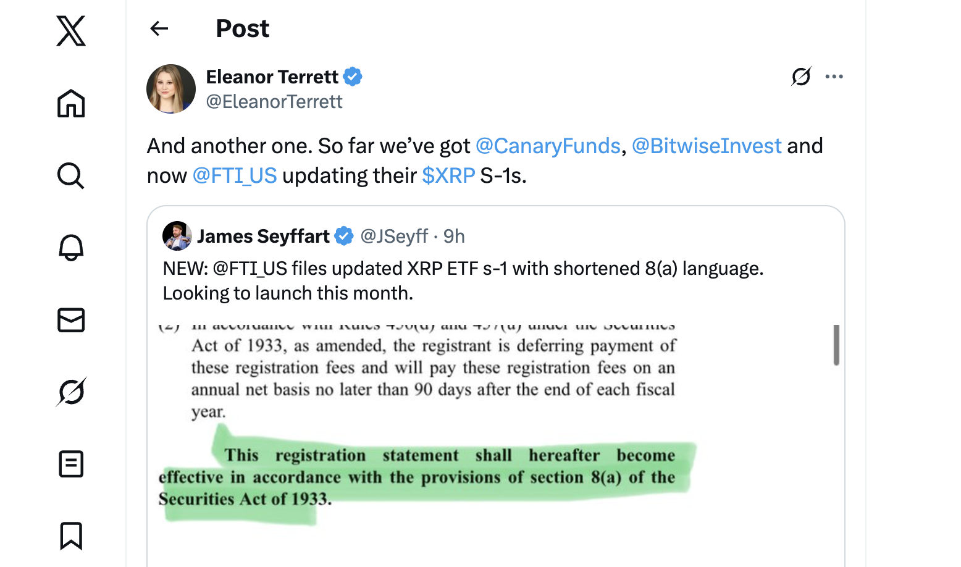
Recent government delays in SEC processing have been mitigated through auto-effective filings, allowing approvals to proceed.
Analysts predict XRP ETFs could channel billions in new institutional capital, driving market activity for the token and marking another step in mainstream crypto adoption.

Next Early-Stage Breakout Opportunity
Meanwhile, Minotaurus (MTAUR) is gaining attention as an early-stage project. The gaming project allows players to explore mazes, defeat mythic beasts, and unlock items using the native token.
Currently priced at 0.00012484 USDT, MTAUR has tripled from earlier levels, with the team planning top-tier exchange listings and strategic partnerships.
With a market cap of just 5.6 million, the project has room for substantial growth. It is fully audited by SolidProof and Coinsult, offering early exposure to a project that combines gaming, Web3, and blockchain innovation. Learn more.


