🇯🇵 Japan officially supports Bitcoin mining – see how BlackchainMining helps investors earn $10,000 a day!

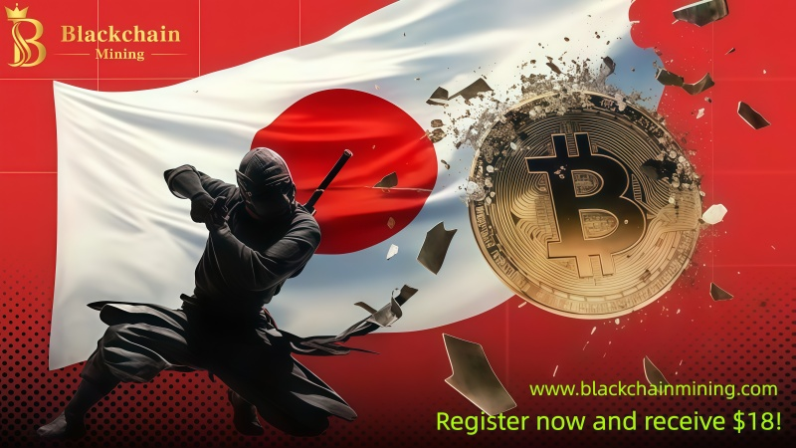

With Japan becoming the 11th country globally to officially support government-backed Bitcoin mining, a trend that has continued to grow since 2020, participating countries include Iran, Bhutan, El Salvador, the UAE, Oman, Ethiopia, Argentina, Kenya, France, and Russia. The cryptocurrency industry has achieved another historic breakthrough. This policy not only signifies that Bitcoin mining is moving towards mainstream adoption, but also opens up new wealth opportunities for global investors.

In this "computing power revolution," BlackchainMining, a leading global cloud mining platform, is becoming one of the world's most popular digital asset appreciation platforms due to its high returns, strong security, and extremely convenient investment experience.

🇯🇵The Japanese government enters a new phase of global mining – trusting BlackchainMining cloud mining.

The Japanese government's official support signifies that Bitcoin mining has risen from a private activity to a national economic strategy. Driven by policy, energy, and technology, Japan is actively participating in blockchain infrastructure development.

This is reshaping the global mining landscape: from national mining projects to individual cloud computing power investments, the barriers to entry are constantly being lowered, and profit models are becoming increasingly diversified. For ordinary investors, participating in mining has become easier and more efficient than ever before, thanks to international platforms like BlackchainMining.

BlackchainMining is a leading platform integrating blockchain technology, cloud computing power, and financial innovation, focusing on providing secure, transparent, and automated digital asset mining services to users worldwide.

Users do not need to purchase mining machines or build mining farms; they only need to register online and purchase computing power contracts to achieve automated profit distribution. The platform offers stable returns, instant settlement, and supports withdrawals in multiple currencies, making it one of the most promising mining investment platforms currently available.

Japan strongly supports crypto mining: BlackchainMining's eight key benefits revealed.

● Registration Bonus: New users receive $18 instantly.
Register now to receive an $18 bonus, allowing you to immediately begin your investment experience without any additional steps, making it easy for new users to enter the world of crypto yield farming.

● Daily Check-in: Easily earn $0.72 daily.
The platform offers daily check-in rewards; users can earn at least $0.72 in cash simply by logging in each day, achieving "earn with zero investment."

● Referral Bonus: Earn up to $18,000 per month.
BlackchainMining's referral program is highly attractive:
Direct Referral Bonus: 3%;
Indirect Referral Bonus: 2%;
Monthly Referral Bonus: The more you invite, the higher your earnings, up to $18,000/month.
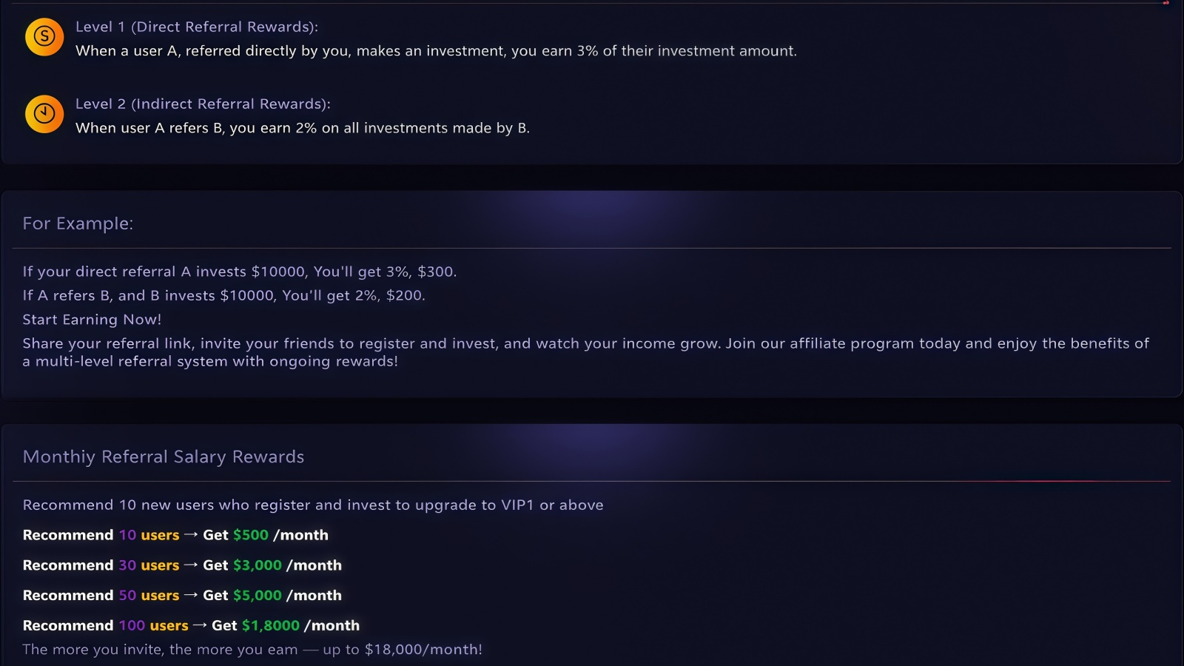
This means you can not only earn money through mining but also build a sustainable passive income system through promotion.

● Multi-Currency Settlement: Supports 9 Major Cryptocurrencies The platform supports settlement with multiple major cryptocurrencies, including:
USDT-TRC20, BTC, ETH, LTC, XRP, USDC, USDT-ERC20, BCH, DOGE, and SOL.

Users can freely choose their payment method, making global fund transfers more convenient.

● Fund Security: 100% Principal + Interest Guaranteed
BlackchainMining offers a full principal and interest guarantee mechanism. Interest is calculated daily during the contract period, and returns are distributed in real time.

All returns can be withdrawn at any time, arriving 24/7, ensuring both liquidity and security.

● 24/7 Customer Support
Whether it's registration, deposit, contract selection, or withdrawal issues, the platform provides 24/7 online customer service to answer your questions in real time, ensuring worry-free investment.

● Automated Mining System, Zero Technical Barrier
BlackchainMining uses an intelligent mining system that automatically allocates computing power and settles returns. Users do not need to understand blockchain technology; simply start with one click to achieve true "passive income."

● Flexible Contracts, Attractive Returns
The platform offers a variety of mining contracts suitable for different types of investors:
Beginner Experience Contract: Invest $100, net profit of $6 in 2 days;
Antminer T19 Contract: Invest $500, net profit of $40.5 in 6 days;
Avalon 1466 Contract: Invest $1100, net profit of $184.8 in 12 days;
Whatsminer M60 Contract: Invest $2600, net profit of $484.8 in 12 days.
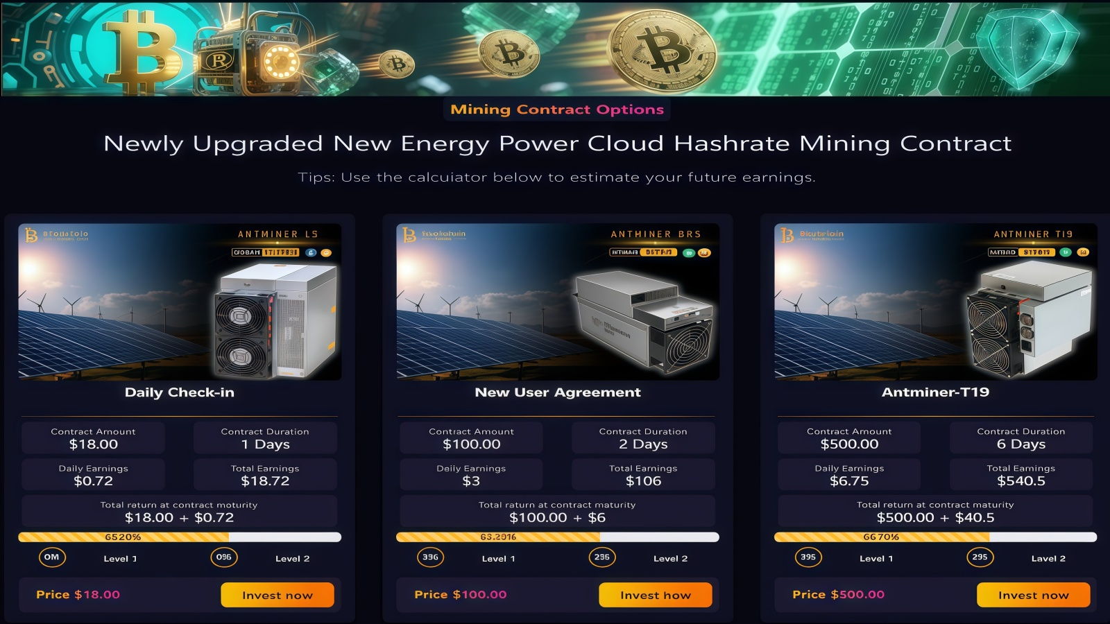
All contract returns are clearly verifiable, with real-time profit settlement, ensuring transparency and reliability.

Favorable global policies + platform advantages: a double wealth opportunity

Japan's entry signifies that major global economies have officially embraced the crypto economy. In the future, with further policy relaxation, energy structure optimization, and the widespread adoption of blockchain technology, the mining industry will usher in a new golden age.

BlackchainMining is at the center of this wave:

● Technologically superior to its peers;

● Higher returns than traditional wealth management;

● More transparent and secure business model.

Whether you are a novice or a seasoned investor, you can find a suitable path to profitability here.

Conclusion:

Japan's policy shift is a significant signal of the maturing global crypto market. At this historical juncture, choosing the right platform is crucial.

BlackchainMining not only makes mining safer, more efficient, and smarter, but also provides global investors with a truly sustainable path to digital wealth growth through its rich reward mechanisms, transparent contract system, and powerful technology.

No need to worry about market fluctuations or spend time on operations—let computing power work for you, and let your earnings grow automatically every day. Bringing global wealth to you is as simple as drinking coffee every day.

Register now and receive an $18 bonus. Start creating your new digital wealth future with BlackchainMining today!

Official Website：www.blackchainmining.com

Download App：https://blackchainmining.com/xml/index.html#/affiliate

