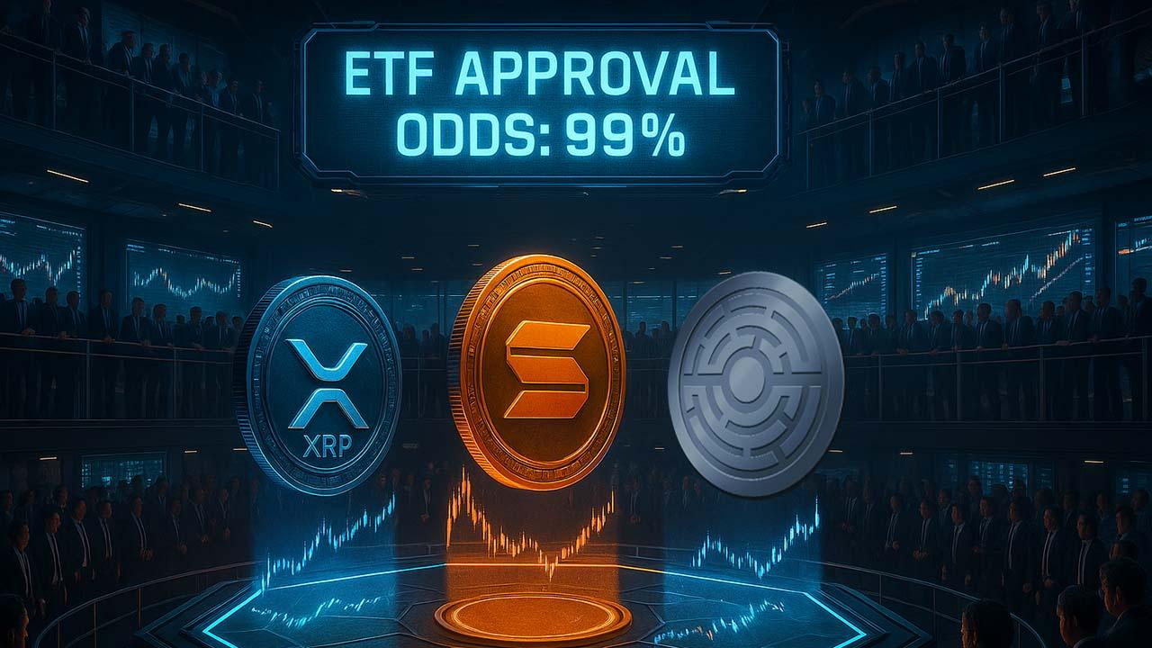XRP ETF, Solana ETF Odds at 99%: Can Approval See SOL, XRP Price Road to ATH?
Meta Description: With XRP and Solana ETFs nearing approval, price breakouts could follow. Will these ETFs pave the way for new ATHs?
With the surging momentum behind XRP and Solana ETFs, the potential for price rallies seems increasingly likely.
Canary Capital, Franklin Templeton, and Bitwise are all pushing to launch the first U.S.ETF, with approval from the Nasdaq expected as early as November 13 which could lead to substantial price movements for both XRP, Solana and new crypto Minotaurus (MTAUR).

XRP ETF Approval Likely to Drive Institutional Rallies
Canary Capital, after filing its S-1 registration update with the crypto regulation agency, is leading the race to launch the first U.S. XRP ETF. CEO Steven McClurg forecasts that the XRP ETF could attract as much as $10 billion in inflows in the first month of transacting.
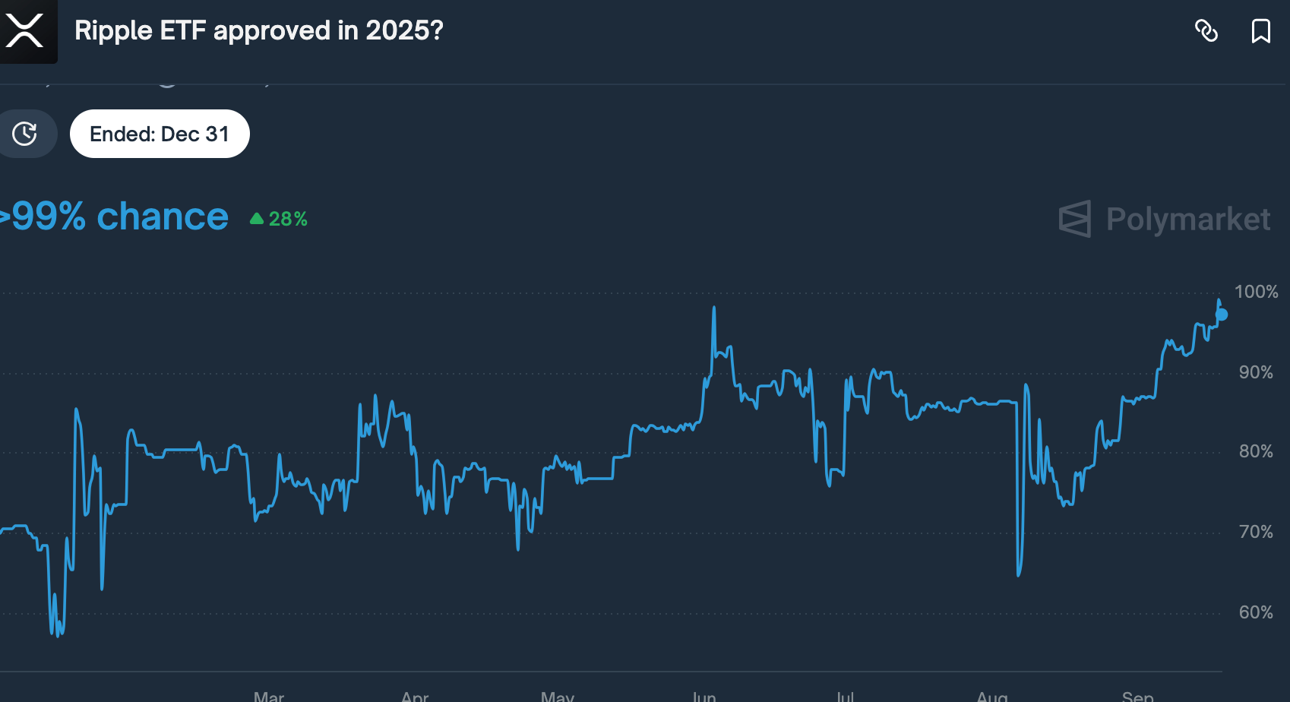
Source: Polymarket
The possibility of this ETF, which are 99% odds on polymarket becoming the gateway for mainstream adoption of XRP could trigger a substantial price rise for the token to new ATH.

Minotaurus (MTAUR): A Rising Star for Retail Holders
While XRP and Solana are making waves with institutional holders, another emerging token is capturing the attention of retail buyers: Minotaurus (MTAUR). Minotaurus has already gotten over 2.9 million USDT, with the goal of reaching 6.44 million USDT.
Minotaurus has passed 100% audits by SolidProof and Coinsult, ensuring that it is a secure and trustworthy holdings. Right now early price is 0.00012485 USDT, and it is expected to surge to 0.00014 USDT soon.
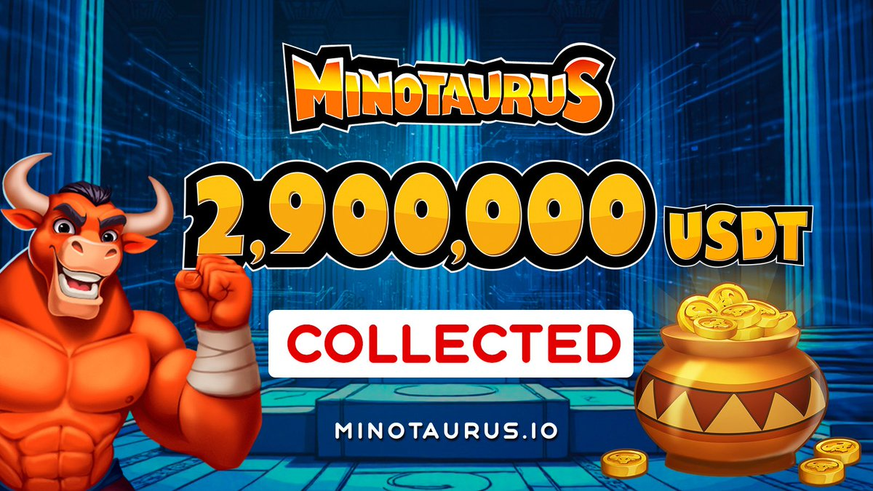
For retail holders, Minotaurus offers an affordable entry point with potential long-term surge. For example, with 10 USDT, holders can acquire approximately 80,000 MTAUR tokens, while 20 USDT would provide around 160,000 tokens.

Conclusion
Consequently, Minotaurus presents a great opportunity for retail holders who are looking for affordable tokens with solid surge potential. The project’s transparency, affordable pricing, and audit verification make it one of the best cryptos to buy before its full listing.

