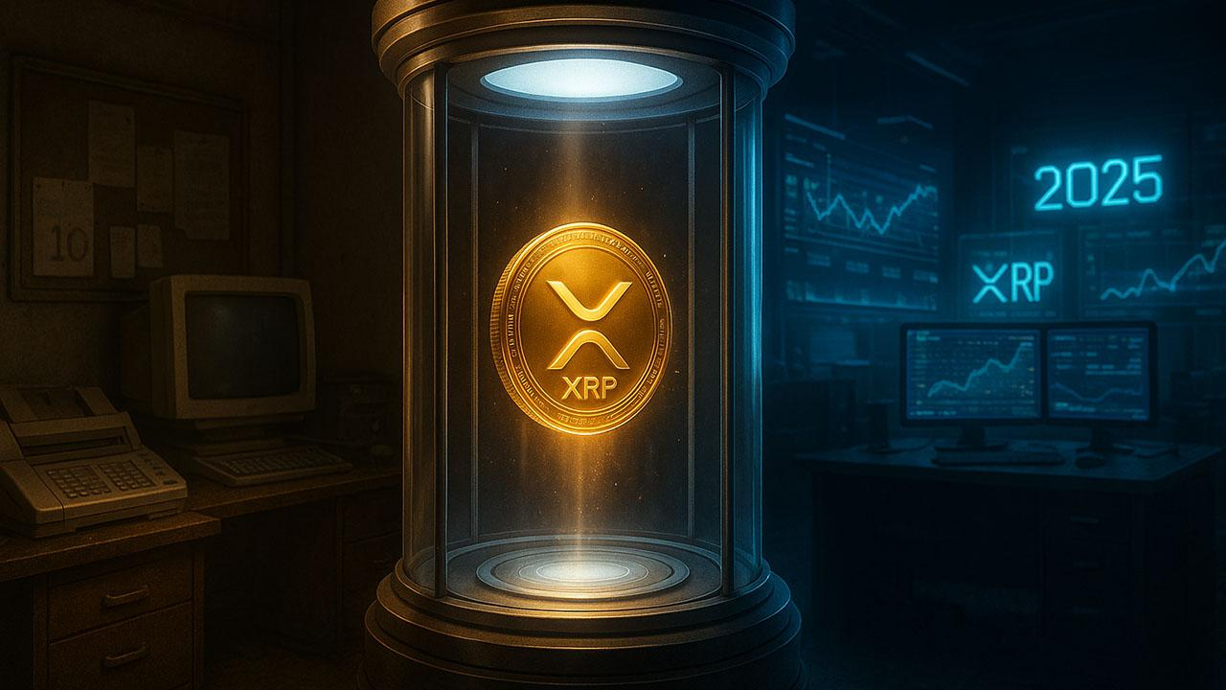Buying XRP Now Is Like Buying It at $0.005 in 2016: Analyst
Analyst XRP Nation has compared today’s price of $2.30 to its 2016 value of $0.005, suggesting this moment could mirror the token’s earliest, most profitable days.
Back then, XRP rose from fractions of a cent to $3.84 in 2018, marking a 75,000% surge. According to XRP Nation, today’s buyers may be on the verge of another generational opportunity.
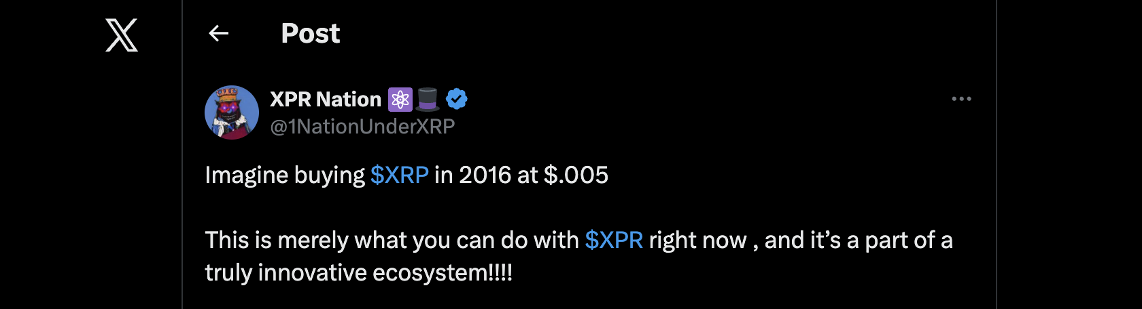

XRP Today is Bitcoin under $0.05
Analyst Dustin Layton supports this outlook, noting that quiet mid-cycle phases often precede explosive rallies. He likened XRP’s current setup to Bitcoin’s sub-$0.05 era, when patient holders saw life-changing upsides.
Historically, XRP has shown multi-year symmetrical triangle patterns that led to major rallies:
- 2013–2014: 600% gain
- 2014–2017: 75,000% surge to $3.84
- 2018–2025: 600% so far, from $0.50 to $3.66
If this pattern continues, analysts such as Javon Marks foresee targets between $20 and $250, with some extreme projections exceeding $1,000.

New Contender with A More Realistic 75,000% Scenario
However, newer altcoins may offer the kind of exponential upside XRP once had. A standout is Minotaurus (MTAUR), a gaming project on the Binance Smart Chain. Audited by SolidProof and Coinsult, MTAUR sells at 0.00012485, up 3X from its early phase, with a market cap of only 5.6 million.
MTAUR’s potential is fueled by upcoming exchange listings, adoption partnerships, and strong ecosystem utility through its maze-navigation game. A 100 USDT buy today could yield 75,000 USDT if it mirrors XRP’s 75,000% surge.
Early entries have historically delivered massive upsurges. After XRP, the next explosive opportunity may come from MTAUR. Learn more.


