1
Navigate Market Volatility, Harvest Steady Returns: How Oak Mining Cloud Mining Helps BTC Holders Generate Daily 9780USD Cash Flow

In the cryptocurrency space, Bitcoin (BTC) maintains an unshakable position, often hailed as digital gold. However, its significant price fluctuations present a dilemma for many long-term holders: should they continue "holding for potential gains" or attempt tactical trading? Both approaches come with uncertainty and inherent risks. Today, an innovative method for asset appreciation—cloud mining—is quietly changing this landscape. It helps BTC holders transform static assets into interest-bearing capital that continuously generates USD cash flow, ushering in a new paradigm of daily stable returns.


While Bitcoin's long-term value is widely acknowledged, its short-term price volatility is intense, leaving many investors grappling with the difficulty of "realizing paper profits." Numerous BTC holders are reluctant to sell their assets prematurely yet seek more predictable, stable returns during the holding period to optimize asset allocation and reduce overall risk.

Traditional mining was once a way to acquire Bitcoin, but its high hardware costs, persistently rising electricity fees, complex operational management, and issues like noise pollution have made it inaccessible for the average investor.

Cloud Mining: The Innovative Solution for Steady Returns

Cloud mining has emerged as an ideal solution, offering unique advantages for BTC holders. Users simply purchase or lease hashrate through a platform to access professional mining services—no need for hands-on hardware management. They automatically receive corresponding Bitcoin outputs daily.

As a leading platform in the industry, Oak Mining has further refined this model, creating an efficient, transparent, and stable passive income channel for its users.

Want to learn more about how Oak Mining can help you achieve asset appreciation? Click here to explore high-yield hashrate plans!

How Oak Mining Delivers Daily USD Returns

Asset Activation: Turn Static BTC into Interest-Bearing Capital
Idle BTC sitting in a wallet is a static store of value. Through Oak Mining, you can allocate a portion of your BTC into cloud hashrate contracts, transforming it into an active asset that continuously generates new Bitcoin.

Navigate Cycles with Daily Stable Output
Regardless of market fluctuations, as long as the Bitcoin network is operational, your hashrate is continuously creating value. Oak Mining automatically distributes mining rewards daily based on your share of the hashrate. This model proves particularly advantageous during market downturns—you can accumulate more BTC through daily production, positioning yourself for future bullish cycles.

USD Denomination for Clear Profit Tracking
Oak Mining provides an intuitive earnings dashboard, converting daily BTC output into its USD equivalent value at real-time prices. This allows you to clearly track your daily cash flow, enabling transparent wealth growth management.

Simplified Operation, Hassle-Free Experience

Zero Technical Barriers: No need to research miner models or hunt for cheap electricity.

One-Click Purchase: Easy selection of hashrate contracts, supported by BTC or fiat payments.

Fully Automated Operations: Professional teams handle equipment maintenance and upgrades.

Transparent & Trustworthy: All earnings and distribution records are publicly verifiable based on blockchain technology.

Earnings Plans: Flexible, Transparent, Fueling Steady Wealth Growth

Oak Mining offers a variety of contract options to meet the needs of different investors:
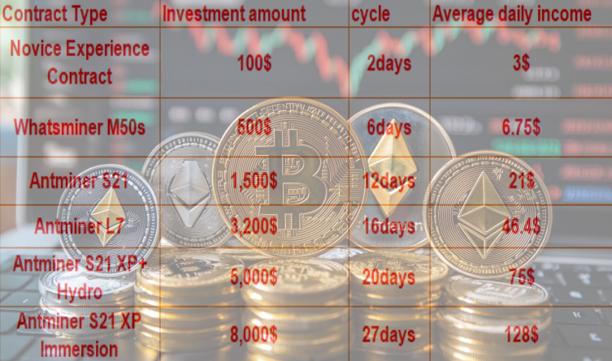
Reinvest your daily earnings to harness the power of compounding and accelerate your growth.

Users can accelerate wealth accumulation through earnings reinvestment and compound interest mechanisms. Some advanced investors have already achieved daily returns exceeding $5,000.

Check the detailed terms for all high-yield hashrate contracts listed above and start your mining journey now!

Top 5 Reasons to Choose Oak Mining

Stable Daily Returns: Receive USD-denominated payouts every 24 hours, navigating market volatility.

Zero Hardware Investment: 100% cloud-based operation—say goodbye to equipment, maintenance, and electricity bills.

AI-Powered Optimization: Dynamically adjusts hashrate allocation to maximize mining efficiency.

Compliant & Green Mining: Adheres to MiCA regulations, utilizes renewable energy sources, and aligns with ESG standards.

Mobile Convenience: Monitor your earnings in real-time via the App, managing your assets anytime, anywhere.

Who is This For?

Long-Term HODLers: Want to generate cash flow without selling their coins.

Passive Income Seekers: Conservative investors pursuing low-risk, stable returns.

Crypto Newcomers: No mining experience, seeking a quick start to earn returns.

Traditional Finance Users: Looking for compliant, transparent channels for crypto asset allocation.

Usher in a New Era of Intelligent Wealth Growth

Against the backdrop of heightened market uncertainty, Oak Mining, leveraging the triple advantages of "AI Technology + Compliant Operations + Green Energy," paves a stable, automated path to returns for BTC holders. Whether you are new to crypto or a seasoned investor, you can utilize this platform to convert market volatility into a driving force for sustained wealth growth.

For more information, please visit our official website: OakMining.com

Or contact us at: info@oakmining.com



