Solana Price Dips Despite ETF Approval, Buyers Turn To Minotaurus (MTAUR)
Solana (SOL) has slipped into the $150–$160 range even after ETF approval, struggling to hold key support. Despite growing institutional demand, SOL remains under pressure, unable to break resistance near $170. Analysts see a possible rebound toward $175–$185 if buying strength returns, though a drop below $150 could send it to $140.
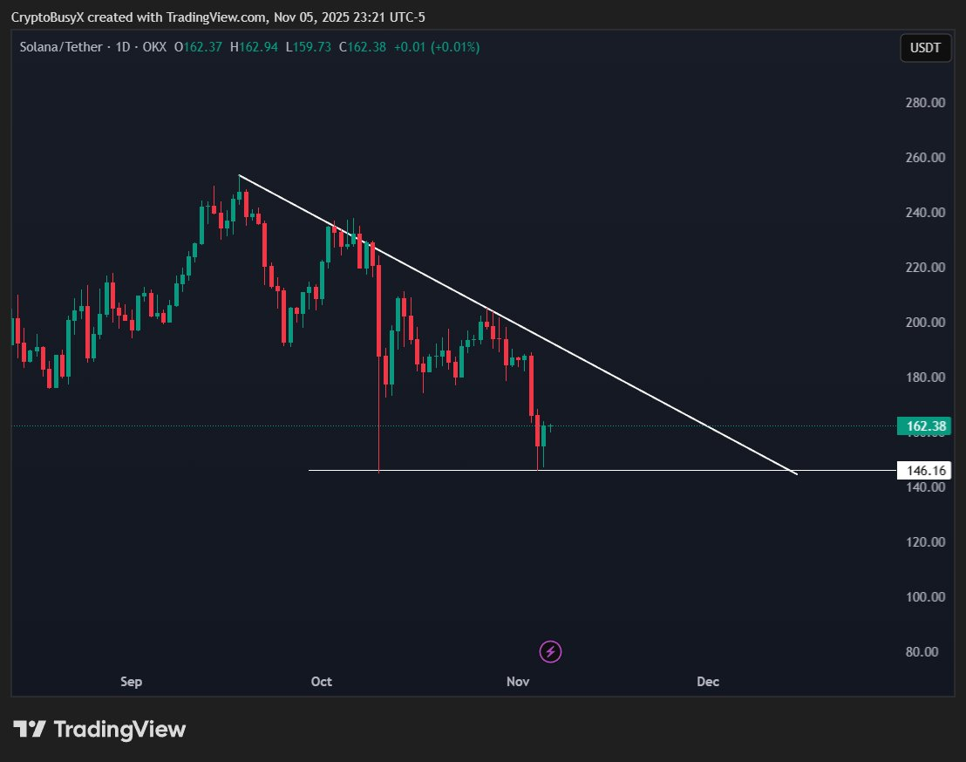
Source: X
As Solana consolidates, buyers are shifting attention to Minotaurus (MTAUR) — a fast-rising Web3 gaming token on the Binance Smart Chain. The project blends blockchain gameplay with NFT-based rewards, attracting strong retail demand.

Minotaurus (MTAUR): The Best Crypto to Buy Before 2026
The MTAUR presale has already exceeded 2.9 million USDT, with tokens priced at 0.00012485 USDT and set to rise to 0.00014 USDT in the next stage. Backed by full audits from SolidProof and Coinsult, Minotaurus combines low cost, transparency, and real in-game utility. Analysts view it as one of the most promising sub-$1 cryptos ahead of 2026 listings.
