Learn how to make money online: Arc Miner will guide you on the path to earning $10,000 a day.

(UK, November 2025) – In an era of ever-evolving digital economy, more and more people are seeking new sources of passive income. Arc Miner, a UK-registered and compliant cloud mining platform, is leading this digital wealth revolution, providing investors with a legal, secure, and intelligent way to mine cryptocurrencies.

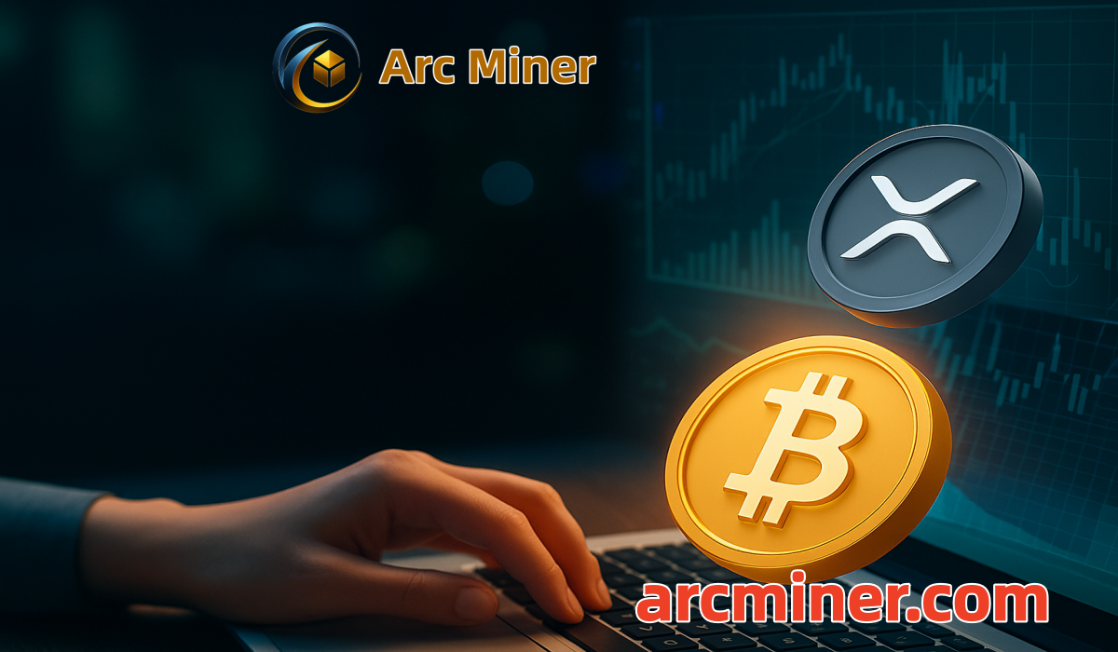

Arc Miner eliminates the need for users to purchase expensive mining rigs or bear high electricity and maintenance costs. Through its AI cloud computing system, the platform automatically allocates optimal mining strategies to ensure maximum returns. Whether it's BTC, ETH, XRP, USDT, DOGE, or other mainstream tokens, users can achieve daily settlement of earnings using only a mobile phone, truly making "assets work for you automatically."

Eight Advantages of Choosing Arc Miner:
1. AI Intelligent Computing System – Automatically identifies the optimal mining strategy and dynamically allocates resources to maximize profits.
2. Flexible Support for Multiple Currencies for Deposits and Withdrawals: USDT (TRC20 / ERC20), BTC, ETH, XRP, LTC, BCH, DOGE, SOL, USDC, etc.
3. Green Energy Driven – Utilizes renewable energy sources such as wind, hydro, and solar power to create an environmentally friendly and efficient mining system.
4. Bank-Grade Security System – Employs SSL financial encryption and multi-layered data isolation to ensure the absolute security of user accounts and funds.
5. Global Platform Strength – Over 6 years of stable operation, with a global network of 70+ mining farms, serving over 7 million users.
6. Referral Reward Mechanism – Earn up to 5% permanent commission for referring friends and receive additional rewards of up to $57,000 per month.
7. Zero-barrier participation – No hardware or maintenance required; all equipment and power costs are covered by Arc Miner.
8. 24/7 support – 24/7 customer service with an average response time of less than 3 minutes ensures uninterrupted user experience and revenue.

How to get started?
1: Register an account and claim the $15 new user bonus.
2: Connect your crypto wallet and complete the deposit and withdrawal settings.
3: Choose a suitable mining contract and start automating your earnings instantly.

Arc Miner Contract Options:
⦁【Free Mining Contract】Investment: $15, Term: 1 Day, Total Earnings: $15.60
⦁【Trial Contract】Investment: $100, Term: 2 Days, Total Earnings: $107.40
⦁【Classic Mining Contract】Investment: $600, Term: 6 Days, Total Earnings: $649.68
⦁【Classic Mining Contract】Investment: $2,800, Term: 20 Days, Total Earnings: $3,628.8
⦁【Advanced Mining Contract】Investment: $10,000, Term: 40 Days, Total Earnings: $17,470
⦁【Super Mining Contract】Investment: $100,000, Term: 40 Days, Total Earnings: $186,000

About Arc Miner:
Arc Miner is a UK-based international cloud mining service platform focused on providing users with efficient, secure, and environmentally friendly cryptocurrency mining solutions. The platform currently operates in over 100 countries and regions worldwide, providing intelligent computing power services to more than 7 million registered users..

Conclusion:
If you're looking for ways to increase passive income, Arc Miner is a great option. Arc Miner helps you grow your cryptocurrency wealth in "autopilot" mode with minimal time investment. Passive income is the goal of every investor and trader, and Arc Miner helps you maximize your passive income potential more easily than ever before.

Official Website: https://arcminer.com/
Contact Email: infot@arcminer.com
App Download: https://arcminer.com/xml/index.html#/app

