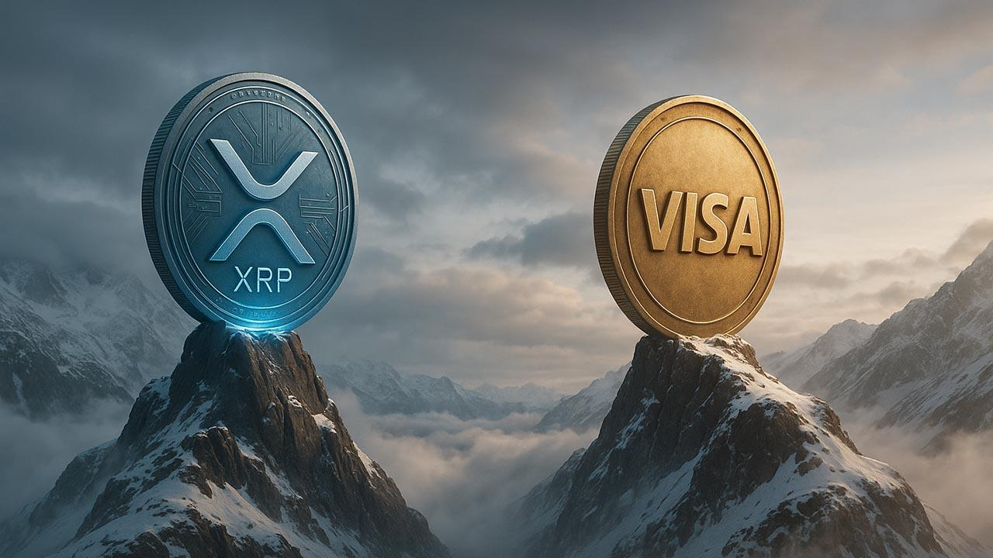Here’s How High XRP Could Rise If It Beats Visa’s $600B Market Value
XRP eyes Visa’s valuation as analysts forecast double-digit prices. Currently valued at around $147 billion with a price of $2.45, XRP ranks third among crypto assets, behind Bitcoin, Ethereum. Analysts project that if XRP’s market cap reaches Visa’s $667 billion, its price could soar to approximately $11.68 per token, a 376% surge.
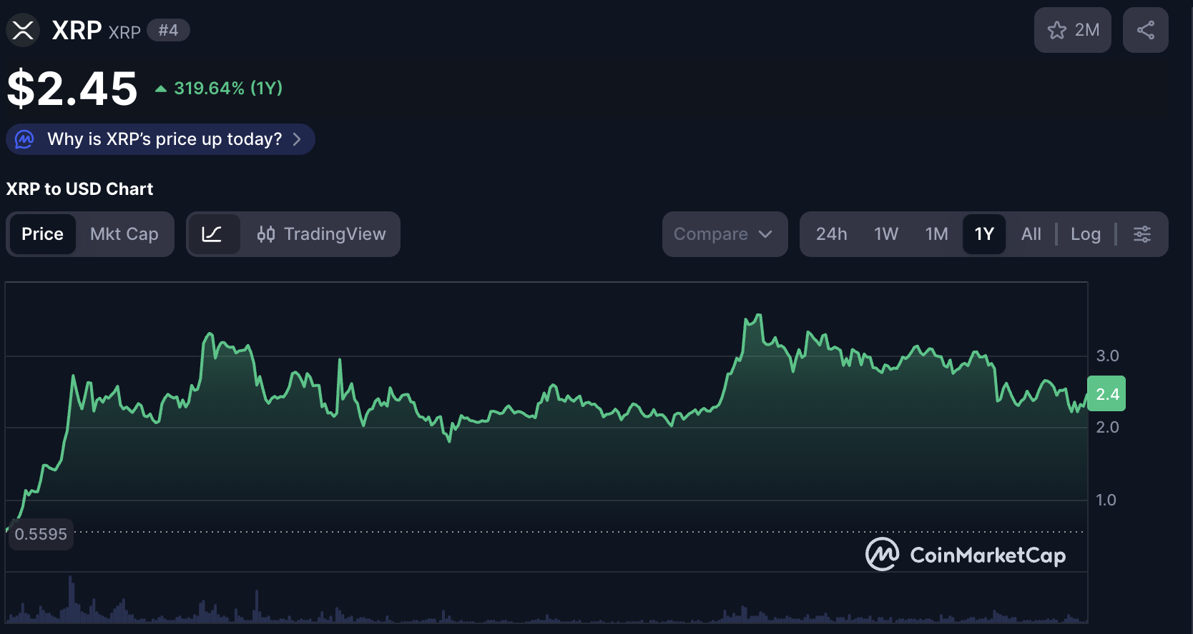

XRP to $50
In July, XRP briefly hit a $210 billion market cap, surpassing companies like Uber and BlackRock before retreating. Analysts believe Q4 2025 could mark XRP’s next major breakout, potentially pushing it into double-digit territory and positioning it to challenge giants such as Netflix, Visa, and Mastercard.
According to Zach Rector, XRP next surge may begin following ETF approvals as it attracts billions in inflows. Some predictions target XRP prices as high as $50 if inflows reach $10 billion.

Another Promising Coin to Watch
Minotaurus (MTAUR) is also capturing interest with strong early momentum. At 0.00012489, MTAUR has already tripled from its starting price of 0.00004, and the momentum remains red hot.
With upcoming exchange listings and strategic partnerships, analysts see room for exponential upside, potentially reaching 0.05, which could turn small early sums into substantial gains.
MTAUR powers a blockchain-based gaming ecosystem where players battle mythical creatures and unlock game utilities. The project has been audited by SolidProof and Coinsult. Visit the official website to explore pre-launch details and how to join before its next major announcement.


