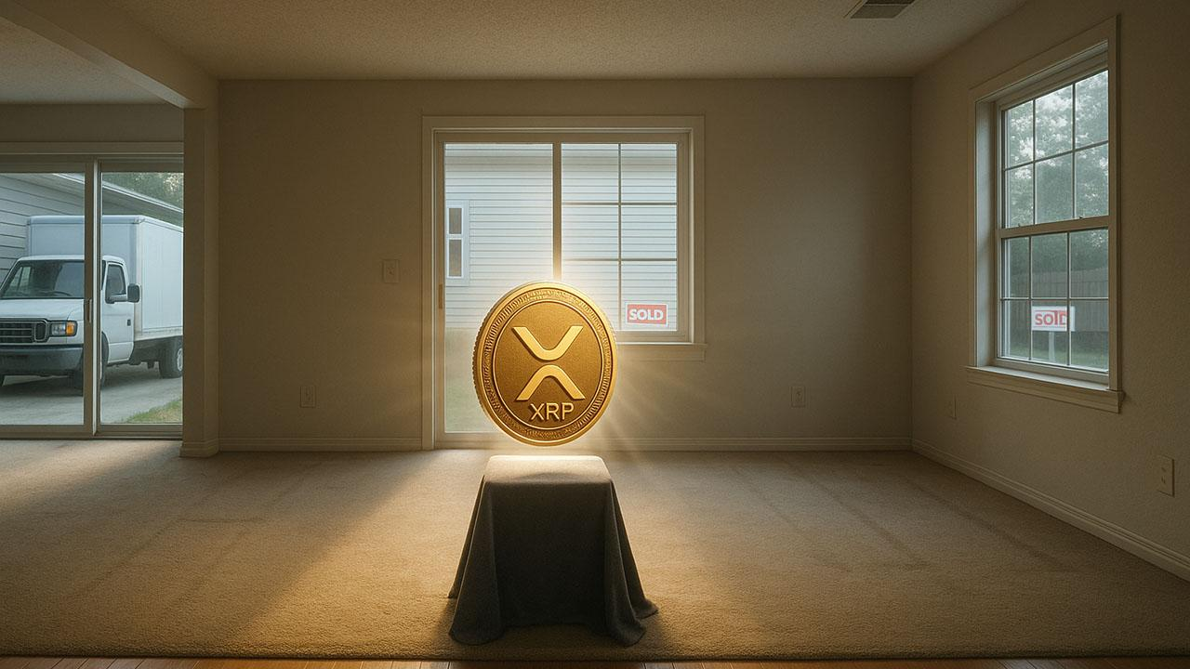Solana Foundation Manager Says Sell Your House, Bed, Clothes, and Buy XRP as ETF Inflows Hit $545M
Vibhu Norby, a manager at the Solana Foundation, sparked online buzz after joking, “Sell your house, bed, kids, cardboard box, clothes, and buy XRP,” joining the heated debate over aggressive XRP accumulation.
His satirical remark followed crypto founder Cameron Scrubs’ call to sell all holdings and go all-in on XRP, which he claims will surpass Bitcoin and Ethereum within five years.

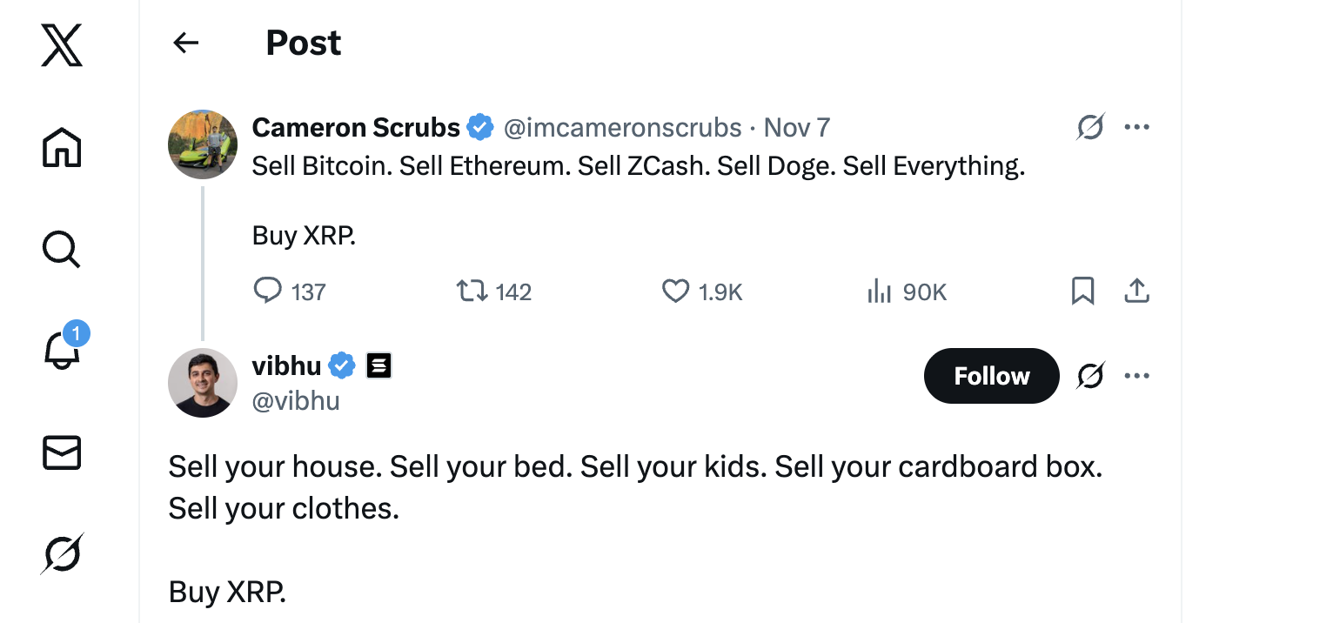
At Ripple Swell 2025, Ripple announced a $500 million funding round led by major firms like Galaxy Digital and Pantera Capital, along with a new Mastercard partnership to use RLUSD for fiat settlements on the XRP Ledger.
Solana’s Bitwise Staking ETF has drawn $545 million in inflows since its October 28 launch, with daily gains despite a 29% monthly price dip. Analysts say the demand reflects Solana’s strong community and long-term potential amid growing competition.

The Next Big Entry Before the Public Phase
Meanwhile, another project sparking significant attention is Minotaurus (MTAUR). The coin sells at just 0.0001249 USDT per token with a 5.6 million market cap, offering rare early-stage upside potential. It has surged 250% since launch, showing strong demand and trust.
Early inflows into the gaming project have already reached 2.9 million USDT, nearing the 3 million milestone. A 100 USDT stake today could yield hundreds of thousands of tokens before the next price leg up.
SolidProof and Coinsult audited the project. Visit the official Minotaurus site to join before public access opens.
