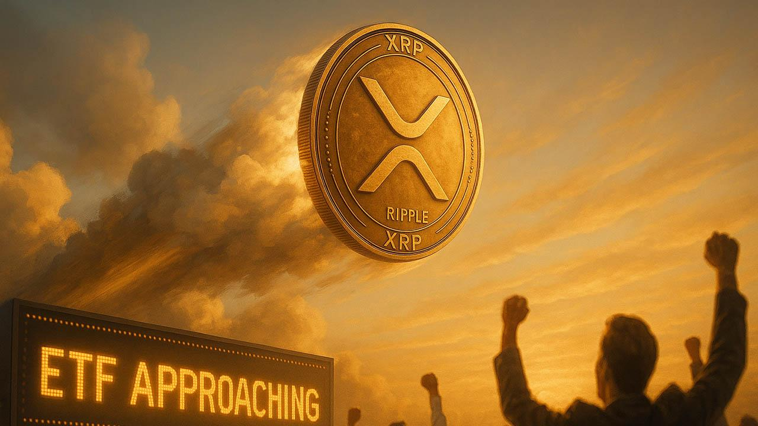Ripple ETF Update: XRP Price Surges Over 10% Ahead of XRP ETF Approval
Meta Description: XRP price rises over 10% to $2.47 as 21Shares starts a 20-day countdown for its spot XRP ETF.
Ripple’s XRP rose over 10% in the past 24 hours to $2.47 as ETF anticipation grew across the market. The token has soared 390% in 2025, maintaining momentum as holders respond to strong technical signals. Analysts say a bullish flag formation on daily charts could extend the rally toward $10 if buying pressure remains steady.

ETF Countdown Drives Institutional Optimism
XRP’s rise follows news that 21Shares has filed an 8(a) submission with the crypto regulation agency, starting a 20-day review period for its proposed spot XRP ETF.
If the crypto regulation agency takes no action within that window, the fund—set to put under the ticker TOXR on Cboe BZX—may be approved by November 27.
Analyst Eric Balchunas noted that the countdown places the ETF “one step closer to launch.” The product will use Coinbase Custody and BitGo for storage with Jane Street as market maker.

Minotaurus (MTAUR) Emerges as New Contender
Alongside XRP’s ETF-related momentum, Minotaurus (MTAUR) has drawn attention in presale markets. The Web3 gaming token built on Binance Smart Chain has gotten $2.9M of its $6.44M target while priced at 0.00012486 USDT. Its smart contracts have passed 100% audits by SolidProof and Coinsult.
The game uses NFT-based bonuses and player ownership features, positioning MTAUR as a low-cost entry for retail buyers seeking utility tokens.
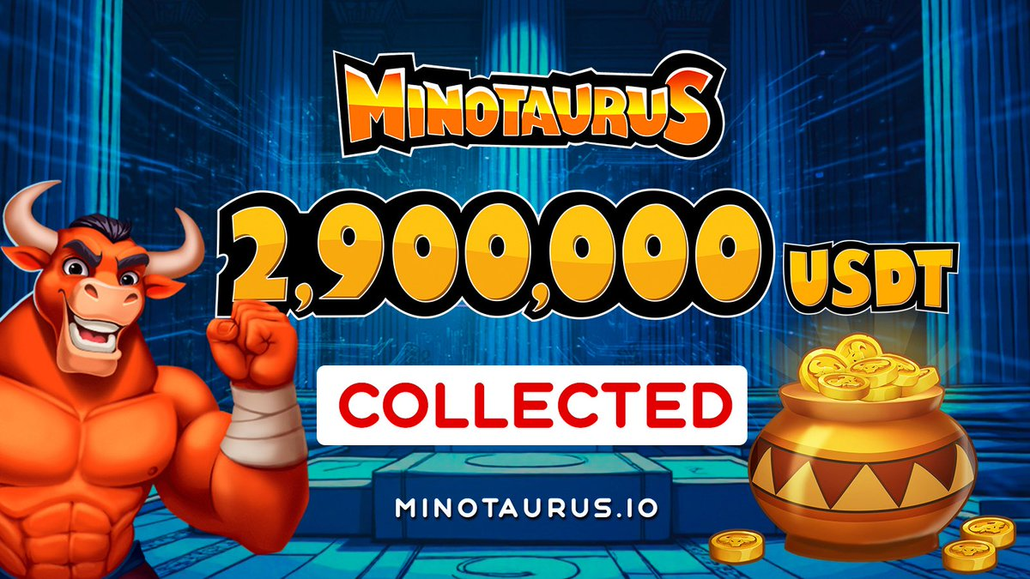
Analysts list it among the best crypto to buy due to its audited foundation and real-world gaming integration. Consequently, while XRP price has seen a bullish phase before, now the rally may not be as huge. However, this new crypto gem Minotaurus (MTAUR) has more rally potential with its low pricing and transparency. Buy MTAUR here

