Ripple CEO Breaks Silence as First Spot XRP ETF Explodes With $26 Million in 30 Minutes
Ripple finally got the moment it spent years fighting for. The first spot XRP ETF launched in the United States — and CEO Brad Garlinghouse immediately jumped online to acknowledge what the market has been waiting for since the earliest days of the SEC v. Ripple saga.
His short post carried the weight of a decade-long battle: regulatory pressure, courtroom delays, and an industry that watched XRP remain the lone top-tier asset without an ETF product. Today, that era is over.

XRPC’s Red-Hot Debut
Trading opened — and XRPC detonated.
Within 30 minutes, more than $26 million in shares had already changed hands. That’s not just a “strong start.” It puts XRPC on pace to challenge the best ETF debut of the year: Bitwise’s Solana ETF (BSOL), which currently holds the 2025 record at $57 million on day one.
Bloomberg ETF analyst Eric Balchunas says XRPC could easily surpass that mark if early demand continues at this speed.
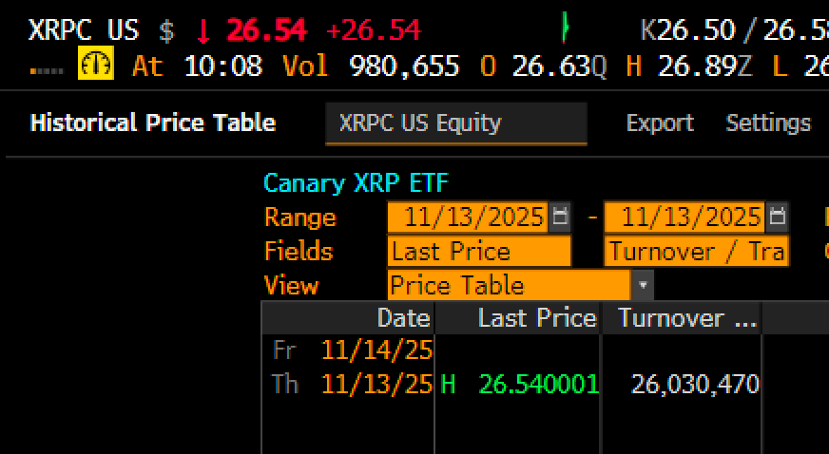
This type of volume confirms what Ripple supporters have argued for years: there is deep, unmet demand for regulated XRP exposure in U.S. markets.
Bitwise CIO Matt Hougan weighed in with one of the clearest explanations for XRPC’s explosive start:
“The median opinion of a crypto asset does not determine an ETF’s success. You’d rather have 20% of people love an asset than 80% of people kinda vaguely like it. ETFs die from apathy, not disagreement.”
XRP has never suffered from apathy. It has one of the most active global communities in crypto, constant institutional interest, and years of pent-up demand due to the legal freeze-out that prevented a U.S. ETF from launching earlier.

The Bigger Picture
As reported earlier, ETF expert Nate Geraci said a spot XRP ETF would mark the final blow to the aggressive anti-crypto stance of prior SEC leadership. The successful debut of XRPC is a symbolic turning point — not just for XRP, but for every asset still waiting for regulatory clarity.
Garlinghouse didn’t need a long statement. The numbers did the talking: $26 million in 30 minutes.

