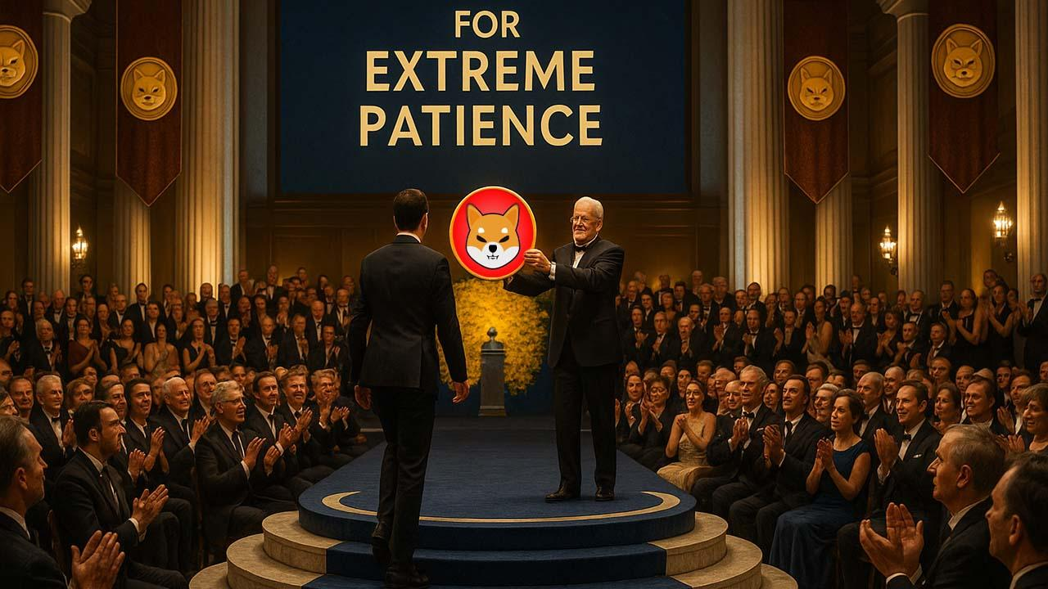Remember Shiba Inu (SHIB)? Expert Says Long-Term Holders Deserve Nobel Prizes – Here’s Why
Blockchain advisor Anndy Lian has called out the hype surrounding new meme-coin traders, arguing that it’s the long-term Shiba Inu holders who truly deserve recognition, perhaps even a Nobel prize.
In a recent tweet, Lian criticized the social media praise for a trader who held a newly launched Solana meme coin through extreme volatility. The trader was lauded for demonstrating “conviction” after holding a three-day-old token and suffering a $30,000 loss in just 24 hours.

Shiba Inu Holders Have Faced Far Greater Volatility
Lian pointed out that this level of risk pales in comparison to the challenges endured by investors in established meme coins like Shiba Inu and Dogecoin. Over the years, Shiba Inu holders have experienced dramatic price swings, from massive surges to severe drawdowns.
Launched in August 2020 at just $0.000000000056, Shiba Inu reached an all-time high of $0.00008845 in October 2021. Since then, it has tumbled 89.68% from its peak, currently trading at $0.000009122.
In the past 24 hours alone, SHIB has dropped 5.47%, posting a seven-day decline of 1.05%, a 13.94% fall over the past month, and a 56.4% loss year-to-date.
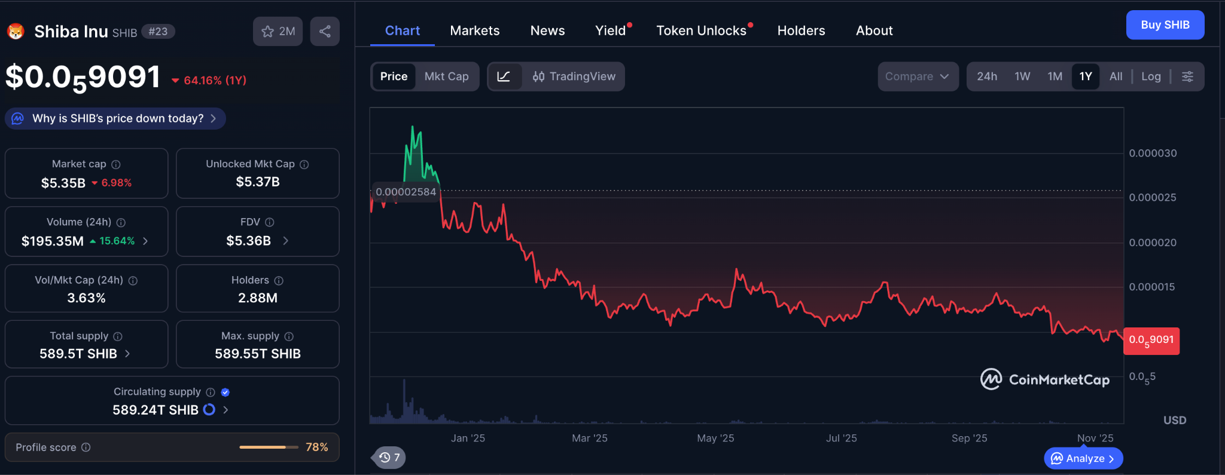

Long-Term Holders Demonstrate True Conviction
Despite these dramatic swings, many Shiba Inu investors have stayed the course. As of May, over 1.17 million SHIB holders had maintained their positions for more than a year, weathering significant volatility along the way.
According to Lian, genuine conviction is shown by those who hold Shiba Inu through years of market turbulence, not by short-term traders riding the overnight swings of newly minted Solana meme coins. Lian himself is among the long-term Shiba Inu holders.
He argued that if enduring a $30,000 loss on a three-day-old token is considered impressive, then long-term SHIB holders deserve Nobel prizes for surviving years of extreme market swings.
Recognition, he says, should go to the investors who have truly endured the rollercoaster ride of the SHIB market, not those experiencing only a fraction of its challenges.

