Shiba Inu Adds a Zero as SHIB Price Breaks Two-Year November Trend: Is the Slide Just Starting?
Shiba Inu has officially entered a danger zone. After weeks of choppy trading, stalled breakouts, and a market losing patience, SHIB has added a new zero, cracking below the psychological $0.00001 level and breaking a two-year streak of bullish Novembers.
The move has revived an old fear: is SHIB sliding into a deeper breakdown, or is this just another reset before the next run?

SHIB Price Loses its Grip
According to CoinMarketCap, SHIB trades at $0.000009771, down 1.3% over the past day as selling pressure continues to build. The token’s failure to hold above key support ranges - a problem that has persisted since early 2025 - has created a fragile technical setup investors are struggling to ignore.
In late October, SHIB cracked below $0.00001, adding an extra zero for the first time in months. The drop was brief, but the psychological damage stuck, and by early November SHIB fell to $0.0000089, marking its lowest level since January 2024 and confirming a nine-month downtrend.
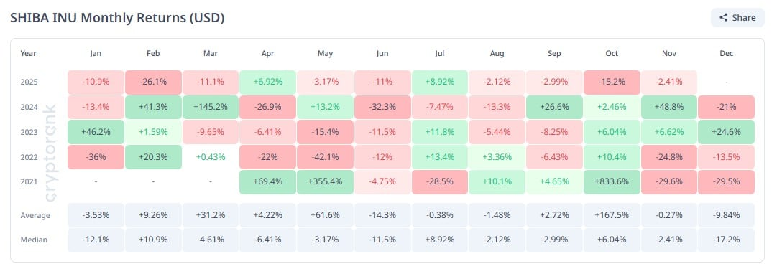
What makes this breakdown even more significant is the shift from two straight bullish Novembers - SHIB gained 6.62% in 2023 and an impressive 48.8% in 2024 - to a 2.44% decline in November 2025. The historical deadlock is broken, and so is sentiment.
Despite the weakness, SHIB’s daily trading volume jumped 26.48% to $168.8 million, signaling that traders are not ignoring the move. Meanwhile, market cap has slid to $5.67 billion, far below the $25+ billion peaks seen earlier in 2025.
The wider picture isn’t flattering: SHIB is flat on momentum, stuck under all major moving averages, and losing ground to competing meme coins with stronger flows.

Is SHIB Really “Going to Zero”?
Every time SHIB dips under a support line, the “SHIB to zero” narrative resurfaces - and this time is no different. Bears are pointing to the long consolidation, failed breakouts, and fresh zero as signs of exhaustion.
But long-time holders counter with a structural argument: a token with a multi-billion-dollar market cap and deep liquidity pools cannot collapse to literal zero without the entire meme-asset sector evaporating alongside it.

What Comes Next?
With SHIB now breaking a pattern that held for two years, November is no longer a friendly seasonal window. Whether this becomes a capitulation bottom or the start of another leg lower depends on liquidity returning - something traders will watch closely as SHIB fights to reclaim the $0.00001 zone.

