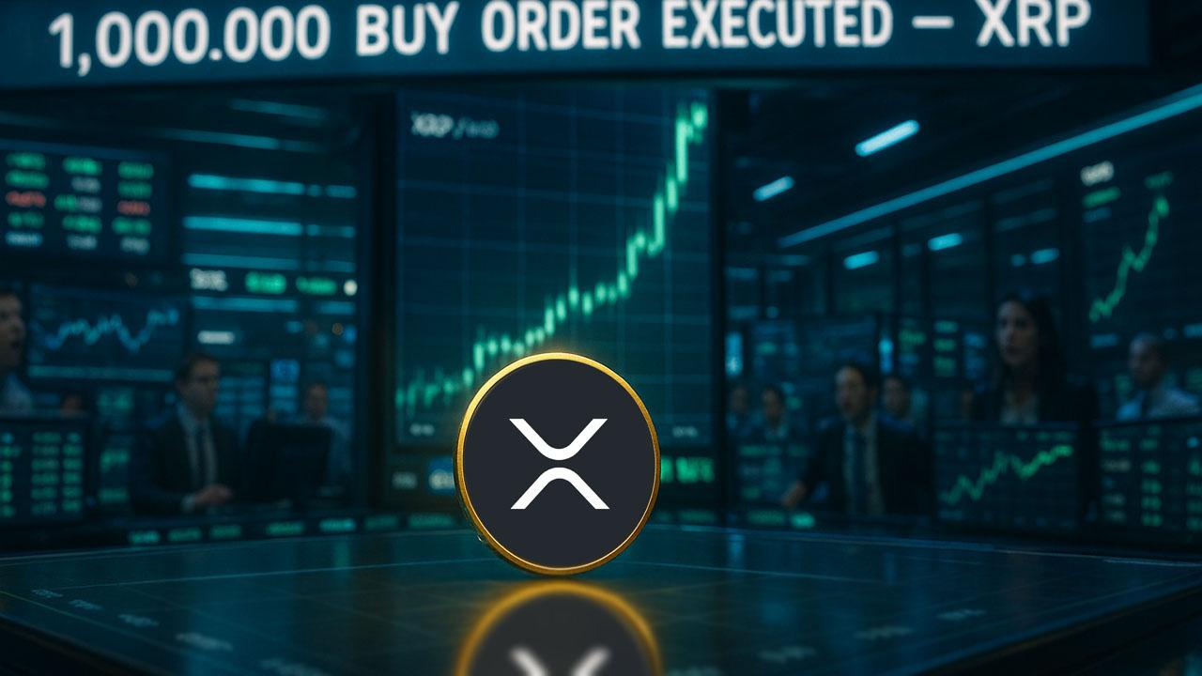Dave Portnoy Drops $1 Million on XRP After Dumping Early and ‘Wanting to Cry’
Dave Portnoy is back in the XRP headlines - and this time he’s buying big. The Barstool Sports founder revealed that he has just scooped up over $1 million worth of XRP, adding to fresh buys of $400,000 in Ethereum (ETH) and $750,000 in Bitcoin (BTC).
Whether this is redemption, revenge trading, or another episode in Portnoy’s chaotic crypto journey is up for debate - but the timing has already sparked a firestorm in the XRP community.
According to CoinGecko, XRP is currently trading at $2.22, down 9% over the past week - the kind of dip Portnoy traditionally sees as a buying opportunity.
This wouldn’t be the first time he punches in late. In his own words, he is “always late to these runs,” and historically tends to buy after volatility spikes and sell before the next rally.

Not Exactly a Diamond-Handed XRP Holder
Portnoy’s relationship with XRP could best be described as… turbulent.
Key moments:
- Dec 2024: Held $1.3M in XRP + $1.5M in Bitcoin, promising his strategy was “bet it and set it.”
- Early 2025: Bought another $1M of XRP during a market dip.
- Mid-July 2025: Posted a video announcing he sold all his XRP two weeks earlier.
- He exited around $2.40, citing advice that Ripple could face competition from Circle.
- Immediately afterward, XRP surged 60%, and Portnoy publicly said he wanted to cry.
He later joked that he was the “leader of the XRP army,” a claim most XRP holders rejected instantly.
Portnoy’s first real crypto exposure came in August 2020, when the Winklevoss twins visited his home to explain Bitcoin. The next day, he bought BTC - and bragged he was “up $100K in Bitcoin.”
Since then, his crypto takes have been inconsistent, emotional, and often self-contradictory. But somehow, he remains one of the most watched retail voices in crypto - even when he’s wrong.

What Now?
With XRP hovering near $2.22 and traders watching the $2.00 zone closely, Portnoy’s re-entry adds another layer of drama to an already tense market.
Will his $1 million buy mark a new leg up - or just another episode in the Dave Portnoy crypto saga?
Either way, the XRP army will be watching.

