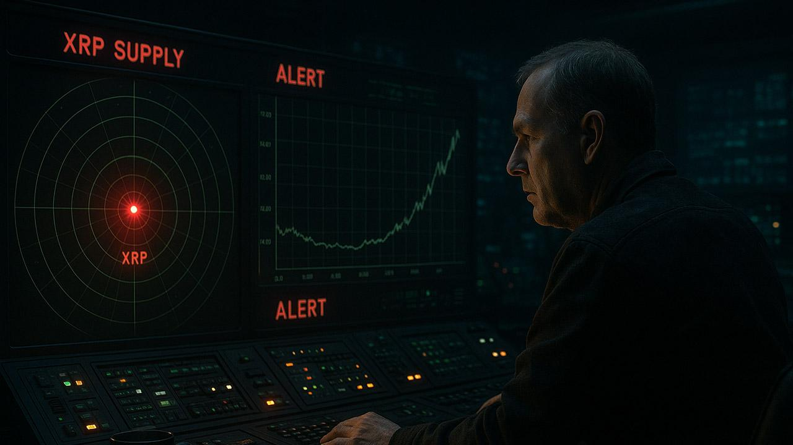Long-Term Bitcoin Dealer Predicts When XRP Supply Will Turn Scarce and Price Could Surge
Long-term Bitcoin holder AltcoinFox argues that XRP spot ETFs may begin draining available supply within months, creating conditions for an aggressive price breakout.
He claimed there are “18 pending ETFs”. He suggested that if each attracted even $50 million in daily inflows, the group could absorb roughly $900 million per day. This would be equivalent to hundreds of millions of XRP leaving the market-available supply every 24 hours..
Based on this, he predicts XRP could become “scarce within six to nine months,” potentially forcing prices higher.
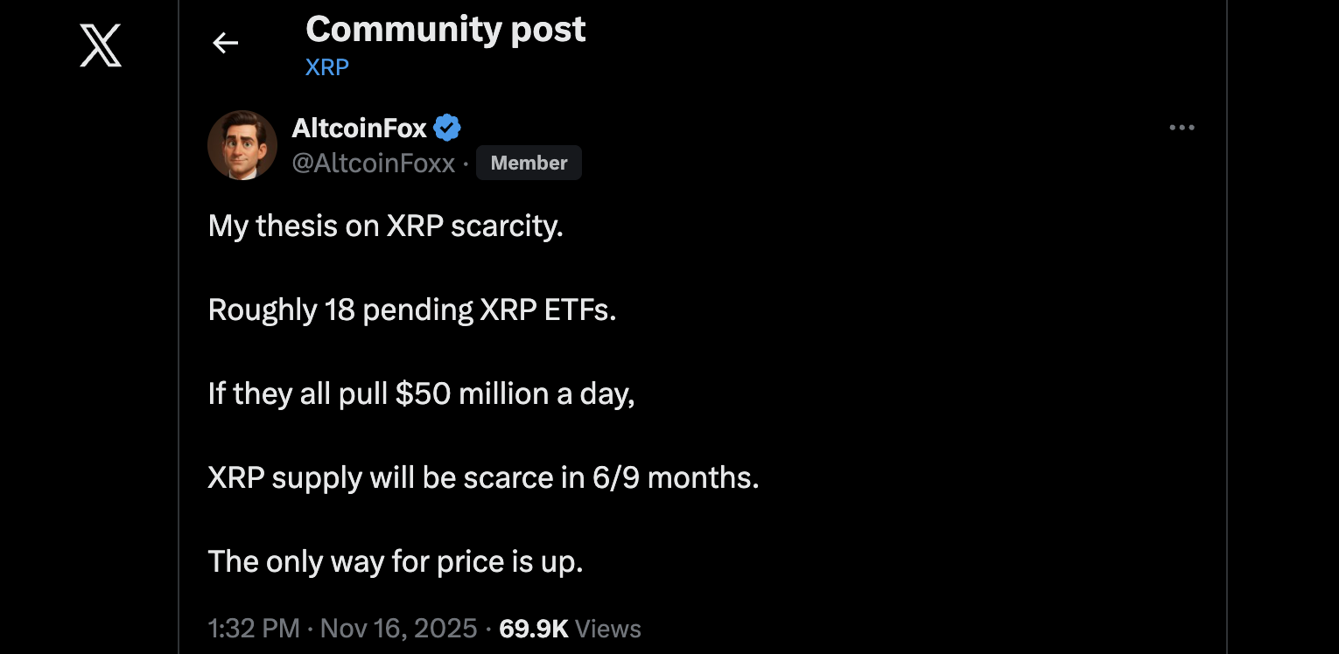
However, only four XRP spot ETFs are currently pending: those from Grayscale, CoinShares, 21Shares, and WisdomTree. Other issuers, including Bitwise and Canary Capital, are already live, pulling in over $400 million in inflows.

Why XRP Price Hasn’t Reacted
AltcoinFox’s view echoes earlier work from analyst Chad Steingraber. His November 20 model estimated that 12 ETFs could accumulate nearly 40 billion XRP in one year, more than two-thirds of the circulating supply.
In another scenario, he suggested that if total ETF inflows reached $1 billion daily, the entire market-available supply could be consumed within twelve months unless prices rose sharply.
Despite these forecasts, XRP remains under $2. Analysts say ETF accumulation occurs largely OTC, keeping demand hidden from public order books. The price impact may only surface once ETF-driven supply absorption becomes impossible to ignore.

