Dogecoin Price Prediction as DOGE Activity Hits 90-Day High
Meta Description: Dogecoin struggles under $0.14 despite whale buying, while Minotaurus (MTAUR) offers a promising low-price buy opportunity.
Dogecoin (DOGE) continues to struggle beneath the $0.14 resistance, despite whale accumulation and rising network activity. Between December 2 and 4, large holders bought 480 million DOGE, raising their total holdings from 28.0B to 28.48B. At the same time, the number of active addresses surged to 71,589, a 90-day high.
However, despite these positive on-chain signals, DOGE’s price remains stuck below $0.14, showing strong resistance at the $0.1409 level.
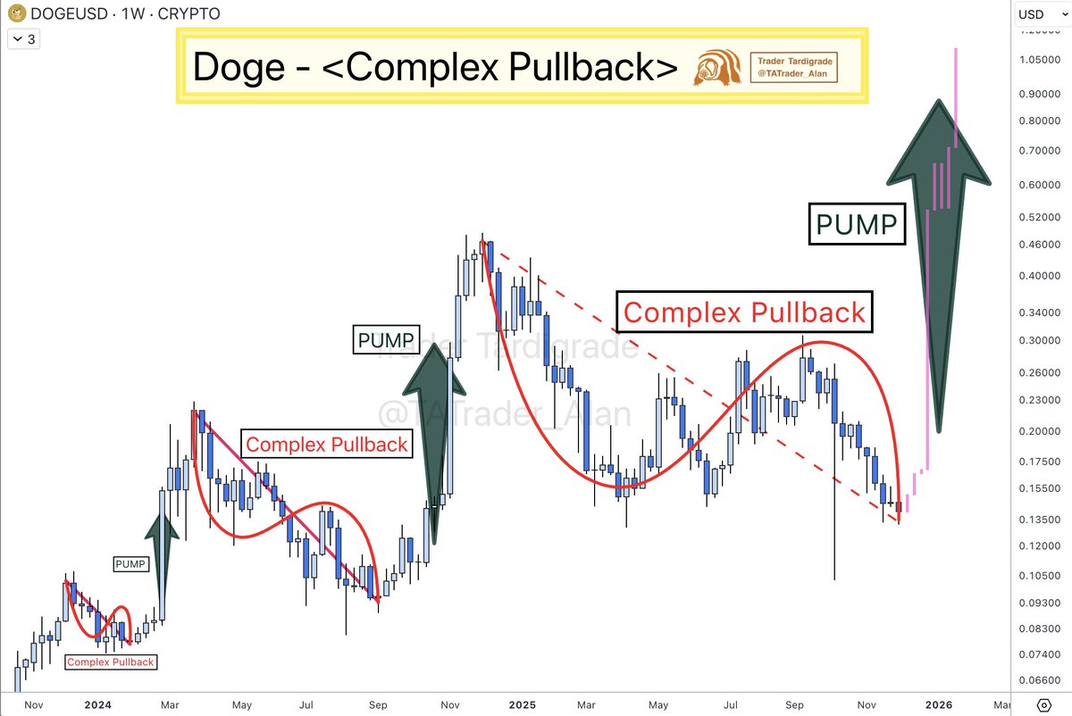
Source: X
Attempts to break this resistance failed as a spike in volume (333 million DOGE) resulted in immediate rejection. The price is now consolidating between $0.1393 and $0.1400.

Minotaurus (MTAUR): A Low Price, High Potential Opportunity
While DOGE struggles, Minotaurus (MTAUR) offers a promising alternative. Currently priced at 0.00012513 USDT, MTAUR powers the Minotaurus ecosystem, a blockchain-based gaming platform built on Binance Smart Chain.
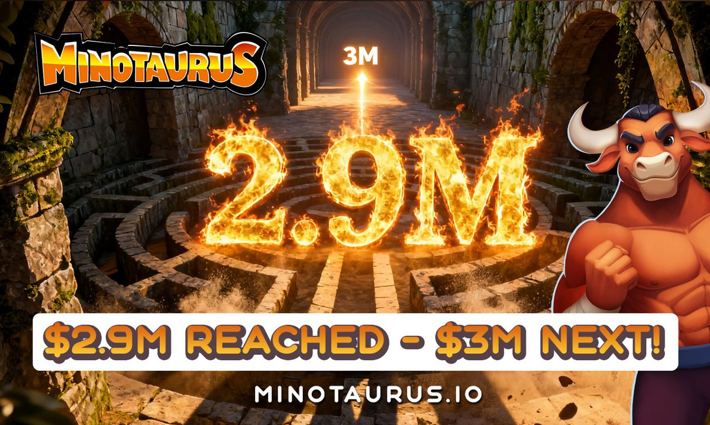
MTAUR is in Stage 6 at 0.00014 USDT, down from the expected launch price of 0.00020 USDT. Buying $100 today can get you over 800,000 MTAUR tokens, with significant upside potential.
MTAUR is audited by SolidProof and Coinsult, ensuring transparency and security for buyers. With the blockchain gaming market projected to reach $29 billion by 2029, MTAUR presents an exciting opportunity for early buyers looking for the best crypto to buy now.

