XRP Poised for 16% Move on Triangle Breakout
XRP finally approaches a decisive move after weeks of flat, frustrating price action. A symmetrical triangle forming on the one-hour XRP/USDT pair shows volatility draining out of the market as price compresses between converging trendlines. This pattern signals indecision, but it also often precedes sharp continuation moves once the breakout hits.
With XRP trading near $2.05, a clean break above resistance implies a measured-move target near $2.40 - 16% higher. The swings inside the triangle have narrowed noticeably, pushing XRP closer to apex, where markets typically resolve fast and violently.
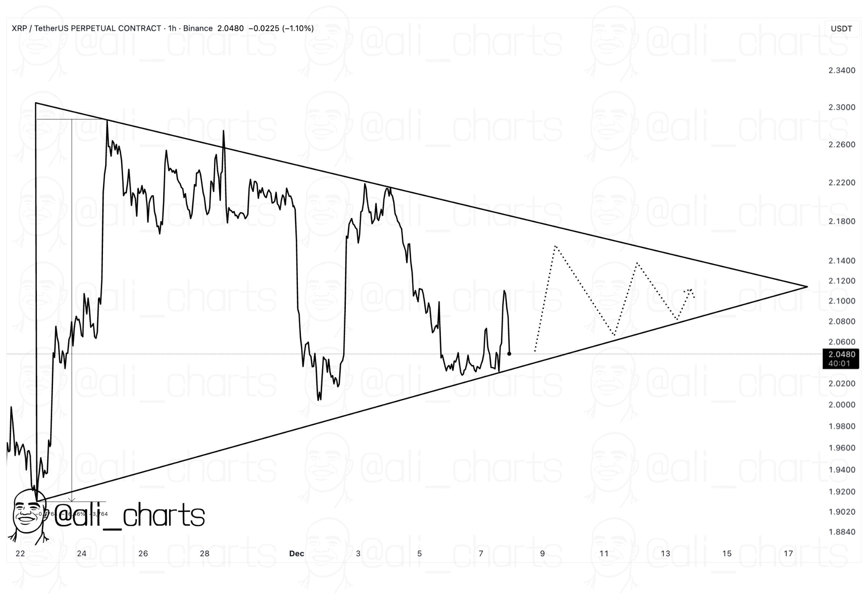
The bigger story is that XRP has not benefited from the historic ETF wave that should have fueled a stronger market reaction. Multiple spot XRP ETFs - led by Canary Capital’s XRPC - have already absorbed more than $900 million in inflows. That level of institutional interest would normally ignite momentum, but heavy distribution from large holders and Bitcoin’s drop below $90,000 wiped out any advantage.

Bottom line for XRP
The token now sits 43% below its all-time high and is barely negative year-to-date, a stark contrast to the hype surrounding ETF approvals.
If bulls take control at the triangle’s edge, XRP finally gets a setup clean enough to break its stagnant trend — but if the breakout fails, the pattern collapses into yet another lower-trend continuation.

