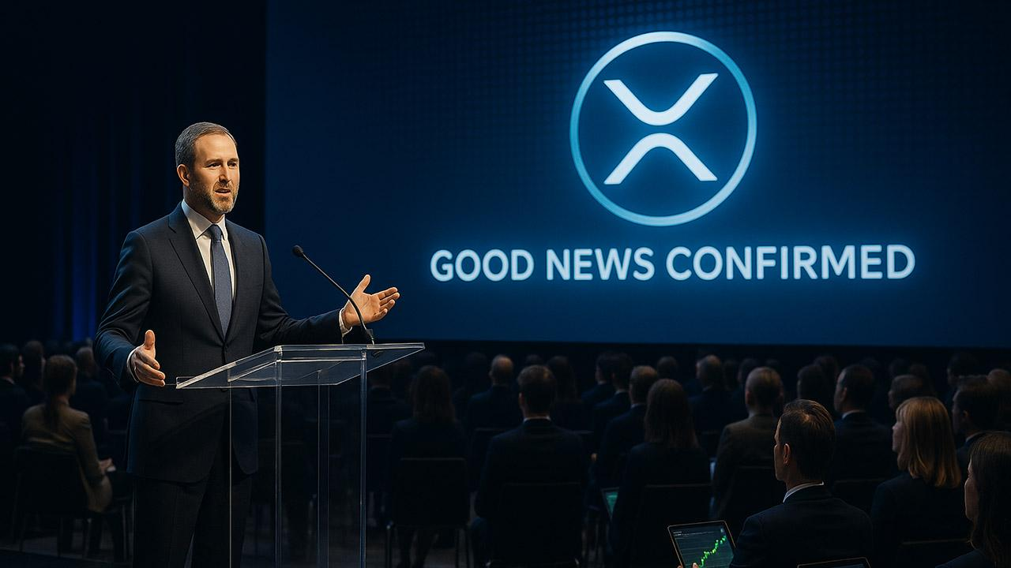Ripple CEO Confirms This XRP Good News That Insiders Already Know
Following the massive success of XRP exchange-traded funds (ETFs) in their first few weeks of debut in the U.S., Ripple's CEO, Brad Garlinghouse, has reiterated an idea insiders already knew.
In his recent appearance in the Binance Blockchain Week program, Garlinghouse spoke out against claims that interest in XRP ETFs has cooled. He confirmed that 2026 is shaping up to be a breakout year for crypto, especially XRP. Notably, the XRP ETFs have amassed approximately $900 million in inflows, highlighting a massive surge in activity with the token.
According to Garlinghouse, one factor contributing to the surge is the regulatory clarity Ripple has achieved in the United States in recent times. He explained that the past few years have not been favorable for XRP, as many prospective institutional holders have stayed away from the coin due to regulatory issues and risk concerns. However, this has come to an end, as these enthusiasts are entering the market and acquiring XRP ETFs to ease the stress of self-custody.
Expressing optimism on the massive growth to expect from XRP and other crypto ETFs in 2026, Garlinghouse stated, “Only 1-2% of the total ETF market is crypto, I will bet anybody here that a year from now, that would be more than 1-2%, and it is going to continue the inflows.”
Moreover, the wave of institutional XRP adoption has also attracted Vanguard, which has taken a sharp turn on its stance after rejecting crypto for years. The asset manager has now listed XRP spot ETFs for trading on its platform.
Notably, analysts are betting that these inflows will significantly affect XRP's price.

