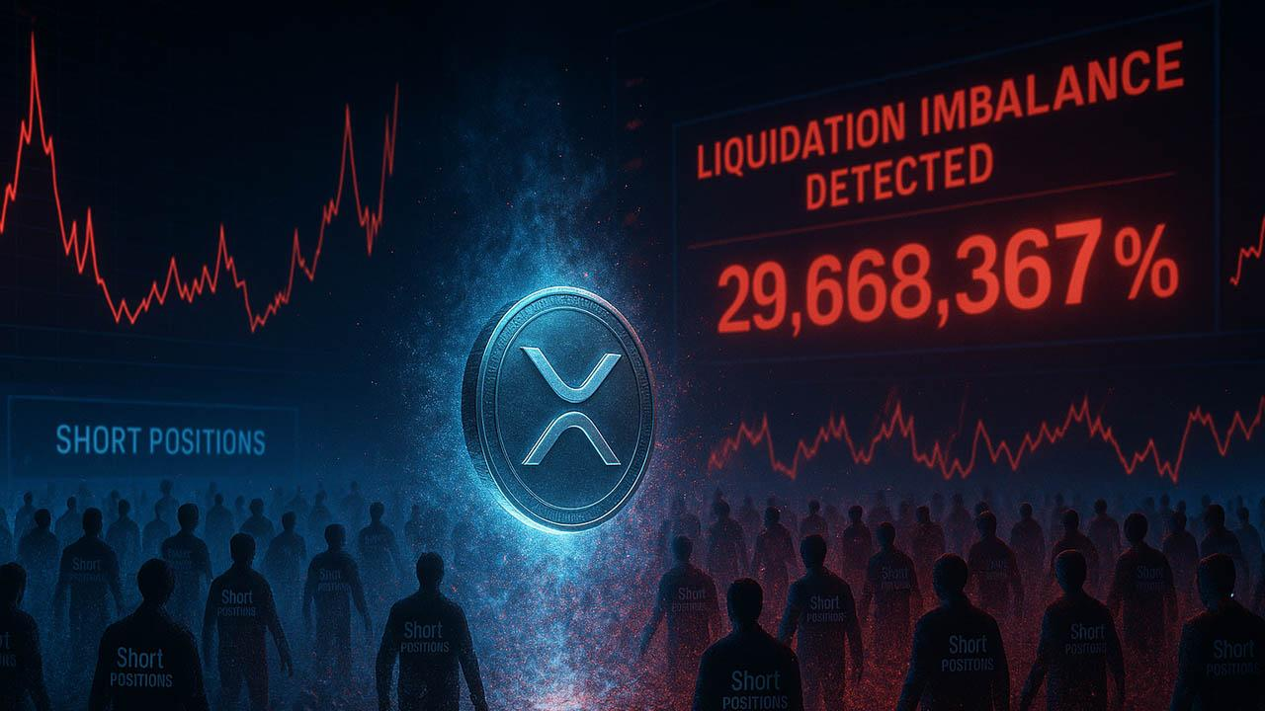XRP Prints 29,668,367% Liquidation Imbalance as Short Sellers Vanish
XRP’s derivatives board just printed a number so absurd it forced traders to double-check the data feed: a 29,668,367% liquidation imbalance on the four-hour map. According to CoinGlass, longs ate $175,000 in liquidations while shorts lost only $588 - a ratio so lopsided it practically announces that there is no real bear presence on the XRP chart right now.
Price softened earlier in the session, slipping out of its intraday band, but the reaction was identical to what has been happening for two weeks: no new shorts stepped in, no attempt to press the breakdown, no crowd trying to force a deeper flush. The market simply cleared out over-leveraged longs and kept moving.
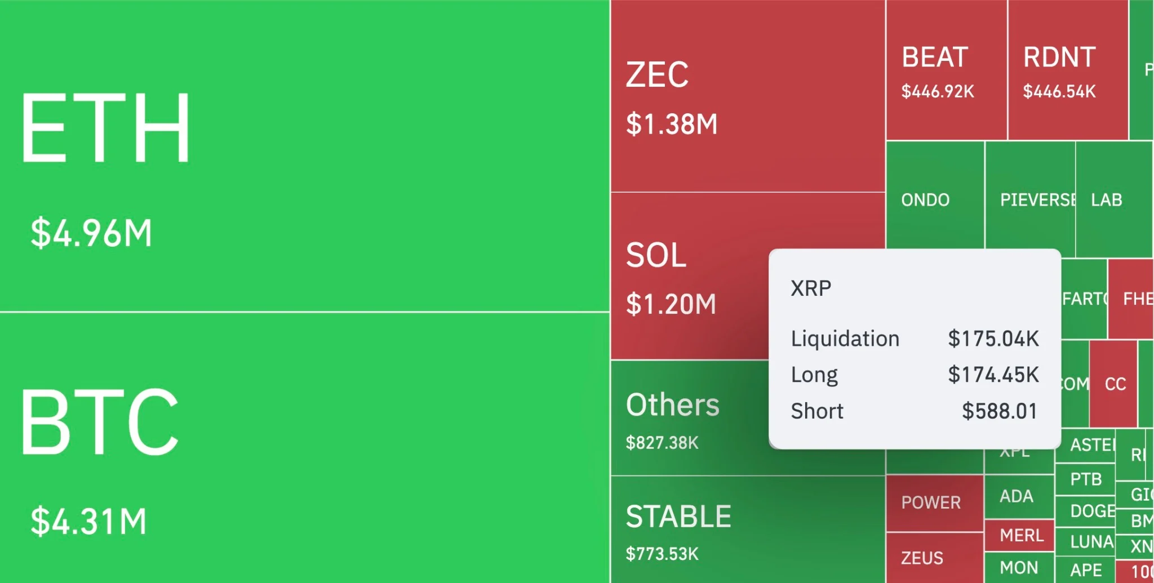
This is the part that matters. When an asset drops without short-side aggression, the move is not a bearish conviction swing - it is a liquidity reset. Traders closing longs create the dip, not bears taking control.

Shorts Refuse to Engage with XRP
The max-pain table confirms the message. Short max pain sits 9.71% above spot, with roughly $12 million in exposure trapped there. Short sellers know that entering early would mean walking straight into their own liquidation cluster, so they are staying light, reactive, and unwilling to commit size.
This creates an unusual picture: XRP is drifting lower, but the downside has no force behind it. A true downtrend requires active short pressure, and XRP simply does not have it. Until that changes, each drop resembles a routine leverage cleanup rather than a structural trend break.
In other words, XRP is falling - but no one is pushing it. A market without motivated bears can move lower, but it cannot form a meaningful bearish sequence. When short interest finally engages, the chart will look very different.

