Ripple Poised to Become a U.S. Bank: Has XRP’s “Blue-Chip” Era Officially Begun?
Ripple’s push for a U.S. national bank license, fresh regulatory clarity from Washington and a wave of ETF/ETP inflows are rapidly transforming XRP’s image from speculative altcoin into bank-grade, blue-chip infrastructure at the core of a new cross-border payments stack.
In a new interpretive letter highlighted by CoinEdition, the U.S. Office of the Comptroller of the Currency (OCC) confirmed that national banks may now engage in “riskless principal” crypto-asset transactions. Under this model, banks can step in between buyers and sellers, execute trades on their clients’ behalf and earn a spread or commission, without holding the crypto on their own balance sheets — treating it more like a brokerage or FX dealing service than proprietary trading. The OCC stresses that institutions must still meet capital, liquidity, risk-management and compliance standards when offering these products.
This letter lands at a pivotal moment for Ripple. As Coinpaper reports, the firm applied in July 2025 for a U.S. national bank charter and a Federal Reserve master account. If approved, “Ripple National Trust Bank” would be able to accept deposits, offer institutional-grade custody and settle payments directly over the Fed’s rails as a fully regulated U.S. bank. Analysts note that such a license would place both XRP and Ripple’s RLUSD stablecoin inside the same regulatory perimeter as traditional bank money, potentially giving risk-averse institutions a clearer framework for using Ripple’s tech in day-to-day finance.

Regulatory Green Light Meets Wall Street Demand
On the asset-allocation side, XRP is quietly climbing the quality ladder. CoinEdition reports that XRP now holds roughly a 5,17% weighting in the Bitwise 10 Crypto Index ETF (BITW), elevating it into the fund’s top-three holdings alongside Bitcoin and Ethereum. In Bitwise’s own words, XRP is “one of the world’s longest-running crypto assets, with the potential to reshape how money moves worldwide” — explicit “blue-chip” language that few altcoins have ever earned in a U.S.-listed product.
Flows data tell a similar story. According to Coinpaper, citing CoinShares statistics, digital-asset ETPs saw 716 million dollars in net inflows last week, with 245 million dollar of that total going into XRP products — nearly six times Ethereum’s weekly inflows and far ahead of Solana, despite their larger DeFi and NFT ecosystems. U.Today adds that XRP ETFs from issuers such as Canary, Grayscale, Bitwise and Franklin Templeton have now logged 16 consecutive days of net inflows, pushing cumulative on-chain ETF demand past the 1 million dollar mark in under a month, one of the strongest altcoin ETF launches on record.
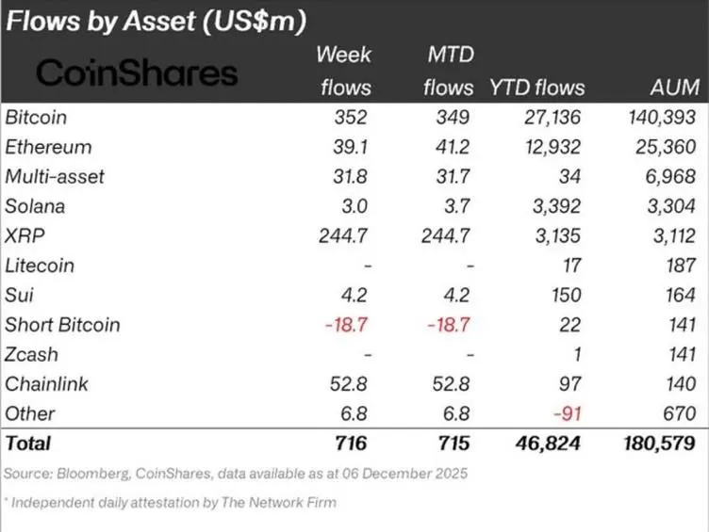

From Speculative Token to Regulated Infrastructure?
At the market-structure level, XRP is trading around the 2 dollar support zone, with analysts talking about a “final squeeze” setup where tightening price action and rising volume often precede a sharp move in either direction. Separate technical work from NewsBTC points to an extended breakout structure with upside targets in the 9–13 dollar region over the longer term, while cautioning that volatility and deeper pullbacks remain part of the path.
Put together, the OCC’s green light for bank-mediated crypto trades, Ripple’s pending U.S. bank charter, its Bitwise blue-chip status and the torrent of ETF/ETP inflows are building a coherent new narrative: XRP is no longer just a high-beta trading vehicle, but a core component in a regulated payments, liquidity and settlement stack that banks, ETF issuers and institutional allocators are actively wiring into their infrastructure. Whether price fully catches up to that story is uncertain — but structurally, XRP is being pulled, step by step, into the heart of mainstream finance.

