Bitcoin Price Prediction as US Interest Rates Were Cut by 25bps
Meta Description: Bitcoin price set for rally after the US Fed cuts rates by 25bps. Can Bitcoin capitalize on the rate cut to push past $100K?
Bitcoin’s price has seen a notable surge after the Federal Reserve's decision to cut interest rates by 25bps for the third consecutive meeting in 2025. The cut comes as part of the Fed’s strategy to boost economic surge, encouraging businesses and individuals to borrow at lower costs. This has a direct impact on riskier assets like Bitcoin, which tends to benefit when institutional confidence rises.
The move is seen as a positive development for Bitcoin and the broader crypto market. Historically, lower interest rates weaken the US dollar and make traditional assets like equities and bonds less attractive. As a result, more buyers may turn to Bitcoin and other cryptocurrencies as an alternative store of value. Bitcoin’s price surged briefly to $94,044 after the rate cut announcement, but the long-term outlook remains contingent on how well the asset can break past key resistance levels, such as $100K.

Institutional and Retail Reactions to the Interest Rate Cut
The response to the 25bps rate cut has been largely positive, particularly among institutional buyers. With the US dollar becoming less attractive, Bitcoin becomes a more appealing buys. Smart wallets have been accumulating Bitcoin, suggesting strong institutional confidence in the crypto space despite overall market uncertainty. The $27.5 billion in open interest for Bitcoin has also decreased significantly, signaling that some buyers are shifting their focus to Bitcoin as a hedge against inflation.
On the retail side, Bitcoin saw some short-term volatility following the announcement. While some holders reacted with optimism, the typical "buy the rumor, sell the news" effect led to quick sell-offs after the rate cut was confirmed. However, this short-term fluctuation shouldn’t overshadow the long-term bullish case for Bitcoin, especially if the macroeconomic environment continues to favor risk assets like crypto.
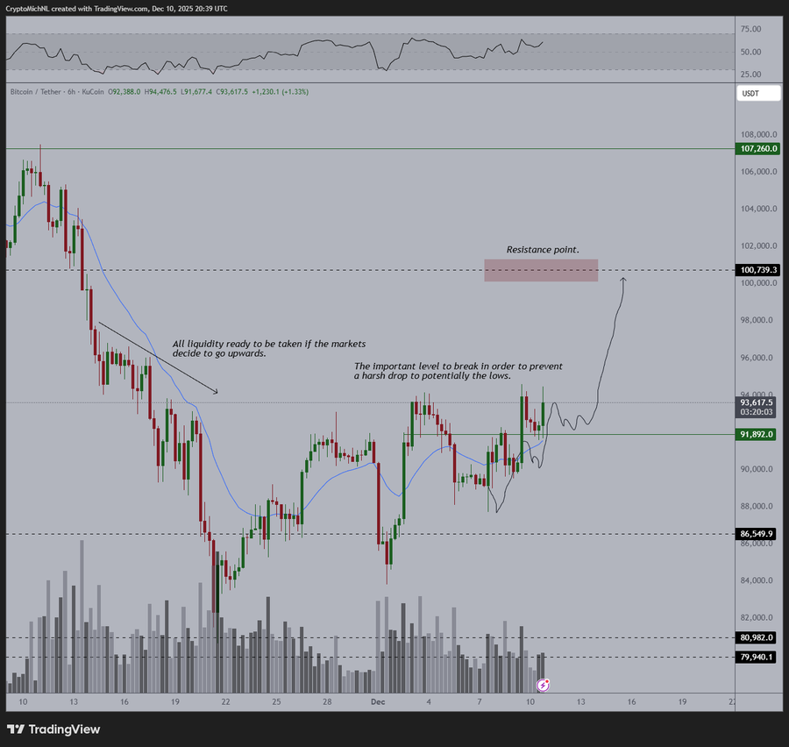
Source: X
Michaël van de Poppe, a crypto analyst, has noted that Bitcoin is "following the bullish path" and that while volatility caused by the FOMC decision may cause some uncertainty, "if it does [remain above $91.8K], it's very likely that Bitcoin continues to run towards $100K in the coming period as it's about to take out the highs and starts to accelerate from here.
The project has also passed audits from SolidProof and Coinsult, ensuring transparency and security for buyers. With more than 2.98 million USDT gotten so far in its presale, Minotaurus is building momentum. The low entry price makes it an attractive opportunity for early-stage buyers looking for high potential advantages as the casual gaming sector continues to surge.

