XRP Locks in Crucial Support: Don’t Miss This 40% Rebound
XRP might be about to bounce back after a few rough weeks, with experts pointing to a key support area that could decide its next move.
According to a TradingView chart, XRP has found a solid support level just above $1.94. This level has been a big deal before, and it's always been a good sign when it's been on the rise. It's one of the most important price zones on the current chart.
XRP, like the rest of the crypto market, has been stuck in a defensive posture amid ongoing volatility and macro uncertainty. Even though the market is down overall, it looks like selling pressure is losing steam around the $1.94 mark. That's where buyers have been stepping in.
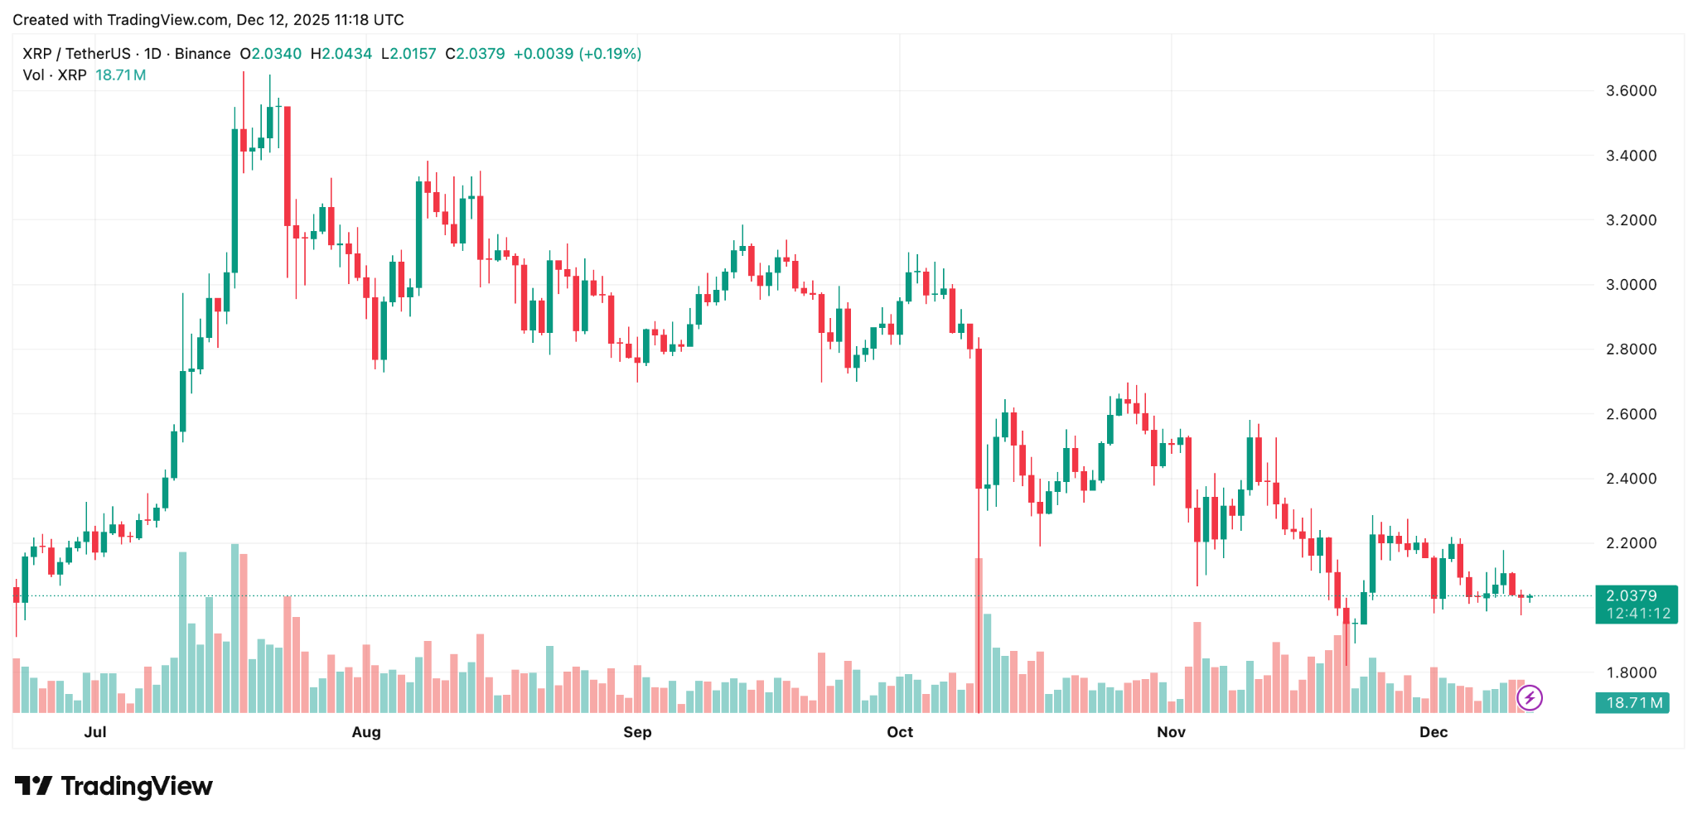
Martinez says that if XRP wants to keep its bullish structure, it's key to hold and close above $1.94. If we can keep defending this level, it could lead to a recovery move toward the $2.40-$2.50 range, which lines up with prior resistance and short-term technical targets.
But the analyst also says that if it doesn't hold this support, it could invalidate the whole rebound theory, which would put new pressure on XRP to go down. If that happens, the market might dip into lower demand zones before we see any real recovery.
Right now, XRP is at a technical crossroads. The token's next move is likely to be determined by the buyer strength around $1.94. If the market conditions continue to test sentiment, the token might remain stuck in consolidation.

