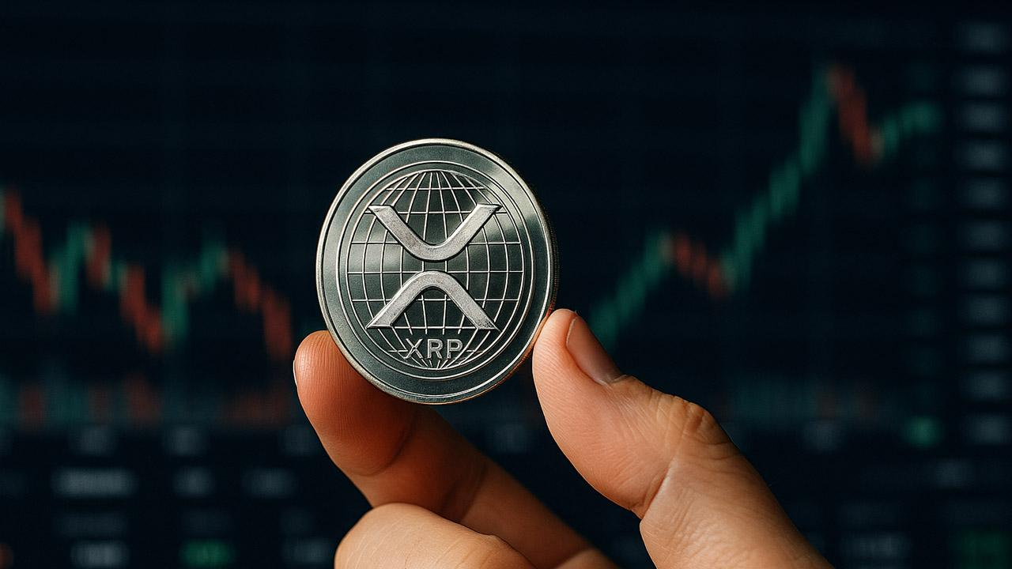Top Analyst Shares What Will Push XRP to $100 in Two Years
A famous XRP educator, X Finance Bull, has predicted that XRP could reach $100 within the next two years as global blockchain adoption continues to thrive. He noted that an intense wave of asset tokenization would mark the coming 24 months and that this development would not rely on “hype chains.”

XRP at $100 by 2027
Notably, many market experts view tokenization as a crucial development that could affect global crypto adoption and liquidity. As the blockchain ecosystem prepares to welcome trillions of dollars from the traditional market, XRPL could become the foundation and key settlement layer, thereby boosting the value of the ledger’s utility token, XRP.
On the other hand, other analysts think more time would pass before the coin would reach such a feat. For instance, Telegaon analysts project that XRP would change hands around $8.7 in the next two years and would surge past to reach $100 around 2050.

Here’s a Realistic 100x Opportunity
Recent research has filtered the noise and identified Minotaurus (MTAUR) as the next promising coin that can turn moderate capital into generational prosperity.
Currently selling at 0.00012523 USDT, Minotaurus offers not just a fair entry but also an affordable price to accumulate, considering its future trajectory.

Here’s Why MTAUR Could Rally 100x
- Promising Niche: Minotaurus targets the casual gaming sector, tipped to reach $29 billion by 2029.
- Solid Token Utility: MTAUR offers in-game utility that enables users to power up and customize characters with the token.
- Massive Incentives: The project offers appealing perks for buyers, including referral and vesting bonuses, as well as a 100,000 USDT giveaway.
Learn more at minotaurus.io

