XRP Price Prediction as New XRP ETF Hits the Market With 21Shares' TOXR Launch
XRP’s price is facing critical support levels as it hovers near $2, with attention focused on its 20-month EMA at $1.93. Holders are closely monitoring whether this support will hold or if a further decline will occur. The recent launch of the 21Shares TOXR ETF on the CBOE exchange has brought new institutional interest to XRP, with the ETF tracking the fourth-largest cryptocurrency by market capitalization. This event is expected to surge the exposure of XRP to more traditional markets, possibly influencing price movement.

XRP Faces Key Support and ETF Boost
XRP’s price structure is testing key technical levels, with the $2 support line coming under pressure. ChartNerd, a prominent technical analyst, has pointed out that XRP is nearing a crucial trendline near $2.01, while the 20-month EMA provides a significant support zone at $1.93.
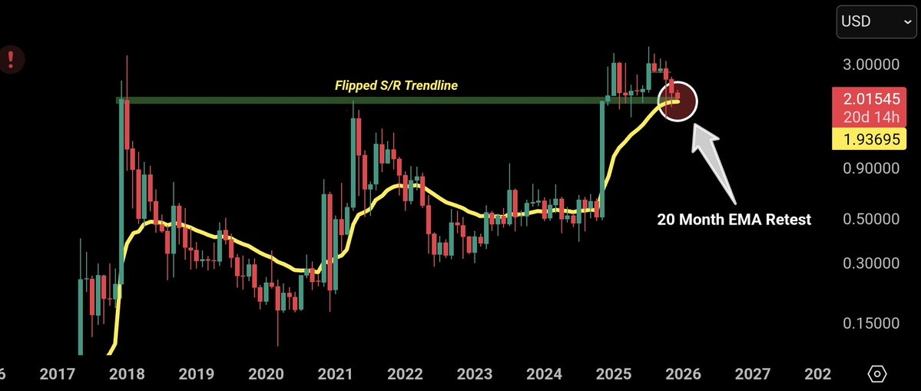
Source: X

Minotaurus (MTAUR): A Rising Star in Web3 Gaming and Crypto
Alongside the action in the XRP market, Minotaurus (MTAUR) is drawing attention as a rising cryptocurrency within the gaming space.

Currently priced at 0.00012522 USDT in its Stage 5 presale, MTAUR is poised for significant rally as it moves towards Stage 6, with a price surge to 0.00014 USDT. The public market price is set at 0.00020 USDT, offering a 60% upside potential for early buyers.
Minotaurus has been 100% audited by SolidProof and Coinsult, ensuring transparency and trust for buyers.
For those looking for the best cryptocurrency to buy under 1 USDT, MTAUR’s use case, audited contracts, and strong community support make it one of the most promising altcoins in the market.

