Dogecoin Price Prediction as Analyst Charts Path of 611% DOGE Rally to $1
Meta Description: Dogecoin could see a 611% rally, with analysts predicting a rise to $1. Key technical support and patterns point to major rallies ahead.
Dogecoin (DOGE) has seen impressive rallies, with significant surges in 2024 and 2025, but it is currently facing critical resistance levels. Technical analysts have identified a path to a potential 611% price surge, suggesting that DOGE could hit $1 if it successfully breaks key resistance levels. The token has gotten momentum after holding strong at key support zones, creating the perfect setup for future rally. With institutional interest surging, and technical patterns aligning, DOGE’s future trajectory may be bullish, potentially bringing it closer to $1.
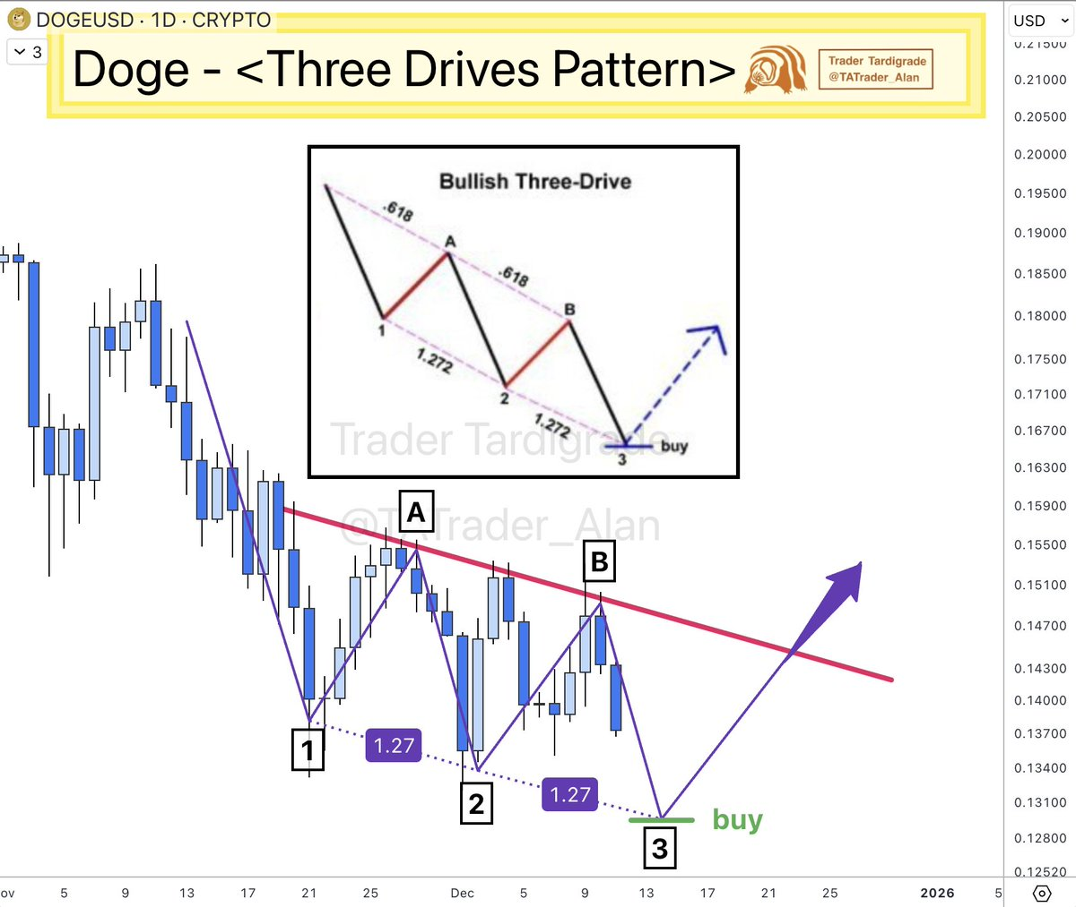
Source: X
Current price action suggests that Dogecoin is sitting at a key inflection point. While the token has struggled to break resistance, the ongoing accumulation and rising support levels indicate that a breakout could be on the horizon. Buyers and analysts are watching for any signs that DOGE can maintain its support and clear $0.22— a critical resistance level. A confirmed breakout could trigger significant upside momentum, pushing Dogecoin toward new price highs.

DOGE Faces Key Resistance and Breakout Potential
Technically, Dogecoin is currently forming a rising wedge pattern, with the price making higher lows but lower highs. This classic pattern often signals an impending breakout, either to the upside or downside. If DOGE breaks through the $0.22 resistance and sustains a close above it, analysts predict it could begin its journey to $1. This would mark a 611% surge from current levels, supported by solid buyer interest and improving technical momentum.
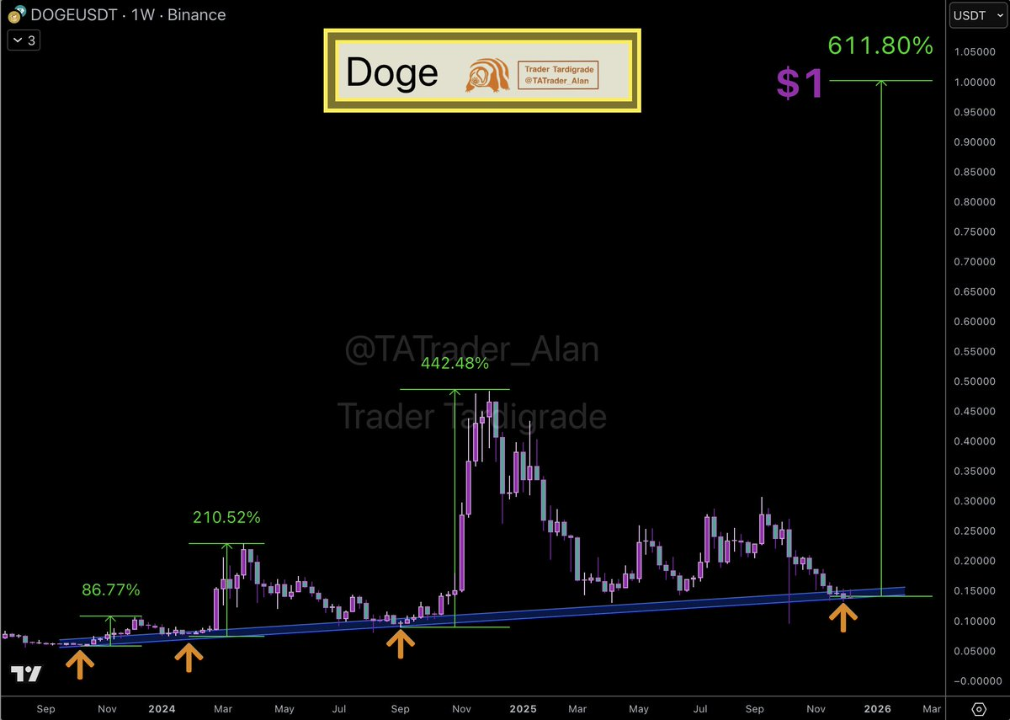
Source: X
The wedge pattern typically suggests that the price is consolidating in a tightening range. As more buyers accumulate near the lower support levels, DOGE is in a prime position for a surge if it can break above the resistance.
However, a failure to break the upper trendline and a fall below $0.135 would shift the trend to a more bearish sentiment, which would mean retesting lower accumulation zones closer to $0.12.

